UNITED STATES

SECURITIES AND EXCHANGE COMMISSION
WASHINGTON, D.C. 20549

FORM 8-K

CURRENT REPORT

Pursuant to Section 13 or 15(d) of
the Securities Exchange Act of 1934

Date of Report (Date of Earliest Event Reported): May 28, 2026


VIASAT, INC.

(Exact Name of Registrant as Specified in its Charter)

 | Delaware |  | 000-21767 |  |  | 33-0174996
(State or Other Jurisdiction of |  |  | (Commission File No.) |  |  | (I.R.S. Employer
Incorporation) |  |  |  |  |  | Identification No.)

6155 El Camino Real

Carlsbad, California 92009
(Address of Principal Executive Offices, Including Zip Code)

(760) 476-2200

(Registrant’s Telephone Number, Including Area Code)

Check the appropriate box below if the Form 8-K filing is intended to simultaneously satisfy the filing obligation of the registrant under any of the following provisions:

☐ Written communications pursuant to Rule 425 under the Securities Act (17 CFR 230.425)

☐ Soliciting material pursuant to Rule 14a-12 under the Exchange Act (17 CFR 240.14a-12)

☐ Pre-commencement communications pursuant to Rule 14d-2(b) under the Exchange Act (17 CFR 240.14d-2(b))

☐ Pre-commencement communications pursuant to Rule 13e-4(c) under the Exchange Act (17 CFR 240.13e-4(c))

 |  | (Trading |  | (Name of Each Exchange
(Title of Each Class) |  | Symbol) |  | on which Registered)
Common Stock, par value $0.0001 per share |  | VSAT |  | The Nasdaq Stock Market LLC

Indicate by check mark whether the registrant is an emerging growth company as defined in Rule 405 of the Securities Act of 1933 (§230.405 of this chapter) or Rule 12b-2 of the Securities Exchange Act of 1934 (§240.12b-2 of this chapter).

Emerging growth company |  | ☐
If an emerging growth company, indicate by check mark if the registrant has elected not to use the extended transition period for |  | ☐
complying with any new or revised financial accounting standards provided pursuant to Section 13(a) of the Exchange Act. |  | ☐

Item 2.02 Results of Operations and Financial Condition.

On May 28, 2026, Viasat, Inc. released its financial results for the fourth quarter and fiscal year 2026 in a letter to shareholders that is available on the investor relations section of its website. A copy of the press release announcing the release of financial results is furnished herewith as Exhibit 99.1 and a copy of the letter to shareholders is furnished herewith as Exhibit 99.2.

The information contained herein and in the accompanying exhibits shall not be incorporated by reference into any filing of the registrant, whether made before or after the date hereof, regardless of any general incorporation language in such filing, unless expressly incorporated by specific reference to such filing. The information in this report, including the exhibit hereto, shall not be deemed to be “filed” for purposes of Section 18 of the Securities Exchange Act of 1934, as amended, or otherwise subject to the liabilities of that section or Sections 11 and 12(a)(2) of the Securities Act of 1933, as amended.

Item 9.01 Financial Statements and Exhibits.

- Exhibits

Exhibit
Number |  | Description of Exhibit
99.1 |  | Press Release dated May 28, |  |  | 2026 issued by Viasat, Inc.
99.2 |  |  | Viasat, Inc. fourth quarter and fiscal year 2026 letter to |  |  | shareholders dated May 28, 2026
104 |  |  |  | Cover Page Interactive Data File (embedded within the Inline XBRL document)
 |  |  |  |  | 2

SIGNATURES

Pursuant to the requirements of the Securities Exchange Act of 1934, the registrant has duly caused this report to be signed on its behalf by the undersigned hereunto duly authorized.

Date: May 28, 2026 Viasat, Inc.

By: /s/ Brett Church

Brett Church
Associate General Counsel

3

Exhibit 99.1


Viasat Releases Fourth Quarter and Fiscal Year 2026 Financial Results

CARLSBAD, Calif., May 28, 2026 — Viasat, Inc. (NASDAQ: VSAT), a global leader in satellite communications, today published its fourth quarter and fiscal year 2026 financial results. A letter to shareholders and accompanying webcast slides are available on the Investor Relations section of the company’s website.

Conference Call Details

As previously announced, Management will host a conference call to discuss the results today, Thursday, May 28, 2026 at 2:30 p.m. PT (5:30 p.m. ET).

Access Information:

- Dial-in: (800) 715-9871 (U.S./Canada toll-free) or (646) 307-1963 (international)

- Conference ID: 2206055

- Live webcast: Available on Viasat’s Investor Relations website.

A replay of the call will be archived on the Investor Relations site.

# # #

About Viasat

Viasat is a global communications company that believes everyone and everything in the world can be connected. With offices in 24 countries around the world, our mission shapes how consumers, businesses, governments and militaries around the world communicate and connect. Viasat is developing the ultimate global communications network to power high-quality, reliable, secure, affordable, fast connections to positively impact people’s lives anywhere they are—on the ground, in the air or at sea, while building a sustainable future in space. In May 2023, Viasat completed its acquisition of Inmarsat, combining the teams, technologies and resources of the two companies to create a new global communications partner. Learn more at www.viasat.com, the Viasat News Room or follow us on LinkedIn, X, Instagram, Facebook, Bluesky, Threads, and YouTube.

Copyright © 2026 Viasat, Inc. All rights reserved. Viasat, the Viasat logo and the Viasat Signal are registered trademarks in the U.S. and in other countries of Viasat, Inc. All other product or company names mentioned are used for identification purposes only and may be trademarks of their respective owners.

Viasat, Inc. Contacts

Scott Goryl/Daniel Bleier, Corporate Communications, PR@viasat.com
Lisa Curran/Peter Lopez, Investor Relations, IR@viasat.com

Exhibit 99.2


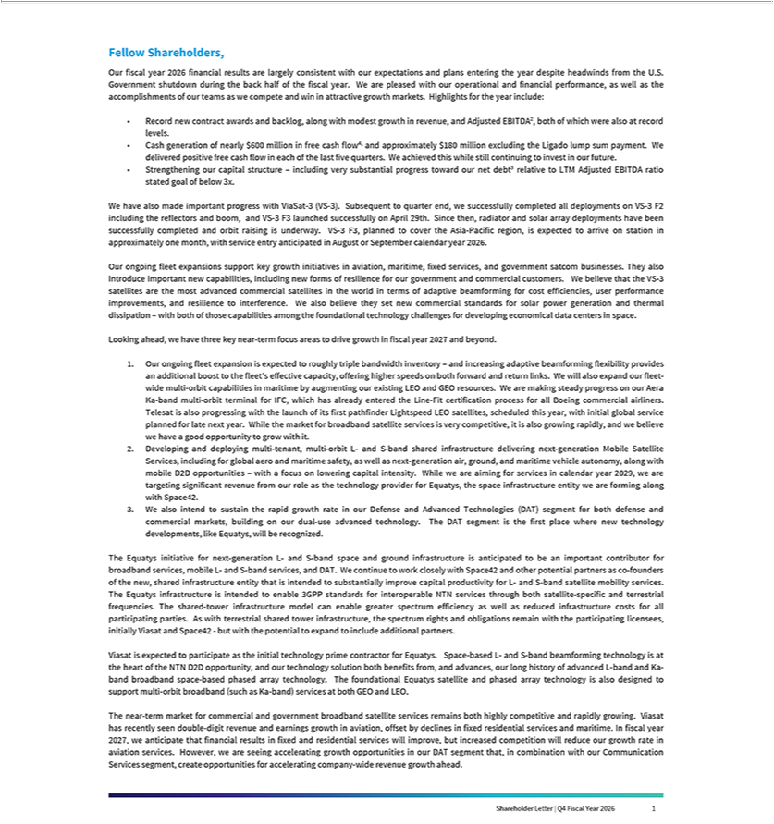

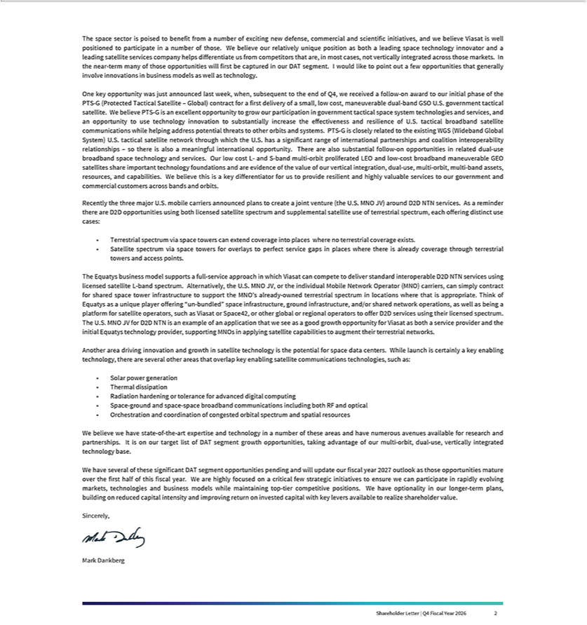

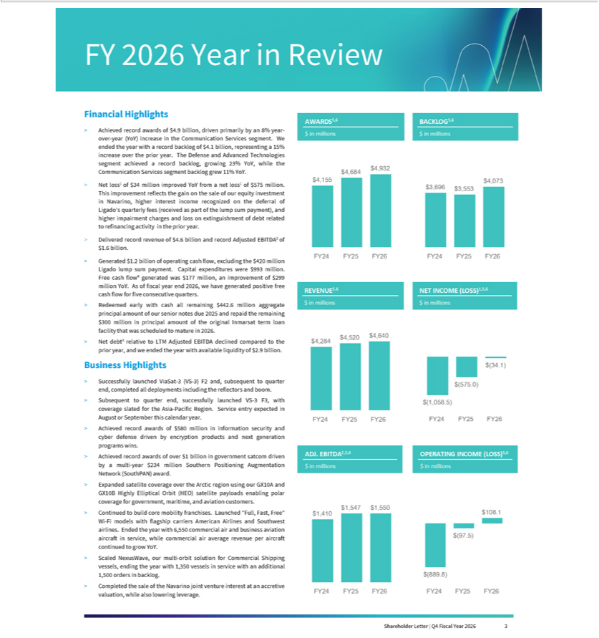

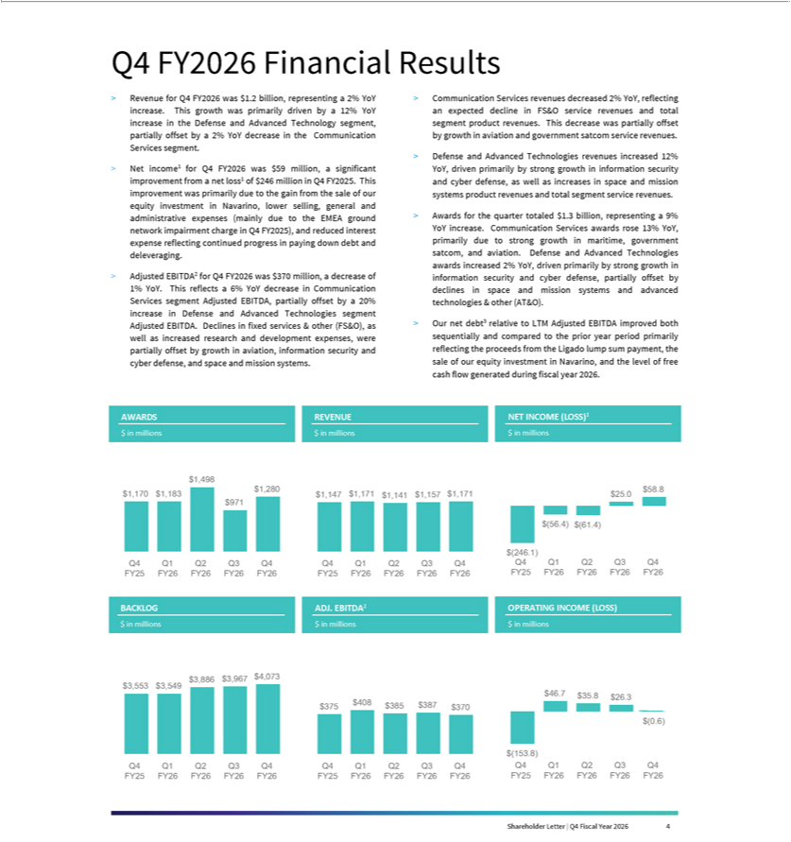

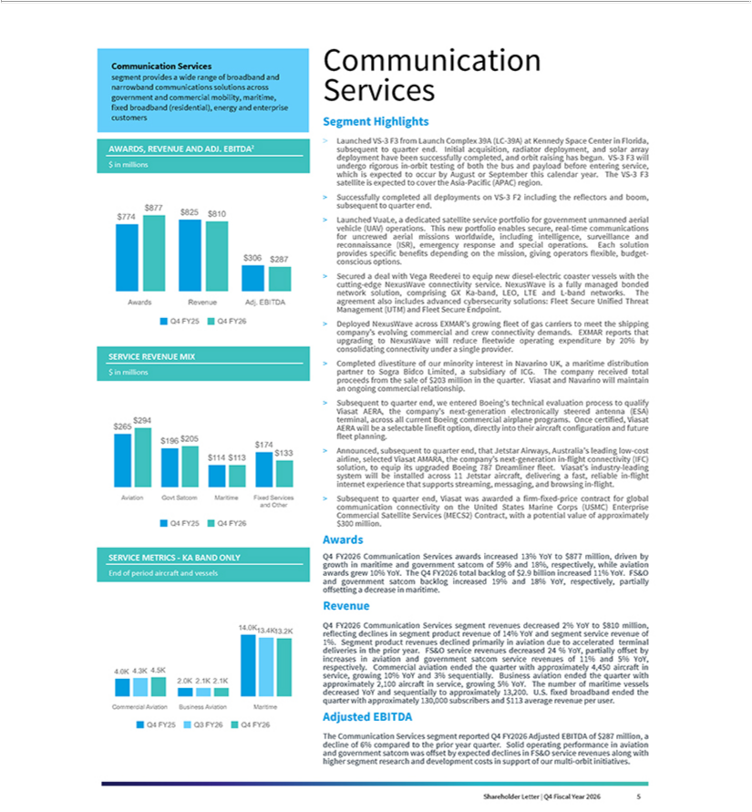

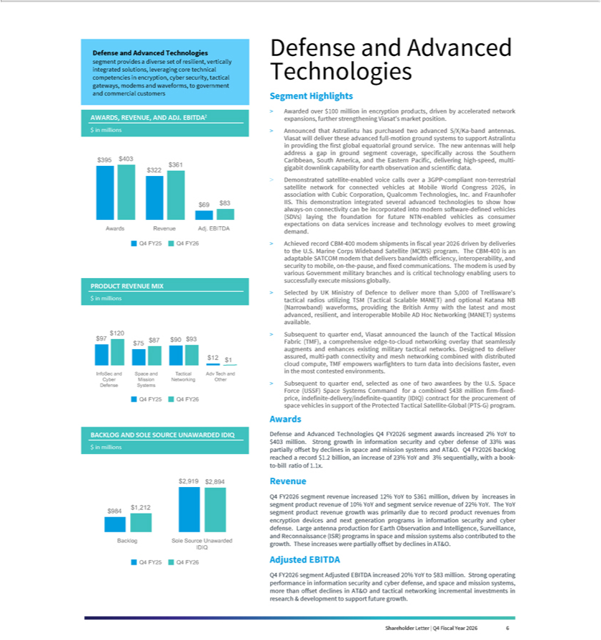

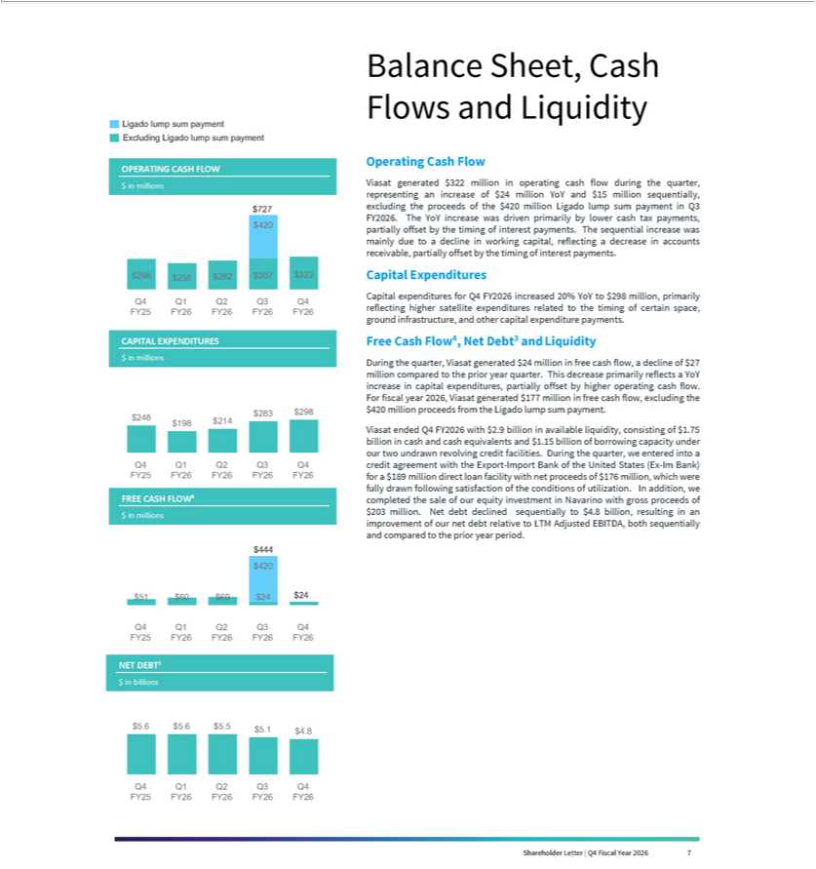



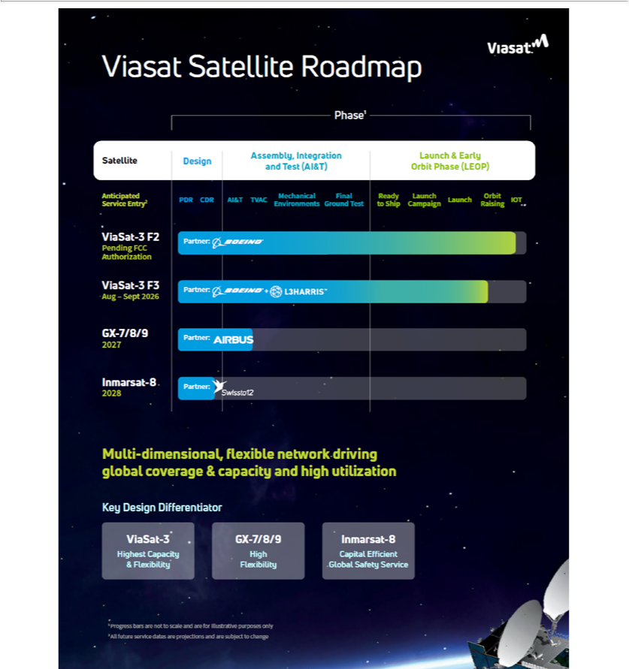

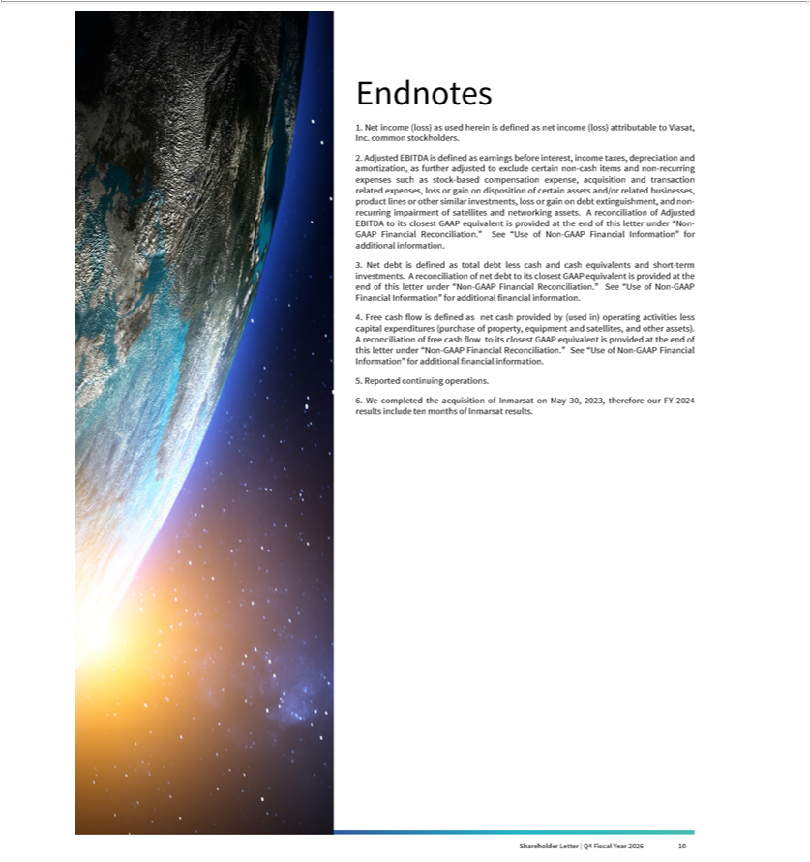

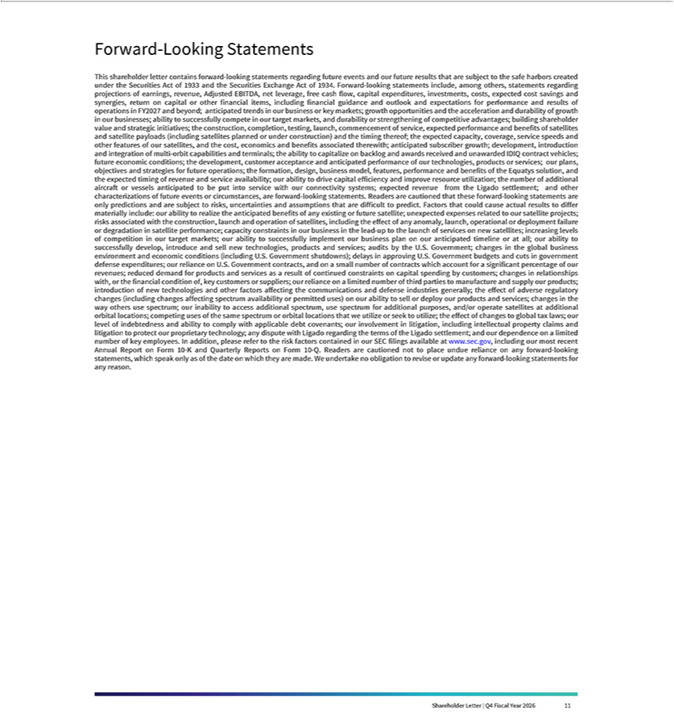

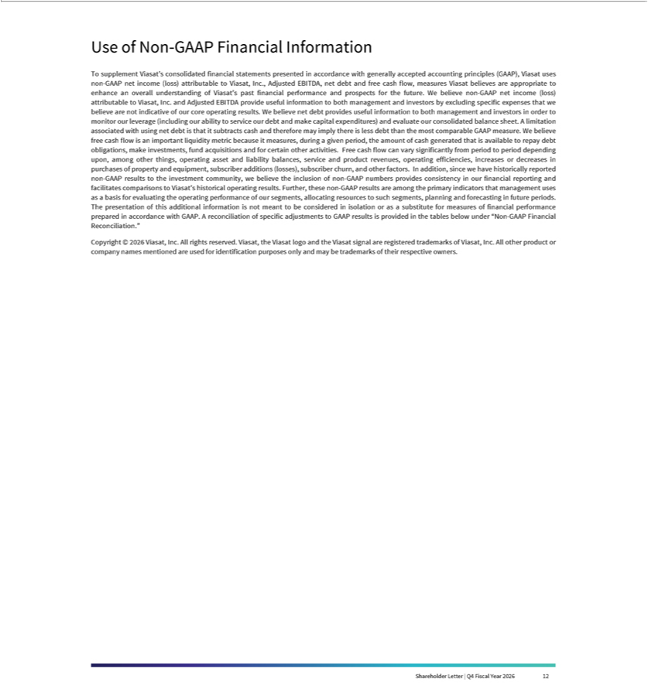

Fourth Quarter Fiscal Year 2026 Results

Financial Results

(In millions, except per share data) | Q4FY26 | Q4FY25 | Year-over-Year | FY26 | FY25 | Year-Over-Year
(In millions, except per share data) | Q4FY26 | Q4FY25 | Change | FY26 | FY25 | Change
Revenues | $1,171.3 | $1,147.1 | 2% | $4,640.3 | $4,519.6 | 3%
Net income (loss) ⁽¹⁾ | $58.8 | ($246.1) | * | ($34.1) | ($575.0) | (94)%
Non-GAAP net income (loss) ⁽¹⁾ | ($3.2) | ($3.0) | 5% | $143.3 | $21.1 | 577%
Adjusted EBITDA | $369.9 | $374.8 | (1)% | $1,550.1 | $1,547.0 | 0%
Diluted per share net income (loss) ⁽¹⁾ | $0.41 | ($1.89) | * | ($0.25) | ($4.48) | (94)%
Non-GAAP diluted per share net
income (loss) ^{(1), (2)} | ($0.02) | ($0.02) | 0% | $1.03 | $0.16 | 544%
Fully diluted weighted average shares | 143.0 | 130.0 | 10% | 134.7 | 128.5 | 5%
(2)
New contract awards ⁽³⁾ | $1,279.8 | $1,169.7 | 9% | $4,931.5 | $4,684.4 | 5%
Backlog ⁽⁴⁾ | $4,072.9 | $3,552.8 | 15% | $4,072.9 | $3,552.8 | 15%
Segment Results
(In millions) | Q4FY26 | Q4FY25 | Year-over-Year | FY26 | FY25 | Year-Over-Year
(In millions) | Q4FY26 | Q4FY25 | Change | FY26 | FY25 | Change
Communication Services
New contract awards ⁽³⁾ | $876.7 | $774.4 | 13% | $3,333.4 | $3,100.8 | 8%
Revenues | $810.3 | $825.0 | (2)% | $3,299.7 | $3,298.5 | 0%
Operating profit (loss) ⁽⁵⁾ | $2.3 | ($136.1) | * | $152.6 | ($50.2) | *
Adjusted EBITDA | $287.3 | $306.2 | (6)% | $1,264.1 | $1,261.7 | 0%
Defense and Advanced
Technologies
New contract awards ⁽³⁾ | $403.1 | $395.3 | 2% | $1,598.1 | $1,583.7 | 1%
Revenues | $361.0 | $322.1 | 12% | $1,340.6 | $1,221.1 | 10%
Operating profit (loss) ⁽⁵⁾ | $62.2 | $48.1 | 29% | $216.3 | $216.7 | 0%
Adjusted EBITDA | $82.5 | $68.6 | 20% | $286.0 | $285.3 | 0%

- Attributable to Viasat, Inc. common stockholders.
- As the twelve months ended March 31, 2026 and three and twelve months ended March 31, 2025 financial information resulted in a net loss, the weighted average number of shares used to calculate basic and diluted net loss per share is the same, as diluted shares would be anti-dilutive. However, as the non-GAAP financial information for the twelve months ended March 31, 2026 and March 31, 2025 resulted in non-GAAP net income, 139.4 million and 130.4 million, respectively, diluted weighted average number of shares were used instead to calculate non-GAAP diluted net income per share.
- Awards exclude future revenue under recurring consumer commitment arrangements.
- Amounts include certain backlog adjustments due to contract changes and amendments. Our backlog includes contracts with subscribers for fixed broadband services in our Communication Services segment. Backlog does not include anticipated purchase orders and requests for the installation of in-flight connectivity systems or future recurring in-flight internet service revenues under our commercial in-flight internet agreements in our Communication Services segment.

- Before corporate.

- Percentage not meaningful.

Note:Some totals may not foot due to rounding.

Shareholder Letter | Q4 Fiscal Year 2026 13

Fourth Quarter Fiscal Year 2026 Results (cont.)

Condensed Consolidated Statements of Operations
 | (Unaudited)
(In thousands, except per share data)
 |  |  | Three months ended
Revenues: |  | March 31, 2026 |  |  | March 31, 2025
Service revenues | $ |  | 803,725 |  | $ | 797,371
Product revenues |  |  | 367,563 |  |  | 349,711
Total revenues
Total revenues |  |  | 1,171,288 |  | 1,147,082
Operating expenses:
Cost of service revenues |  |  | 546,571 |  |  | 515,743
Cost of product revenues |  |  | 264,603 |  |  | 266,040
Selling, general and administrative ⁽¹⁾ |  |  | 254,151 |  |  | 419,497
Independent research and development |  |  | 41,523 |  |  | 33,740
Amortization of acquired intangible assets |  |  | 65,064 |  |  | 65,847
Income (loss) from operations
Income (loss) from operations |  |  | (624) |  |  | (153,785)
Interest (expense) income, net |  |  | (65,484) |  |  | (86,828)
(Loss) gain on extinguishment of debt, net |  |  | — |  |  | —
Other income (expense), net (Q4FY26 includes gain on disposition of equity
method investment) |  |  | 168,062 |  |  | —
Income (loss) before income taxes
Income (loss) before income taxes |  |  | 101,954 |  |  | (240,613)
(Provision for) benefit from income taxes |  |  | (40,081) |  |  | (3,758)
Equity in income (loss) of unconsolidated affiliates, net |  |  | 4,108 |  |  | 3,636
Net income (loss)
Net income (loss) |  |  | 65,981 |  |  | (240,735)
Less: net income (loss) attributable to noncontrolling interest, net of tax |  |  | 7,157 |  |  | 5,318
Net income (loss) attributable to Viasat, Inc.
Net income (loss) attributable to Viasat, Inc. |  | $ | 58,824 |  | $ | (246,053)
Diluted net income (loss) per share attributable to Viasat, Inc. common
stockholders |  | $ | 0.41 |  | $ | (1.89)
Diluted common equivalent shares ⁽²⁾
Diluted common equivalent shares ⁽²⁾ |  |  | 142,957 |  |  | 130,028
AN ITEMIZED RECONCILIATION BETWEEN NET INCOME (LOSS) ATTRIBUTABLE TO VIASAT, INC.
ON A GAAP BASIS AND NON-GAAP BASIS IS AS FOLLOWS:
(In thousands, except per share data) |  |  | Three months ended
 |  | March 31, 2026 |  |  | March 31, 2025

Twelve months ended

March 31, 2026 March 31, 2025

$ | 3,274,423 |  | $ | 3,225,776
 | 1,365,857 |  |  | 1,293,795
 | 4,640,280 |  |  | 4,519,571
 | 2,126,496 |  |  | 2,091,721
 | 980,563 |  |  | 937,912
 | 999,476 |  |  | 1,181,091
 | 164,908 |  |  | 142,394
 | 260,712 |  |  | 263,933
 | 108,125 |  |  | (97,480)
 | (154,401) |  |  | (338,024)
 | (11,935) |  |  | (99,814)
 | 163,012 |  |  | (9,976)
 | 104,801 |  |  | (545,294)
 | (116,223) |  |  | 941
 | 15,348 |  |  | 13,228
 | 3,926 |  |  | (531,125)
 | 38,012 |  |  | 43,837
$ | (34,086) |  | $ | (574,962)
$ | (0.25) |  | $ | (4.48)
 | 134,744 |  |  | 128,476
 | Twelve months ended
March 31, 2026 |  |  | March 31, 2025

GAAP net income (loss) attributable to Viasat, Inc. |  | $ | 58,824 |  | $ | (246,053)
Amortization of acquired intangible assets |  |  | 65,064 |  |  | 65,847
Stock-based compensation expense |  |  | 22,142 |  |  | 16,917
Acquisition and transaction related expenses ⁽³⁾ |  |  | 4,062 |  |  | 6,761
Ground network impairment and related charges, net |  |  | — |  |  | 169,400
Loss (gain) on extinguishment of debt, net |  |  | — |  |  | —
Other income (expense), net (Q4FY26 includes gain on disposition of equity
method investment) |  |  | (168,062) |  |  | —
Income tax effect ⁽⁴⁾ |  |  | 14,769 |  |  | (15,909)
Non-GAAP net income (loss) attributable to Viasat, Inc.
Non-GAAP net income (loss) attributable to Viasat, Inc. |  | $ | (3,201) |  | $ | (3,037)
Non-GAAP diluted net income (loss) per share attributable to Viasat, Inc.
common stockholders |  | $ | (0.02) |  | $ | (0.02)
Diluted common equivalent shares ⁽²⁾
Diluted common equivalent shares ⁽²⁾ |  |  | 136,503 |  |  | 130,028
AN ITEMIZED RECONCILIATION BETWEEN NET INCOME (LOSS) ATTRIBUTABLE TO VIASAT, INC.
AND ADJUSTED EBITDA IS AS FOLLOWS:

$ (34,086)

260,712

81,070

24,392

—

11,935

(163,012)

(37,760)
$ 143,251

$ 1.03

139,390

$ (574,962)

263,933

80,385

64,467

169,400

99,814

9,976

(91,866)
$ 21,147

$ 0.16

130,408

(In thousands) |  |  | Three months ended
GAAP net income (loss) attributable to Viasat, Inc. |  | March 31, 2026 |  |  | March 31, 2025
GAAP net income (loss) attributable to Viasat, Inc. |  | $ | 58,824 |  | $ | (246,053)
Provision for (benefit from) income taxes |  |  | 40,081 |  |  | 3,758
Interest expense (income), net |  |  | 65,484 |  |  | 86,828
Depreciation and amortization ⁽⁵⁾ |  |  | 347,327 |  |  | 337,182
Stock-based compensation expense |  |  | 22,142 |  |  | 16,917
Acquisition and transaction related expenses ⁽³⁾ |  |  | 4,062 |  |  | 6,761
Ground network impairment and related charges, net |  |  | — |  |  | 169,400
Loss (gain) on extinguishment of debt, net |  |  | — |  |  | —
Other income (expense), net (Q4FY26 includes gain on disposition of equity
method investment) |  |  | (168,062) |  |  | —
Adjusted EBITDA
Adjusted EBITDA | $ |  | 369,858 |  | $ | 374,793

Twelve months ended
 | March 31, 2026 |  |  | March 31, 2025
 | $ | (34,086) |  | $ | (574,962)
 |  | 116,223 |  |  | (941)
 |  | 154,401 |  |  | 338,024
 |  | 1,359,159 |  |  | 1,360,807
 |  | 81,070 |  |  | 80,385
 |  | 24,392 |  |  | 64,467
 |  | — |  |  | 169,400
 |  | 11,935 |  |  | 99,814
 |  | (163,012) |  |  | 9,976
$ |  | 1,550,082 |  | $ | 1,546,970

- Amounts include ground network impairment and related charges, net, of approximately $169 million for the three and twelve months ended March 31, 2025.
- As the twelve months ended March 31, 2026 and three and twelve months ended March 31, 2025 financial information resulted in a net loss, the weighted average number of shares used to calculate basic and diluted net loss per share is the same, as diluted shares would be anti-dilutive. However, as the non-GAAP financial information for the twelve months ended March 31, 2026 and March 31, 2025 resulted in non-GAAP net income, diluted weighted average number of shares were used instead to calculate non-GAAP diluted net income per share.
- Costs typically consist of acquisition, integration, and disposition related costs.
- The income tax effect is calculated using the tax rate applicable for the non-GAAP adjustments.
- Including amortization of capitalized cloud computing implementation costs.

Shareholder Letter | Q4 Fiscal Year 2026 14

Fourth Quarter Fiscal Year 2026 Results (cont.)

AN ITEMIZED RECONCILIATION BETWEEN SEGMENT OPERATING PROFIT (LOSS) BEFORE CORPORATE

AND ADJUSTED EBITDA IS AS FOLLOWS:

(In thousands)

 |  |  | Three months ended March 31, 2026 |  |  |  |  |  |  |  |  | Three months ended March 31, 2025
 |  |  |  |  |  | Defense and |  |  |  |  |  |  |  |  | Defense and
 |  | Communication |  |  |  | Advanced |  |  |  |  | Communication |  |  |  | Advanced
 |  |  | Services |  | Technologies |  |  |  |  |  |  | Services |  | Technologies
Segment operating profit (loss) before corporate |  |  | Segment |  |  | Segment |  |  | Total |  |  | Segment |  |  | Segment |  |  | Total
Segment operating profit (loss) before corporate |  | $ | 2,264 |  | $ | 62,176 |  | $ | 64,440 |  | $ | (136,051) |  | $ | 48,113 |  | $ | (87,938)
Depreciation ⁽⁶⁾ |  |  | 254,506 |  |  | 12,481 |  |  | 266,987 |  |  | 244,311 |  |  | 12,481 |  |  | 256,792
Stock-based compensation expense |  |  | 13,495 |  |  | 8,647 |  |  | 22,142 |  |  | 10,298 |  |  | 6,619 |  |  | 16,917
Other than acquired intangible assets amortization ⁽⁵⁾ |  |  | 9,398 |  |  | 5,878 |  |  | 15,276 |  |  | 9,375 |  |  | 5,168 |  |  | 14,543
Acquisition and transaction related expenses ⁽³⁾ |  |  | 3,497 |  |  | 565 |  |  | 4,062 |  |  | 5,275 |  |  | 1,486 |  |  | 6,761
Ground network impairment and related charges, net |  |  | — |  |  | — |  |  | — |  |  | 169,400 |  |  | — |  |  | 169,400
Equity in income (loss) of unconsolidated affiliates,
net |  |  | 4,108 |  |  | — |  |  | 4,108 |  |  | 3,636 |  |  | — |  |  | 3,636
Noncontrolling interest |  |  | 46 |  |  | (7,203) |  |  | (7,157) |  |  | (30) |  |  | (5,288) |  |  | (5,318)
Adjusted EBITDA | $ |  | 287,314 | $ |  | 82,544 | $ |  | 369,858 | $ |  | 306,214 | $ |  | 68,579 | $ |  | 374,793
 |  |  | Twelve months ended March 31, 2026 |  |  |  |  |  |  |  |  | Twelve months ended March 31, 2025
 |  |  |  |  |  | Defense and |  |  |  |  |  |  |  |  | Defense and
 |  | Communication |  |  |  | Advanced |  |  |  |  | Communication |  |  |  | Advanced
 |  |  | Services |  | Technologies |  |  |  |  |  |  | Services |  | Technologies
Segment operating profit (loss) before corporate |  |  | Segment |  |  | Segment |  |  | Total |  |  | Segment |  |  | Segment |  |  | Total
Segment operating profit (loss) before corporate |  | $ | 152,553 |  | $ | 216,284 |  | $ | 368,837 |  | $ | (50,222) |  | $ | 216,675 |  | $ | 166,453
Depreciation ⁽⁶⁾ |  |  | 990,147 |  |  | 48,368 |  |  | 1,038,515 |  |  | 988,447 |  |  | 48,020 |  |  | 1,036,467
Stock-based compensation expense |  |  | 48,685 |  |  | 32,385 |  |  | 81,070 |  |  | 48,760 |  |  | 31,625 |  |  | 80,385
Other than acquired intangible assets amortization ⁽⁵⁾ |  |  | 37,321 |  |  | 22,611 |  |  | 59,932 |  |  | 41,373 |  |  | 19,034 |  |  | 60,407
Acquisition and transaction related expenses ⁽³⁾ |  |  | 19,691 |  |  | 4,701 |  |  | 24,392 |  |  | 50,807 |  |  | 13,660 |  |  | 64,467
Ground network impairment and related charges, net |  |  | — |  |  | — |  |  | — |  |  | 169,400 |  |  | — |  |  | 169,400
Equity in income (loss) of unconsolidated affiliates,
net |  |  | 15,348 |  |  | — |  |  | 15,348 |  |  | 13,228 |  |  | — |  |  | 13,228
Noncontrolling interest |  |  | 372 |  |  | (38,384) |  |  | (38,012) |  |  | (120) |  |  | (43,717) |  |  | (43,837)
Adjusted EBITDA | $ |  | 1,264,117 | $ |  | 285,965 | $ |  | 1,550,082 | $ |  | 1,261,673 | $ |  | 285,297 | $ |  | 1,546,970

- Depreciation expenses not specifically recorded in a particular segment have been allocated based on other indirect allocable costs, which management believes is a reasonable method.

Shareholder Letter | Q4 Fiscal Year 2026 15

Fourth Quarter Fiscal Year 2026 Results (cont.)

Condensed Consolidated Balance Sheets

(Unaudited)

(In thousands)

 |  |  | As of |  |  | As of
Assets |  | March 31, 2026 March 31, 2025
Current assets:
Cash and cash equivalents | $ |  | 1,746,835 $ |  |  | 1,612,105
Accounts receivable, net |  |  | 753,430 |  |  | 699,552
Inventories |  |  | 281,220 |  |  | 293,943
Prepaid expenses and other current assets |  |  | 342,522 |  |  | 282,343
Total current assets |  |  | 3,124,007 |  |  | 2,887,943
Property, equipment and satellites, net |  |  | 7,272,637 |  |  | 7,405,664
Operating lease right-of-use assets |  |  | 427,994 |  |  | 416,490
Acquired intangible assets, net |  |  | 1,997,436 |  |  | 2,270,777
Goodwill |  |  | 1,625,013 |  |  | 1,622,132
Other assets |  |  | 779,509 |  |  | 845,778
Total assets | $ |  | 15,226,596 $ |  |  | 15,448,784

 |  |  | As of |  |  | As of
Liabilities and Equity |  | March 31, 2026 |  | March 31, 2025
Current liabilities:
Accounts payable | $ |  | 288,154 $ |  |  | 264,300
Accrued and other liabilities |  |  | 951,192 |  |  | 908,529
Current portion of long-term debt |  |  | 57,753 |  |  | 503,825
Total current liabilities |  |  | 1,297,099 |  |  | 1,676,654
Senior notes |  |  | 3,664,848 |  |  | 3,652,882
Other long-term debt |  |  | 2,726,004 |  |  | 2,879,402
Non-current operating lease liabilities |  |  | 430,082 |  |  | 414,133
Other liabilities |  |  | 2,379,301 |  |  | 2,181,153
Total liabilities |  |  | 10,497,334 |  |  | 10,804,224
Total Viasat Inc. stockholders’ equity |  |  | 4,660,301 |  |  | 4,553,831
Noncontrolling interest in subsidiary |  |  | 68,961 |  |  | 90,729
Total equity |  |  | 4,729,262 |  |  | 4,644,560
Total liabilities and equity | $ |  | 15,226,596 | $ |  | 15,448,784

Shareholder Letter | Q4 Fiscal Year 2026 16

Non-GAAP Financial Reconciliation

AN ITEMIZED RECONCILIATION BETWEEN NET INCOME (LOSS) ATTRIBUTABLE TO VIASAT, INC.

AND ADJUSTED EBITDA IS AS FOLLOWS:

(In thousands)

 |  |  |  |  |  | Three months ended
GAAP net income (loss) attributable | March 31, 2026 |  |  | December 31, 2025 |  |  | September 30, 2025 |  |  | June 30, 2025 |  |  | March 31, 2025
to Viasat, Inc. | $ | 58,824 | $ |  | 24,968 |  | $ | (61,444) | $ |  | (56,434) | $ |  | (246,053)
Provision for (benefit from) income
taxes |  | 40,081 |  |  | 58,670 |  |  | 10,862 |  |  | 6,610 |  |  | 3,758
Interest expense (income), net |  | 65,484 |  |  | (78,112) |  |  | 80,962 |  |  | 86,067 |  |  | 86,828
Depreciation and amortization ⁽⁵⁾ |  | 347,327 |  |  | 340,360 |  |  | 329,128 |  |  | 342,344 |  |  | 337,182
Stock-based compensation expense |  | 22,142 |  |  | 24,099 |  |  | 20,122 |  |  | 14,707 |  |  | 16,917
Acquisition and transaction related
expenses ⁽³⁾ |  | 4,062 |  |  | 5,525 |  |  | 5,080 |  |  | 9,725 |  |  | 6,761
Ground network impairment and
related charges, net |  | — |  |  | — |  |  | — |  |  | — |  |  | 169,400
Loss (gain) on extinguishment of
debt, net |  | — |  |  | 11,647 |  |  | — |  |  | 288 |  |  | —
Other income (expense), net
(Q4FY26 includes gain on
disposition of equity method
investment) |  | (168,062) |  |  | (114) |  |  | — |  |  | 5,164 |  |  | —
Adjusted EBITDA | $ | 369,858 | $ |  | 387,043 |  | $ | 384,710 | $ |  | 408,471 | $ |  | 374,793

NET DEBT |  |  |  |  |  |  |  |  |  |  |  |  |  |  |  | As of
(In thousands) | March 31, 2026 |  |  |  |  |  |  | December 31, 2025 |  |  |  |  |  | September 30, 2025 |  |  |  |  |  |  |  |  | June 30, 2025 |  |  |  |  |  |  |  | March 31, 2025
Total debt | $ |  | 6,585,115 |  |  |  |  | $ |  | 6,406,911 |  |  |  | $ |  |  |  | 6,731,043 |  |  |  |  | $ | 6,741,529 |  |  |  |  |  |  | $ |  | 7,204,275
Less: cash and cash equivalents |  |  | 1,746,835 |  |  |  |  |  |  | 1,346,136 |  |  |  |  |  |  |  | 1,230,074 |  |  |  |  |  | 1,177,492 |  |  |  |  |  |  |  |  | 1,612,105
Net debt | $ |  | 4,838,280 |  |  |  | $ |  |  | 5,060,775 |  |  |  | $ |  |  |  | 5,500,969 |  |  |  | $ |  | 5,564,037 |  |  |  |  |  | $ |  |  | 5,592,170
FREE CASH FLOW
(In thousands)
The following table reconciles free cash flow to Net cash provided by (used in) operating activities.
 |  |  |  |  |  |  |  |  | Three months ended |  |  |  |  |  |  |  |  |  |  |  |  |  |  |  |  |  | Fiscal years ended
 |  | March 31, |  |  |  | December 31, |  |  |  |  | September 30, |  |  |  |  |  | June 30, |  |  |  | March 31, |  |  |  |  | March 31, |  |  |  |  |  | March 31,
Net cash provided by (used in) |  |  | 2026 |  |  |  | 2025 |  |  |  | 2025 |  |  |  |  |  |  | 2025 |  |  |  | 2025 |  |  |  |  | 2026 |  |  |  |  |  | 2025
operating activities |  | $ | 322,295 |  |  | $ | 726,888 |  |  |  | $ | 282,242 |  |  |  |  | $ | 258,460 |  | $ |  | 298,443 |  |  | $ |  | 1,589,885 |  |  |  | $ |  | 908,187
Purchase of property, equipment and
satellites, and other assets (capital
expenditures) |  |  | (298,341) |  |  |  | (282,721) |  |  |  |  | (213,699) |  |  |  |  |  | (198,013) |  |  |  | (247,723) |  |  |  |  | (992,774) |  |  |  |  |  | (1,030,182)
Free cash flow
Free cash flow |  | $ | 23,954 |  |  | $ | 444,167 |  |  |  | $ | 68,543 |  |  |  |  | $ | 60,447 |  | $ |  | 50,720 |  |  | $ |  | 597,111 |  |  |  | $ |  | (121,995)

Shareholder Letter | Q4 Fiscal Year 2026 17

Selected Segment Financial Information

(Unaudited)

(In thousands)

 |  | Three months ended |  |  |  |  |  |  | Twelve months ended
Revenues: | March 31, 2026 |  |  | March 31, 2025 |  |  |  | March 31, 2026 |  |  | March 31, 2025
Communication services
Aviation services | $ | 294,109 |  | $ | 265,203 |  | $ |  | 1,191,426 |  | $ | 1,048,225
Government satcom services |  | 205,106 |  |  | 195,756 |  |  |  | 795,043 |  |  | 754,552
Maritime services |  | 112,717 |  |  | 113,947 |  |  |  | 463,061 |  |  | 477,968
Fixed services and other services |  | 132,700 |  |  | 173,950 |  |  |  | 607,693 |  |  | 741,601
Total services |  | 744,632 |  |  | 748,856 |  |  |  | 3,057,223 |  |  | 3,022,346
Total products |  | 65,651 |  |  | 76,110 |  |  |  | 242,428 |  |  | 276,139
Total communication services revenues |  | 810,283 |  |  | 824,966 |  |  |  | 3,299,651 |  |  | 3,298,485
Defense and advanced technologies
Total services |  | 59,093 |  |  | 48,515 |  |  |  | 217,200 |  |  | 203,430
Information security and cyber defense products |  | 120,452 |  |  | 96,887 |  |  |  | 414,482 |  |  | 325,439
Space and mission systems products |  | 87,173 |  |  | 75,030 |  |  |  | 330,867 |  |  | 304,870
Tactical networking products |  | 93,045 |  |  | 89,605 |  |  |  | 329,417 |  |  | 319,577
Advanced technologies and other products |  | 1,242 |  |  | 12,079 |  |  |  | 48,663 |  |  | 67,770
Total products |  | 301,912 |  |  | 273,601 |  |  |  | 1,123,429 |  |  | 1,017,656
Total defense and advanced technologies
revenues |  | 361,005 |  |  | 322,116 |  |  |  | 1,340,629 |  |  | 1,221,086
Elimination of intersegment revenues |  | — |  |  | — |  |  |  | — |  |  | —
Total revenues
Total revenues | $ | 1,171,288 |  | $ | 1,147,082 |  | $ |  | 4,640,280 |  | $ | 4,519,571

Shareholder Letter | Q4 Fiscal Year 2026 18

