UNITED STATES

SECURITIES AND EXCHANGE COMMISSION
WASHINGTON, D.C. 20549

FORM 8-K

CURRENT REPORT

Pursuant to Section 13 or 15(d) of
the Securities Exchange Act of 1934

Date of Report (Date of Earliest Event Reported): November 8, 2021


VIASAT, INC.

(Exact Name of Registrant as Specified in its Charter)

 | Delaware |  | 000-21767 |  |  |  |  | 33-0174996
(State or Other Jurisdiction of |  |  |  | (Commission File No.) |  |  |  | (I.R.S. Employer
Incorporation) |  |  |  |  |  |  |  | Identification No.)
 |  |  |  | 6155 El Camino Real
 |  |  |  | Carlsbad, California 92009
 |  |  | (Address of Principal Executive Offices, Including Zip Code)
 |  |  | (760) 476-2200
 |  |  | (Registrant’s Telephone Number, Including Area Code)

Check the appropriate box below if the Form 8-K filing is intended to simultaneously satisfy the filing obligation of the registrant under any of the following provisions:

- Written communications pursuant to Rule 425 under the Securities Act (17 CFR 230.425)

- Soliciting material pursuant to Rule 14a-12 under the Exchange Act (17 CFR 240.14a-12)

- Pre-commencement communications pursuant to Rule 14d-2(b) under the Exchange Act (17 CFR 240.14d-2(b))

- Pre-commencement communications pursuant to Rule 13e-4(c) under the Exchange Act (17 CFR 240.13e-4(c))

 |  |  |  | (Name of Each Exchange
(Title of Each Class) |  | (Trading Symbol) |  | on which Registered)
Common Stock, par value $0.0001 per |  | VSAT |  | The Nasdaq Stock Market LLC
share

Indicate by check mark whether the registrant is an emerging growth company as defined in Rule 405 of the Securities Act of 1933 (§230.405 of this chapter) or Rule 12b-2 of the Securities Exchange Act of 1934 (§240.12b-2 of this chapter).

Emerging growth company | ☐
If an emerging growth company, indicate by check mark if the registrant has elected not to use the extended transition period for | ☐
complying with any new or revised financial accounting standards provided pursuant to Section 13(a) of the Exchange Act. | ☐

Item 2.02 Results of Operations and Financial Condition.

On November 8, 2021, Viasat, Inc. released its financial results for the second quarter of fiscal year 2022 in a letter to shareholders that is available on the investor relations section of its website. A copy of the press release announcing the release of financial results is furnished herewith as Exhibit 99.1 and a copy of the letter to shareholders is furnished herewith as Exhibit 99.2.

The information contained herein and in the accompanying exhibits shall not be incorporated by reference into any filing of the registrant, whether made before or after the date hereof, regardless of any general incorporation language in such filing, unless expressly incorporated by specific reference to such filing. The information in this report, including the exhibit hereto, shall not be deemed to be “filed” for purposes of Section 18 of the Securities Exchange Act of 1934, as amended, or otherwise subject to the liabilities of that section or Sections 11 and 12(a)(2) of the Securities Act of 1933, as amended.

Item 9.01 Financial Statements and Exhibits.

(d) | Exhibits
 | Exhibit
 | Number |  | Description of Exhibit
 | 99.1 |  | Press Release dated November 8, 2021 issued by Viasat, Inc.
 | 99.2 |  | Viasat, Inc. second quarter of fiscal year 2022 letter to shareholders dated November 8, 2021
- Cover Page Interactive Data File (embedded within the Inline XBRL document) 1

Additional Information About the Transaction and Where You Can Find It

This communication is being made in respect of the proposed business combination transaction between Viasat and Connect Topco Limited (“Inmarsat”) pursuant to the terms of that certain Share Purchase Agreement, dated as of November 8, 2021, by and among Viasat and the shareholders of Inmarsat. Viasat intends to file with the Securities and Exchange Commission (the “SEC”) a proxy statement and other relevant documents in respect of a stockholder meeting to obtain stockholder approval in connection with the transaction. The definitive proxy statement will be sent or given to the stockholders of Viasat and will contain important information about the transaction and related matters. INVESTORS AND STOCKHOLDERS ARE URGED TO READ THE DEFINITIVE PROXY

STATEMENT AND OTHER RELEVANT MATERIALS CAREFULLY IN THEIR ENTIRETY WHEN THEY BECOME AVAILABLE BECAUSE THEY WILL CONTAIN IMPORTANT INFORMATION ABOUT VIASAT, INMARSAT AND THE PROPOSED TRANSACTION. Investors and stockholders may obtain a free copy of these materials (when available) and other documents filed by Viasat with the SEC through the website maintained by the SEC at www.sec.gov. In addition, free copies of these materials will be made available free of charge through Viasat’s website at https://www.viasat.com.

Participants in the Solicitation

Viasat, and its directors and executive officers may be deemed to be participants in the solicitation of proxies from the stockholders of Viasat in connection with the transaction. Information regarding the persons who may, under the rules of the SEC, be considered to be participants in the solicitation of Viasat’s stockholders in connection with the transaction will be set forth in Viasat’s definitive proxy statement for its stockholder meeting. Additional information regarding these individuals and any direct or indirect interests they may have in the transaction will be set forth in the definitive proxy statement when and if it is filed with the SEC in connection with the transaction.

2

SIGNATURES

Pursuant to the requirements of the Securities Exchange Act of 1934, the registrant has duly caused this report to be signed on its behalf by the undersigned hereunto duly authorized.

Date: November 8, 2021 Viasat, Inc.

By: /s/ Brett Church

Brett Church
Associate General Counsel

3

Exhibit 99.1


Viasat Releases Second Quarter Fiscal Year 2022 Financial Results

CARLSBAD, Calif., November 8, 2021—Viasat Inc. (NASDAQ: VSAT), a global communications company, today announced its second quarter fiscal year 2022 financial results in a letter to shareholders, which is now posted to the Investor Relations section of Viasat’s website.

In addition to releasing its second quarter fiscal year 2022 financial results today, Viasat also announced it entered into a definitive agreement to acquire Inmarsat. This release can be found on Viasat’s Investor Relations website here.

In lieu of holding a conference call focused on second quarter fiscal year 2022 financial results, Viasat and Inmarsat will host a conference call and webcast for investors today, November 8, 2021 at 8:00 a.m. Eastern Time to discuss the transaction.

Conference call and webcast information

Date: | November 8, 2021
Time: | 8:00 a.m. Eastern Time
Live conference call: | To participate on the live conference call, please dial: (877) 640-9809 in the U.S. or (914)
Live webcast: | 495-8528 internationally and reference the conference ID 5854938
Live webcast: | Available on Viasat’s investor relations website at: investors.viasat.com

A replay of the conference call will be made available from 11:00 a.m. Eastern Time on November 8, 2021, until 11:00 a.m. Eastern Time on November 10, 2021. To access the replay, please dial: (855) 859-2056 in the U.S. and (404) 537-3406 internationally and enter the conference ID 5854938. The webcast will be archived and available on the Viasat investor relations website for approximately one month immediately following the conference call.

About Viasat

Viasat is a global communications company that believes everyone and everything in the world can be connected. For 35 years, Viasat has helped shape how consumers, businesses, governments and militaries around the world communicate. Today, the Company is developing the ultimate global communications network to power high-quality, secure, affordable, fast connections to impact people’s lives anywhere they are—on the ground, in the air or at sea. To learn more about Viasat, visit: www.viasat.com, go to Viasat’s Corporate Blog, or follow the Company on social media at: Facebook, Instagram, LinkedIn, Twitter or YouTube.

Copyright © 2021 Viasat, Inc. All rights reserved. Viasat, the Viasat logo and the Viasat signal are registered trademarks of Viasat, Inc. All other product or company names mentioned are used for identification purposes only and may be trademarks of their respective owners.

Viasat, Inc. Contacts

Chris Phillips, Public Relations, +1 (760) 476-2322, Christina.Phillips@viasat.com
Paul Froelich/Peter Lopez, Investor Relations, +1 (760) 476-2633, IR@viasat.com

# # #

Exhibit 99.2


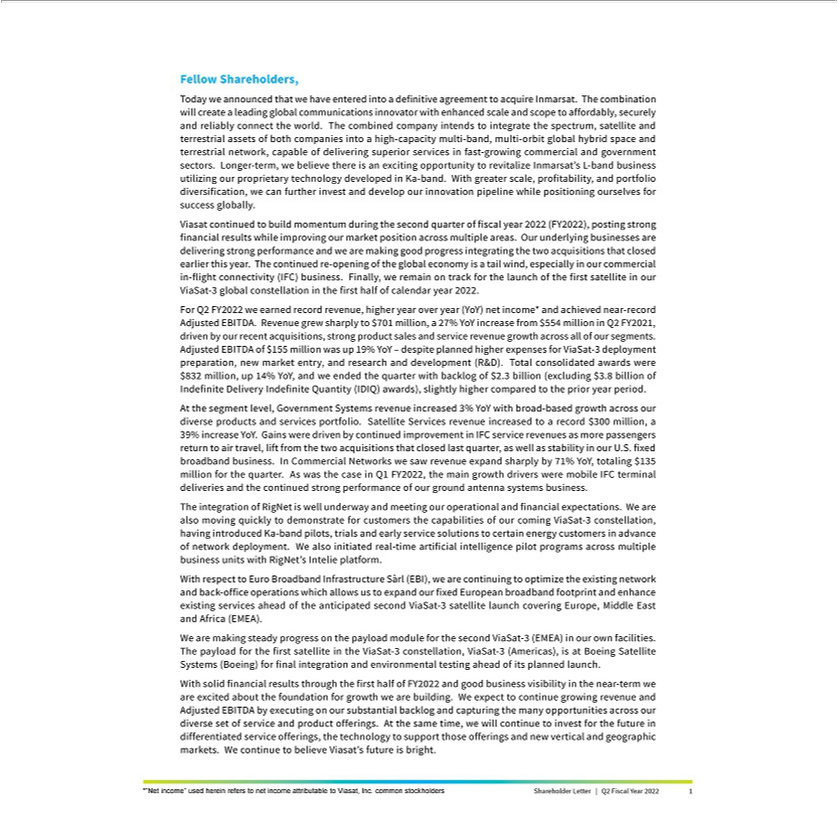

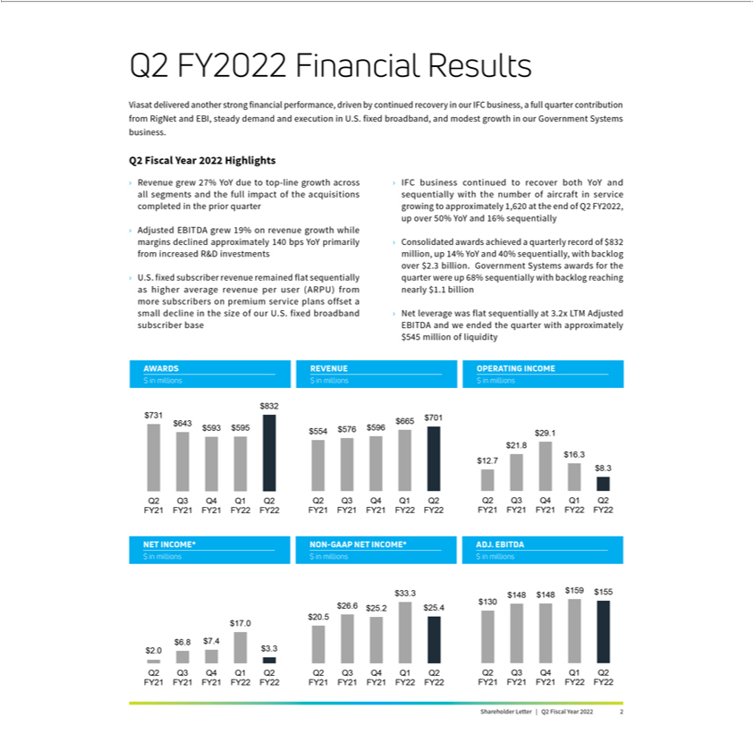

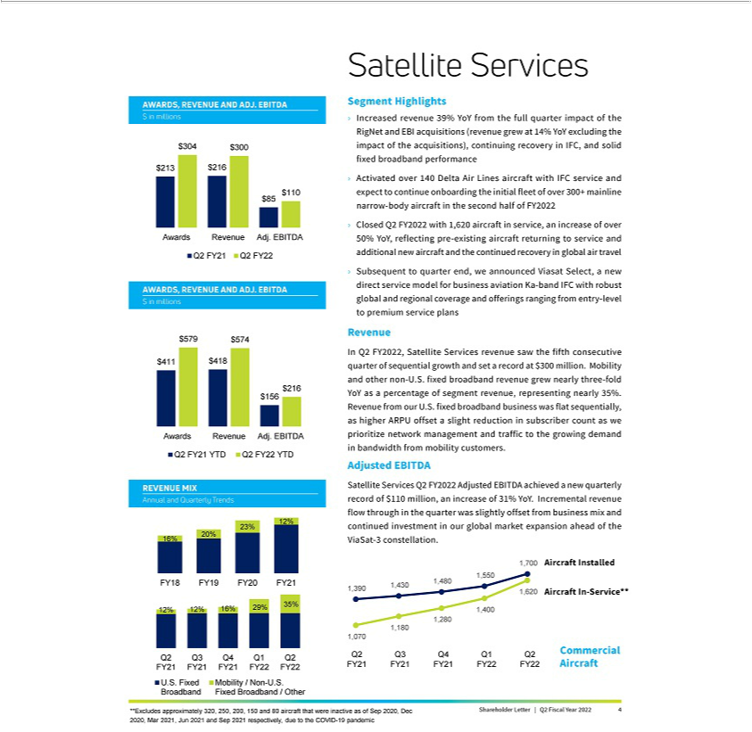

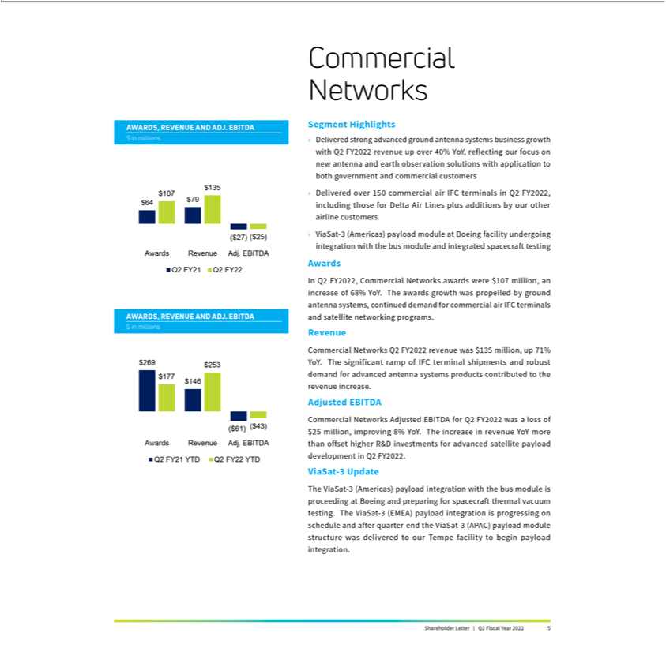

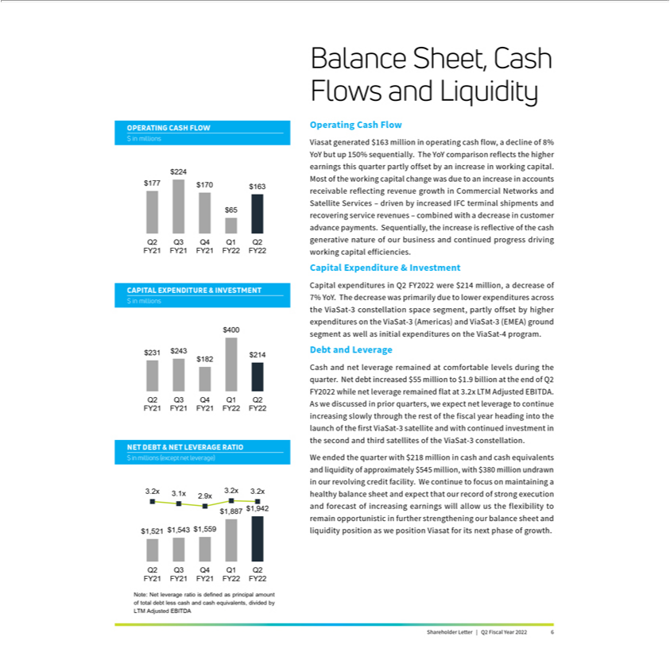



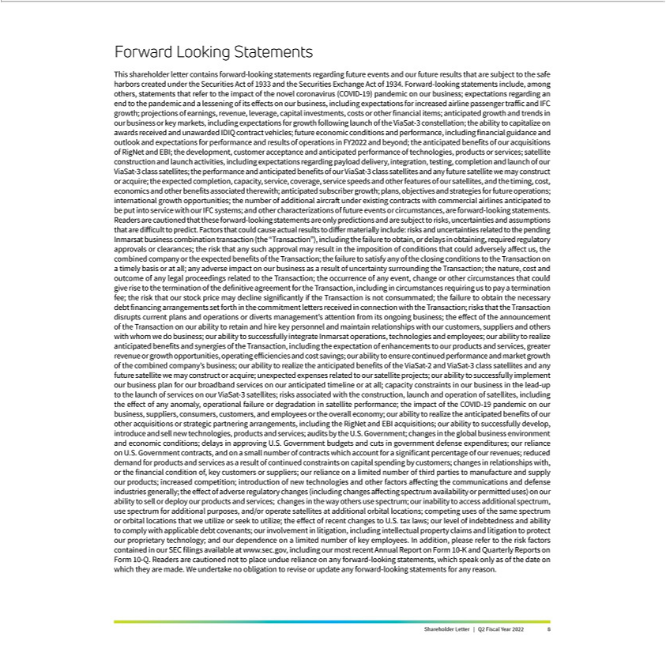

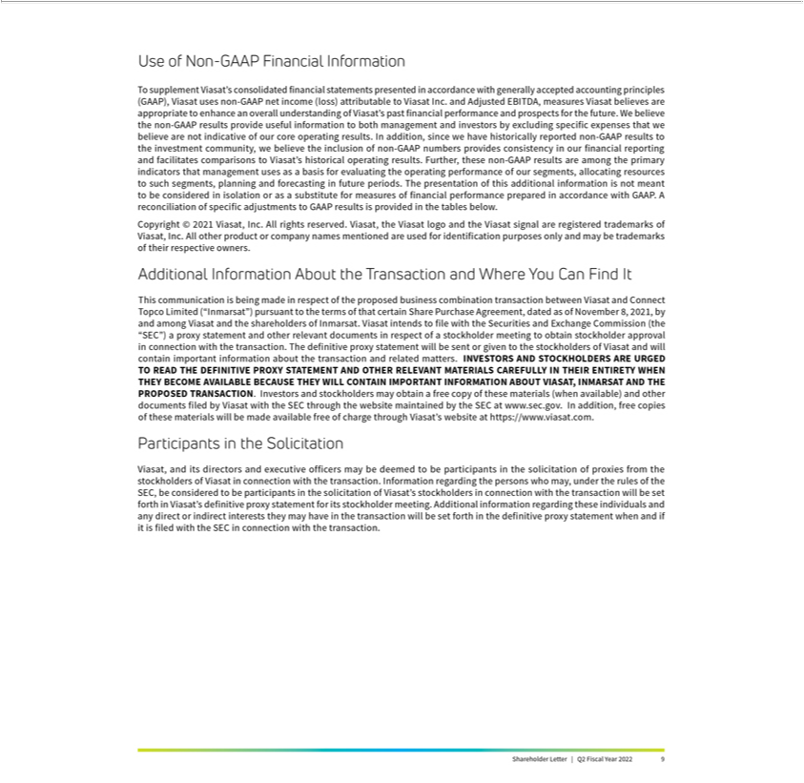

Viasat Second Quarter Fiscal Year 2022 Results

Financial Results

 | (In millions,except per | Q2 FY22 | Q2 FY21 | Year-Over-Year | First 6 Months | First 6 Months | Year-Over-Year
 | share data) |  |  | Change | FY22 | FY21 | Change
 | Revenues | $701.4 | $554.3 | 27% | $1,366.2 | $1,084.8 | 26%
 | Net income (loss)(1) | $3.3 | $2.0 | 68% | $20.3 | ($10.4) | *
 | Non-GAAP net income(1) | $25.4 | $20.5 | 24% | $58.7 | $25.3 | 132%
 | Adjusted EBITDA | $155.1 | $130.3 | 19% | $314.0 | $235.0 | 34%
 | Diluted per share net income
 | (loss)(1) | $0.04 | $0.03 | 33% | $0.27 | ($0.16) | *
 | Non-GAAP diluted per share net
 | income(1), (2) | $0.34 | $0.31 | 10% | $0.79 | $0.39 | 103%
 | Fully diluted weighted average
 | shares(2) | 74.9 | 67.0 | 12% | 73.9 | 64.6 | 14%
 | New contract awards(3) | $831.7 | $730.6 | 14% | $1,426.7 | $1,467.5 | (3)%
 | Sales backlog(4) | $2,324.4 | $2,304.7 | 1% | $2,324.4 | $2,304.7 | 1%
Segment Results
 | (In millions) | Q2 FY22 | Q2 FY21 | Year-Over-Year | First 6 Months | First 6 Months | Year-Over-Year
 |  |  |  | Change | FY22 | FY21 | Change
 | Satellite Services
 | New contract awards(3) | $304.2 | $213.3 | 43% | $579.2 | $411.1 | 41%
 | Revenues | $300.1 | $215.9 | 39% | $574.2 | $417.9 | 37%
 | Operating profit(5) | $17.0 | $11.5 | 48% | $29.6 | $9.6 | 207%
 | Adjusted EBITDA | $110.4 | $84.6 | 31% | $216.5 | $156.0 | 39%
 | Commercial Networks
 | New contract awards | $107.1 | $63.9 | 68% | $177.1 | $268.9 | (34)%
 | Revenues | $134.8 | $78.9 | 71% | $253.4 | $146.0 | 74%
 | Operating loss(5) | ($45.3) | ($45.4) | (0)% | ($83.0) | ($96.8) | (14)%
 | Adjusted EBITDA | ($24.5) | ($26.6) | (8)% | ($43.2) | ($60.7) | (29)%
 | Government Systems
 | New contract awards | $420.4 | $453.4 | (7)% | $670.4 | $787.5 | (15)%
 | Revenues | $266.4 | $259.5 | 3% | $538.6 | $520.9 | 3%
 | Operating profit(5) | $44.0 | $47.9 | (8)% | $91.4 | $97.4 | (6)%
 | Adjusted EBITDA | $69.1 | $72.3 | (4)% | $140.8 | $139.8 | 1%

- Attributable to Viasat, Inc. common stockholders.
- As the six months ended September 30, 2020 financial information resulted in a net loss, the weighted average number of shares used to calculate basic and diluted net loss per share is the same, as diluted shares would be anti-dilutive. However, as the non-GAAP financial information for the six months ended September 30, 2020 resulted in non-GAAP net income, 65.1 million diluted weighted average number of shares were used instead to calculate non-GAAP diluted net income per share.

- Awards exclude future revenue under recurring consumer commitment arrangements.
- Amounts include certain backlog adjustments due to contract changes and amendments. Our backlog includes contracts with subscribers for fixed broadband services in our satellite services segment. Backlog does not include anticipated purchase orders and requests for the installation of in-flight connectivity systems or future recurring in-flight internet service revenues under our commercial in-flight internet agreements in our Commercial Networks and Satellite Services segments, respectively.

- Before corporate and amortization of acquired intangible assets.
* Percentage not meaningful.

Shareholder Letter | Q2 Fiscal Year 2022 | 10

Viasat Second Quarter Fiscal Year 2022 Results (cont.)

Condensed Consolidated Statements of Operations

(Unaudited)
(In thousands, except per share data)

 |  | Three months ended |  |  |  |  |  | Six months ended
 |  | September 30, 2021 |  |  | September 30, 2020 |  | September 30, 2021 |  |  |  | September 30, 2020
Revenues:
Product revenues | $ | 308,666 | $ |  | 255,980 | $ |  | 601,930 | $ |  | 506,614
Service revenues |  | 392,688 |  |  | 298,298 |  |  | 764,284 |  |  | 578,152
Total revenues |  | 701,354 |  |  | 554,278 |  |  | 1,366,214 |  |  | 1,084,766
Operating expenses:
Cost of product revenues |  | 234,721 |  |  | 191,890 |  |  | 454,068 |  |  | 379,782
Cost of service revenues |  | 253,722 |  |  | 195,423 |  |  | 488,351 |  |  | 393,100
Selling, general and administrative |  | 156,684 |  |  | 125,451 |  |  | 310,884 |  |  | 246,490
Independent research and
development |  | 40,530 |  |  | 27,531 |  |  | 74,993 |  |  | 55,167
Amortization of acquired intangible
assets |  | 7,399 |  |  | 1,300 |  |  | 13,328 |  |  | 2,858
Income from operations |  | 8,298 |  |  | 12,683 |  |  | 24,590 |  |  | 7,369
Interest expense, net |  | (6,022) |  |  | (9,662) |  |  | (12,251) |  |  | (18,954)
Other income, net |  | — |  |  | — |  |  | 4,118 |  |  | —
Income (loss) before income taxes |  | 2,276 |  |  | 3,021 |  |  | 16,457 |  |  | (11,585)
Benefit from income taxes |  | 2,874 |  |  | 687 |  |  | 6,961 |  |  | 6,435
Equity in (loss) income of
unconsolidated affiliate, net |  | — |  |  | (317) |  |  | (256) |  |  | 14
Net income (loss) |  | 5,150 |  |  | 3,391 |  |  | 23,162 |  |  | (5,136)
Less: net income attributable to
noncontrolling interest, net of tax |  | 1,859 |  |  | 1,428 |  |  | 2,903 |  |  | 5,290
Net income (loss) attributable to
Viasat, Inc. | $ | 3,291 | $ |  | 1,963 | $ |  | 20,259 | $ |  | (10,426)
Diluted net income (loss) per share
attributable to Viasat, Inc.
common stockholders | $ | 0.04 | $ |  | 0.03 | $ |  | 0.27 | $ |  | (0.16)
Diluted common equivalent
shares⁽²⁾ |  | 74,872 |  |  | 67,006 |  |  | 73,862 |  |  | 64,554
AN ITEMIZED RECONCILIATION BETWEEN NET INCOME (LOSS) ATTRIBUTABLE TO VIASAT, INC.
ON A GAAP BASIS AND NON-GAAP BASIS IS AS FOLLOWS:
(In thousands, except per share
data) |  | Three months ended |  |  |  |  |  | Six months ended
GAAP net income (loss) attributable |  | September 30, 2021 |  |  | September 30, 2020 |  |  | September 30, 2021 |  |  | September 30, 2020
to Viasat, Inc. | $ | 3,291 | $ |  | 1,963 | $ |  | 20,259 | $ |  | (10,426)
Amortization of acquired intangible
assets |  | 7,399 |  |  | 1,300 |  |  | 13,328 |  |  | 2,858
Stock-based compensation expense |  | 21,023 |  |  | 22,386 |  |  | 43,241 |  |  | 43,328
Acquisition related expenses |  | 488 |  |  | — |  |  | 7,490 |  |  | —
Other income, net |  | — |  |  | — |  |  | (4,118) |  |  | —
Income tax effect⁽¹⁾ |  | (6,784) |  |  | (5,183) |  |  | (21,512) |  |  | (10,504)
Non-GAAP net income attributable
to Viasat, Inc. | $ | 25,417 | $ |  | 20,466 | $ |  | 58,688 | $ |  | 25,256
Non-GAAP diluted net income per
share attributable to Viasat, Inc.
common stockholders | $ | 0.34 | $ |  | 0.31 | $ |  | 0.79 | $ |  | 0.39
Diluted common equivalent
shares⁽²⁾ |  | 74,872 |  |  | 67,006 |  |  | 73,862 |  |  | 65,056
- The income tax effect is calculated using the tax rate applicable for the non-GAAP adjustments.
- As the six months ended September 30, 2020 financial information resulted in a net loss, the weighted average number of shares used to calculate basic and diluted net loss per share is the same, as diluted shares would be anti-dilutive. However, as the non-GAAP financial information for the six months ended September 30, 2020 resulted in non-GAAP net income, diluted weighted average number of shares were used instead to calculate non-GAAP diluted net income per share.

AN ITEMIZED RECONCILIATION BETWEEN NET INCOME (LOSS) ATTRIBUTABLE TO VIASAT, INC.

AND ADJUSTED EBITDA IS AS FOLLOWS:

(In thousands) |  | Three months ended |  |  |  |  |  | Six months ended
GAAP net income (loss) attributable to Viasat, | September 30, 2021 |  |  | September 30, 2020 |  |  | September 30, 2021 |  |  | September 30, 2020
Inc. | $ | 3,291 | $ |  | 1,963 | $ |  | 20,259 | $ |  | (10,426)
Benefit from income taxes |  | (2,874) |  |  | (687) |  |  | (6,961) |  |  | (6,435)
Interest expense, net |  | 6,022 |  |  | 9,662 |  |  | 12,251 |  |  | 18,954
Depreciation and amortization |  | 127,108 |  |  | 97,012 |  |  | 241,860 |  |  | 189,614
Stock-based compensation expense |  | 21,023 |  |  | 22,386 |  |  | 43,241 |  |  | 43,328
Acquisition related expenses |  | 488 |  |  | — |  |  | 7,490 |  |  | —
Other income, net |  | — |  |  | — |  |  | (4,118) |  |  | —
Adjusted EBITDA | $ | 155,058 | $ |  | 130,336 | $ |  | 314,022 | $ |  | 235,035

Shareholder Letter | Q2 Fiscal Year 2022 11

Viasat Second Quarter Fiscal Year 2022 Results (cont.)

AN ITEMIZED RECONCILIATION BETWEEN NET INCOME (LOSS) ATTRIBUTABLE TO VIASAT, INC.

CORPORATE AND AMORTIZATION OF ACQUIRED INTANGIBLE ASSETS AND ADJUSTED EBITDA IS AS FOLLOWS:
(In thousands)

 |  | Three months ended September 30, 2021 |  |  |  |  |  |  |  |  |  |  |  |  |  |  | Three months ended September 30, 2020
 |  | Satellite |  |  |  | Commercial |  |  |  | Government |  |  |  |  |  |  | Satellite |  |  |  | Commercial |  |  | Government
Segment operating profit (loss) |  | Services |  |  |  | Networks |  |  |  | Systems |  |  | Total |  |  |  | Services |  |  |  | Networks |  |  | Systems |  |  |  | Total
before corporate and amortization
of acquired intangible assets | $ | 17,046 |  | $ |  | (45,321) |  | $ |  | 43,972 |  | $ | 15,697 |  | $ |  | 11,483 |  | $ |  | (45,363) |  | $ | 47,863 |  | $ |  | 13,983
Depreciation ⁽³⁾ |  | 77,477 |  |  |  | 11,400 |  |  |  | 15,944 |  |  | 104,821 |  |  |  | 58,701 |  |  |  | 8,148 |  |  | 13,330 |  |  |  | 80,179
Stock-based compensation
expense |  | 7,279 |  |  |  | 6,866 |  |  |  | 6,878 |  |  | 21,023 |  |  |  | 6,519 |  |  |  | 8,030 |  |  | 7,837 |  |  |  | 22,386
Other amortization |  | 8,210 |  |  |  | 2,538 |  |  |  | 4,140 |  |  | 14,888 |  |  |  | 8,205 |  |  |  | 2,590 |  |  | 4,738 |  |  |  | 15,533
Acquisition related expenses |  | 488 |  |  |  | — |  |  |  | — |  |  | 488 |  |  |  | — |  |  |  | — |  |  | — |  |  |  | —
Equity in loss of unconsolidated
affiliate, net |  | — |  |  |  | — |  |  |  | — |  |  | — |  |  |  | (317) |  |  |  | — |  |  | — |  |  |  | (317)
Noncontrolling interest |  | (60) |  |  |  | — |  |  |  | (1,799) |  |  | (1,859) |  |  |  | — |  |  |  | — |  |  | (1,428) |  |  |  | (1,428)
Adjusted EBITDA | $ | 110,440 |  | $ |  | (24,517) |  | $ |  | 69,135 |  | $ | 155,058 |  | $ |  | 84,591 |  | $ |  | (26,595) |  | $ | 72,340 |  | $ |  | 130,336

 |  | Six months ended September 30, 2021 |  |  |  |  |  |  |  |  |  |  |  |  |  |  | Six months ended September 30, 2020
 |  | Satellite |  |  |  | Commercial |  |  |  | Government |  |  |  |  |  |  | Satellite |  |  |  | Commercial |  |  | Government
Segment operating profit (loss) |  | Services |  |  |  | Networks |  |  |  | Systems |  |  | Total |  |  |  | Services |  |  |  | Networks |  |  | Systems |  |  |  | Total
before corporate and amortization
of acquired intangible assets | $ | 29,559 |  | $ |  | (83,029) |  | $ |  | 91,388 |  | $ | 37,918 |  | $ |  | 9,626 |  | $ |  | (96,757) |  | $ | 97,358 |  | $ |  | 10,227
Depreciation ⁽³⁾ |  | 147,724 |  |  |  | 20,942 |  |  |  | 30,304 |  |  | 198,970 |  |  |  | 117,217 |  |  |  | 15,550 |  |  | 25,172 |  |  |  | 157,939
Stock-based compensation
expense |  | 15,620 |  |  |  | 13,809 |  |  |  | 13,812 |  |  | 43,241 |  |  |  | 12,730 |  |  |  | 15,604 |  |  | 14,994 |  |  |  | 43,328
Other amortization |  | 16,449 |  |  |  | 5,048 |  |  |  | 8,065 |  |  | 29,562 |  |  |  | 16,365 |  |  |  | 4,859 |  |  | 7,593 |  |  |  | 28,817
Acquisition related expenses |  | 7,490 |  |  |  | — |  |  |  | — |  |  | 7,490 |  |  |  | — |  |  |  | — |  |  | — |  |  |  | —
Equity in (loss) income of
unconsolidated affiliate, net |  | (256) |  |  |  | — |  |  |  | — |  |  | (256) |  |  |  | 14 |  |  |  | — |  |  | — |  |  |  | 14
Noncontrolling interest |  | (100) |  |  |  | — |  |  |  | (2,803) |  |  | (2,903) |  |  |  | — |  |  |  | — |  |  | (5,290) |  |  |  | (5,290)
Adjusted EBITDA | $ | 216,486 |  | $ |  | (43,230) |  | $ |  | 140,766 |  | $ | 314,022 |  | $ |  | 155,952 |  | $ |  | (60,744) |  | $ | 139,827 |  | $ |  | 235,035

- Depreciation expenses not specifically recorded in a particular segment have been allocated based on other indirect allocable costs, which management believes is a reasonable method.

Condensed Consolidated Balance Sheets

(Unaudited)
(In thousands)

 |  | As of |  |  | As of |  |  |  |  | As of |  |  |  |  | As of
Assets | September 30, 2021 |  |  | March 31, 2021 |  |  | Liabilities and Equity |  | September 30, 2021 |  |  |  |  | March 31, 2021
Current assets: |  |  |  |  |  |  | Current liabilities:
Cash and cash equivalents | $ | 217,654 |  | $ | 295,949 |  | Accounts payable | $ |  | 193,247 |  |  | $ |  | 145,134
Accounts receivable, net |  | 369,222 |  |  | 238,652 |  | Accrued and other liabilities |  |  | 511,093 |  |  |  |  | 532,831
Inventories |  | 348,342 |  |  | 336,672 |  | Current portion of long-term debt |  |  | 29,965 |  |  |  |  |  | 30,472
Prepaid expenses and other current
assets |  | 131,169 |  |  | 119,960 |  | Total current liabilities |  |  | 734,305 |  |  |  |  | 708,437
Total current assets |  | 1,066,387 |  |  | 991,233 |  | Senior notes |  |  | 1,684,744 |  |  |  |  | 1,683,264
 |  |  |  |  |  |  | Other long-term debt |  |  | 425,829 |  |  |  |  | 119,420
 |  |  |  |  |  |  | Non-current operating lease liabilities |  |  | 310,565 |  |  |  |  | 313,762
Property, equipment and satellites, net |  | 3,465,367 |  |  | 3,050,483 |  | Other liabilities |  |  | 163,947 |  |  |  |  | 137,350
Operating lease right-of-use assets |  | 340,165 |  |  | 340,456 |  | Total liabilities |  |  | 3,319,390 |  |  |  |  | 2,962,233
Other acquired intangible assets, net |  | 243,331 |  |  | 9,568 |  | Total Viasat, Inc. stockholders’ equity |  |  | 2,634,813 |  |  |  |  | 2,351,469
Goodwill |  | 191,125 |  |  | 122,300 |  | Noncontrolling interest in subsidiary |  |  | 38,657 |  |  |  |  |  | 35,765
Other assets |  | 686,485 |  |  | 835,427 |  | Total equity |  |  | 2,673,470 |  |  |  |  | 2,387,234
Total assets | $ | 5,992,860 |  | $ | 5,349,467 |  | Total liabilities and equity | $ |  | 5,992,860 |  |  | $ |  | 5,349,467
 |  |  |  |  |  |  |  | Shareholder Letter | Q2 Fiscal Year 2022 |  |  |  |  |  |  |  | 12

Viasat Financial Reconciliation Prior Periods

AN ITEMIZED RECONCILIATION BETWEEN NET INCOME ATTRIBUTABLE TO VIASAT, INC.

ON A GAAP BASIS AND NON-GAAP BASIS IS AS FOLLOWS:
(In thousands)

 |  |  |  | Three months ended
GAAP net income attributable to Viasat, Inc. | June 30, 2021 |  |  |  | March 31, 2021 |  |  | December 31, 2020
GAAP net income attributable to Viasat, Inc. | $ | 16,968 |  |  | $ | 7,357 |  | $ | 6,760
Amortization of acquired intangible assets |  | 5,929 |  |  |  | 1,311 |  |  | 1,313
Stock-based compensation expense |  | 22,218 |  |  |  | 19,912 |  |  | 21,639
Acquisition related expenses |  | 7,002 |  |  |  | 1,452 |  |  | 1,876
Other income, net |  | (4,118) |  |  |  | — |  |  | —
Income tax effect (1) |  | (14,728) |  |  |  | (4,844) |  |  | (5,031)
Non-GAAP net income attributable to Viasat, Inc. | $ | 33,271 |  |  | $ | 25,188 |  | $ | 26,557

- The income tax effect is calculated using the tax rate applicable for the non-GAAP adjustments.

AN ITEMIZED RECONCILIATION BETWEEN NET INCOME ATTRIBUTABLE TO VIASAT, INC.

AND ADJUSTED EBITDA IS AS FOLLOWS:
(In thousands)

 |  |  |  |  | Three months ended
GAAP net income attributable to Viasat, Inc. |  | June 30, 2021 |  |  |  | March 31, 2021 |  |  | December 31, 2020
GAAP net income attributable to Viasat, Inc. |  | $ | 16,968 |  |  | $ | 7,357 |  | $ |  | 6,760
(Provision for) benefit from income taxes |  |  | (4,087) |  |  |  | 8,868 |  |  |  | 7,008
Interest expense, net |  |  | 6,229 |  |  |  | 5,527 |  |  |  | 7,766
Depreciation and amortization |  |  | 114,752 |  |  |  | 104,986 |  |  | 102,502
Stock-based compensation expense |  |  | 22,218 |  |  |  | 19,912 |  |  | 21,639
Acquisition related expenses |  |  | 7,002 |  |  |  | 1,452 |  |  |  | 1,876
Other income, net |  |  | (4,118) |  |  |  | — |  |  |  | —
Adjusted EBITDA |  | $ | 158,964 |  | $ |  | 148,102 |  | $ | 147,551
 |  |  |  |  |  | Shareholder Letter | Q2 Fiscal Year 2022 |  |  |  |  | 13

