UNITED STATES

SECURITIES AND EXCHANGE COMMISSION
WASHINGTON, D.C. 20549

FORM 8-K

CURRENT REPORT

Pursuant to Section 13 or 15(d) of
the Securities Exchange Act of 1934

Date of Report (Date of Earliest Event Reported): February 3, 2022


VIASAT, INC.

(Exact Name of Registrant as Specified in its Charter)

 | Delaware |  | 000-21767 |  |  |  |  | 33-0174996
(State or Other Jurisdiction of |  |  |  | (Commission File No.) |  |  |  | (I.R.S. Employer
Incorporation) |  |  |  |  |  |  |  | Identification No.)
 |  |  |  | 6155 El Camino Real
 |  |  |  | Carlsbad, California 92009
 |  |  | (Address of Principal Executive Offices, Including Zip Code)
 |  |  | (760) 476-2200
 |  |  | (Registrant’s Telephone Number, Including Area Code)

Check the appropriate box below if the Form 8-K filing is intended to simultaneously satisfy the filing obligation of the registrant under any of the following provisions:

- Written communications pursuant to Rule 425 under the Securities Act (17 CFR 230.425)

- Soliciting material pursuant to Rule 14a-12 under the Exchange Act (17 CFR 240.14a-12)

- Pre-commencement communications pursuant to Rule 14d-2(b) under the Exchange Act (17 CFR 240.14d-2(b))

- Pre-commencement communications pursuant to Rule 13e-4(c) under the Exchange Act (17 CFR 240.13e-4(c))

 |  |  |  | (Name of Each Exchange
(Title of Each Class) |  | (Trading Symbol) |  | on which Registered)
Common Stock, par value $0.0001 per share |  | VSAT |  | The Nasdaq Stock Market LLC

Indicate by check mark whether the registrant is an emerging growth company as defined in Rule 405 of the Securities Act of 1933 (§230.405 of this chapter) or Rule 12b-2 of the Securities Exchange Act of 1934 (§240.12b-2 of this chapter).

Emerging growth company ☐

If an emerging growth company, indicate by check mark if the registrant has elected not to use the extended transition period for
complying with any new or revised financial accounting standards provided pursuant to Section 13(a) of the Exchange Act. ☐

Item 2.02 Results of Operations and Financial Condition.

On February 3, 2022, Viasat, Inc. released its financial results for the third quarter of fiscal year 2022 in a letter to shareholders that is available on the investor relations section of its website. A copy of the press release announcing the release of financial results is furnished herewith as Exhibit 99.1 and a copy of the letter to shareholders is furnished herewith as Exhibit 99.2.

The information contained herein and in the accompanying exhibits shall not be incorporated by reference into any filing of the registrant, whether made before or after the date hereof, regardless of any general incorporation language in such filing, unless expressly incorporated by specific reference to such filing. The information in this report, including the exhibit hereto, shall not be deemed to be “filed” for purposes of Section 18 of the Securities Exchange Act of 1934, as amended, or otherwise subject to the liabilities of that section or Sections 11 and 12(a)(2) of the Securities Act of 1933, as amended.

Item 9.01 Financial Statements and Exhibits.

(d) | Exhibits
 | Exhibit
 | Number |  | Description of Exhibit
 | 99.1 |  | Press Release dated February 3, 2022 issued by Viasat, Inc.
 | 99.2 |  | Viasat, Inc. third quarter of fiscal year 2022 letter to shareholders dated February 3, 2022
- Cover Page Interactive Data File (embedded within the Inline XBRL document) 1

Additional Information About the Transaction and Where You Can Find It

This communication is being made in respect of the proposed business combination transaction between Viasat and Connect Topco Limited (“Inmarsat”) pursuant to the terms of that certain Share Purchase Agreement, dated as of November 8, 2021, by and among Viasat and the shareholders of Inmarsat. Viasat intends to file with the Securities and Exchange Commission (the “SEC”) a proxy statement and other relevant documents in respect of a stockholder meeting to obtain stockholder approval in connection with the transaction. The definitive proxy statement will be sent or given to the stockholders of Viasat and will contain important information about the transaction and related matters. INVESTORS AND STOCKHOLDERS ARE URGED TO READ THE DEFINITIVE PROXY

STATEMENT AND OTHER RELEVANT MATERIALS CAREFULLY IN THEIR ENTIRETY WHEN THEY BECOME AVAILABLE BECAUSE THEY WILL CONTAIN IMPORTANT INFORMATION ABOUT VIASAT, INMARSAT AND THE PROPOSED TRANSACTION. Investors and stockholders may obtain a free copy of these materials (when available) and other documents filed by Viasat with the SEC through the website maintained by the SEC at www.sec.gov. In addition, free copies of these materials will be made available free of charge through Viasat’s website at https://www.viasat.com.

Participants in the Solicitation

Viasat, and its directors and executive officers may be deemed to be participants in the solicitation of proxies from the stockholders of Viasat in connection with the transaction. Information regarding the persons who may, under the rules of the SEC, be considered to be participants in the solicitation of Viasat’s stockholders in connection with the transaction will be set forth in Viasat’s definitive proxy statement for its stockholder meeting. Additional information regarding these individuals and any direct or indirect interests they may have in the transaction will be set forth in the definitive proxy statement when and if it is filed with the SEC in connection with the transaction.

2

SIGNATURES

Pursuant to the requirements of the Securities Exchange Act of 1934, the registrant has duly caused this report to be signed on its behalf by the undersigned hereunto duly authorized.

Date: February 3, 2022 Viasat, Inc.

By: /s/ Brett Church

Brett Church
Associate General Counsel

3

Exhibit 99.1


Viasat Releases Third Quarter Fiscal Year 2022 Financial Results

CARLSBAD, Calif., February 3, 2022—Viasat Inc. (NASDAQ: VSAT), a global communications company, today announced its third quarter fiscal year 2022 financial results in a letter to shareholders, which is now posted to the Investor Relations section of Viasat’s website.

As previously announced, the Company will host a conference call and webcast today at 10:00 a.m. Pacific / 1:00 p.m. Eastern Time. To participate on the live conference call, please dial: (877) 640-9809 in the U.S. or (914) 495-8528 internationally and reference the conference ID 2296352. The live webcast will be available on Viasat’s investor relations website at: investors.viasat.com.

A replay of the conference call will be made available from 4:00 p.m. Eastern Time on Thursday, February 3, 2022 until 11:59 p.m. Eastern Time on Friday, February 4, 2022. To access the replay, please dial: (855) 859-2056 in the U.S. and (404) 537-3406 internationally, and enter the conference ID 2296352. The webcast will be archived and available on the Viasat investor relations website for approximately one month immediately following the conference call.

About Viasat

Viasat is a global communications company that believes everyone and everything in the world can be connected. For more than 35 years, Viasat has helped shape how consumers, businesses, governments and militaries around the world communicate. Today, the Company is developing the ultimate global communications network to power high-quality, secure, affordable, fast connections to impact people’s lives anywhere they are—on the ground, in the air or at sea. To learn more about Viasat, visit: www.viasat.com, go to Viasat’s Corporate Blog, or follow the Company on social media at: Facebook, Instagram, LinkedIn, Twitter or YouTube.

Copyright © 2022 Viasat, Inc. All rights reserved. Viasat, the Viasat logo and the Viasat signal are registered trademarks of Viasat, Inc. All other product or company names mentioned are used for identification purposes only and may be trademarks of their respective owners.

Viasat, Inc. Contacts

Chris Phillips, Public Relations, +1 (760) 476-2322, Christina.Phillips@viasat.com
Paul Froelich/Peter Lopez, Investor Relations, +1 (760) 476-2633, IR@viasat.com

# # #

Exhibit 99.2


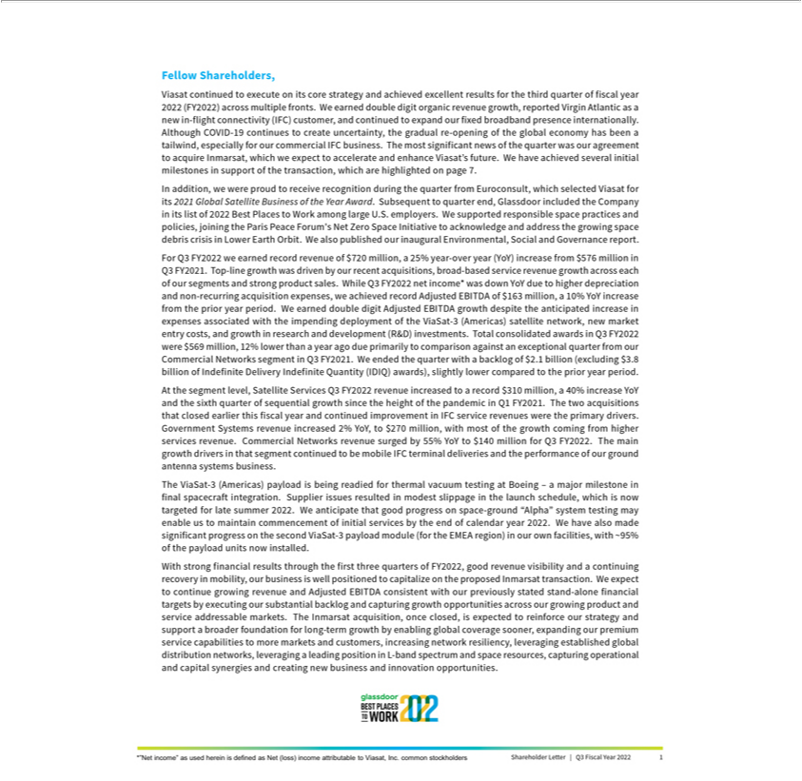

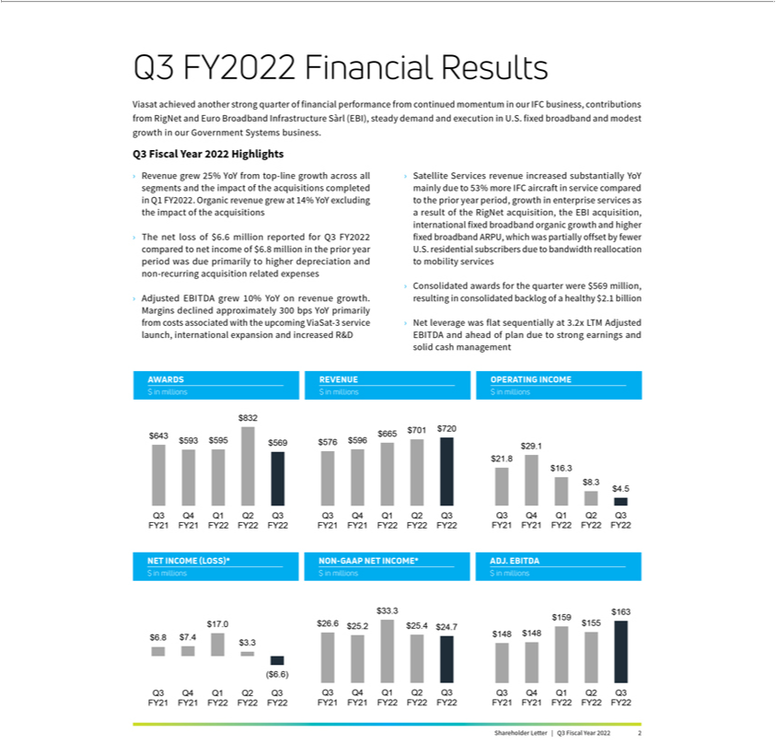

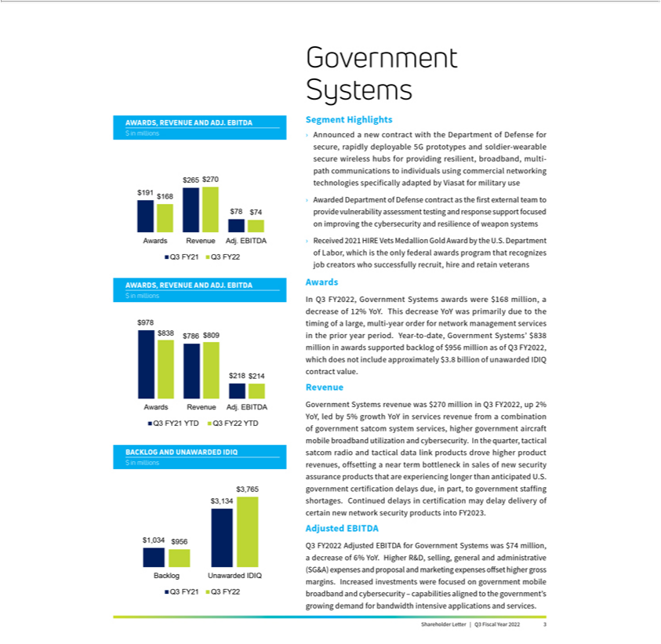

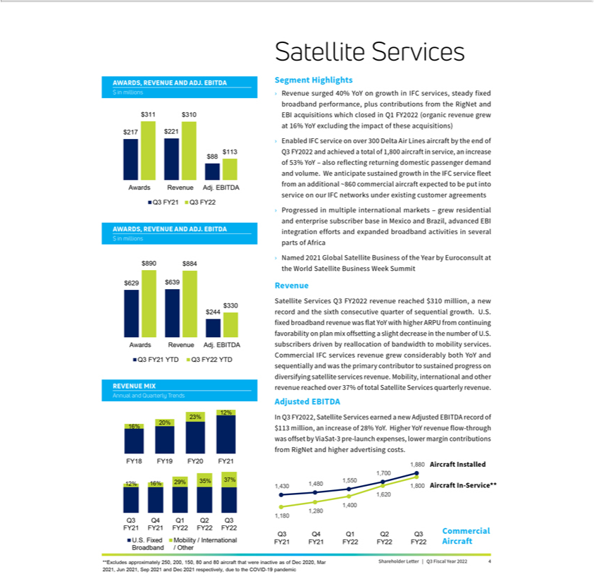

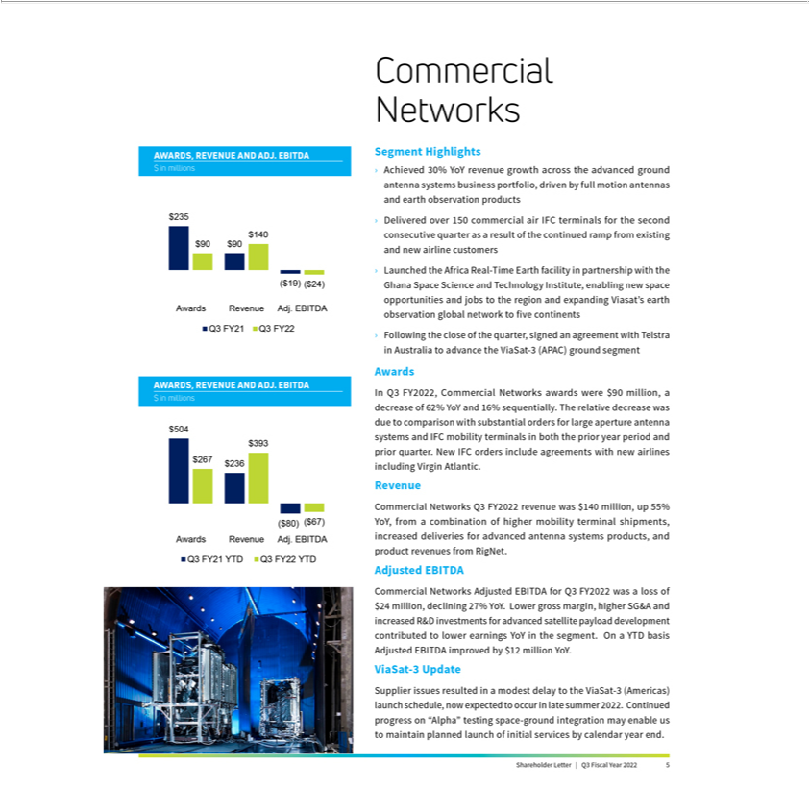

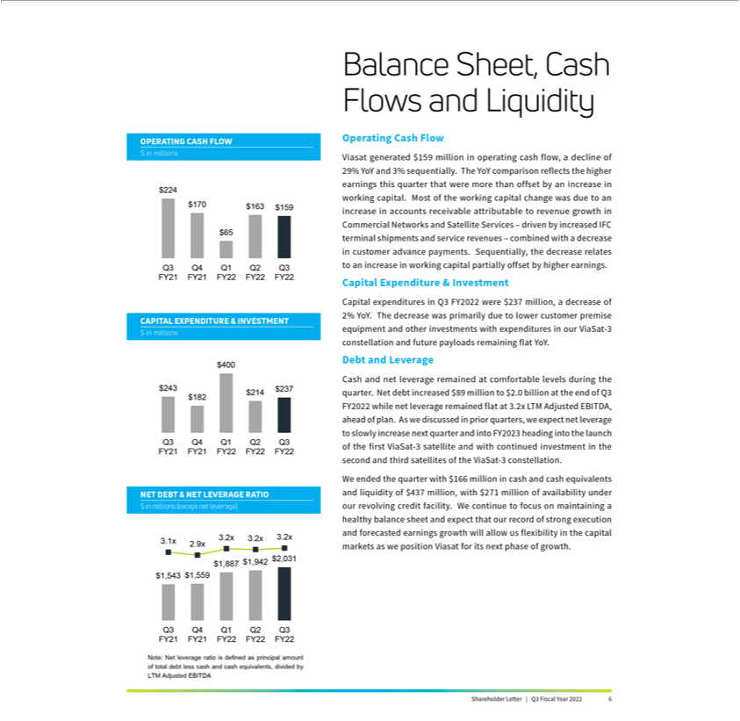

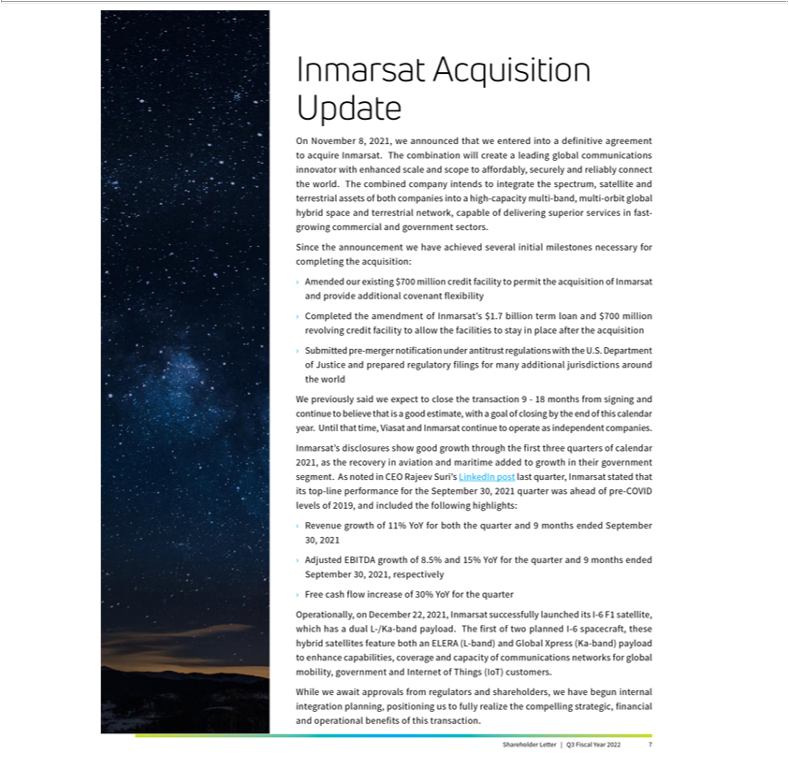



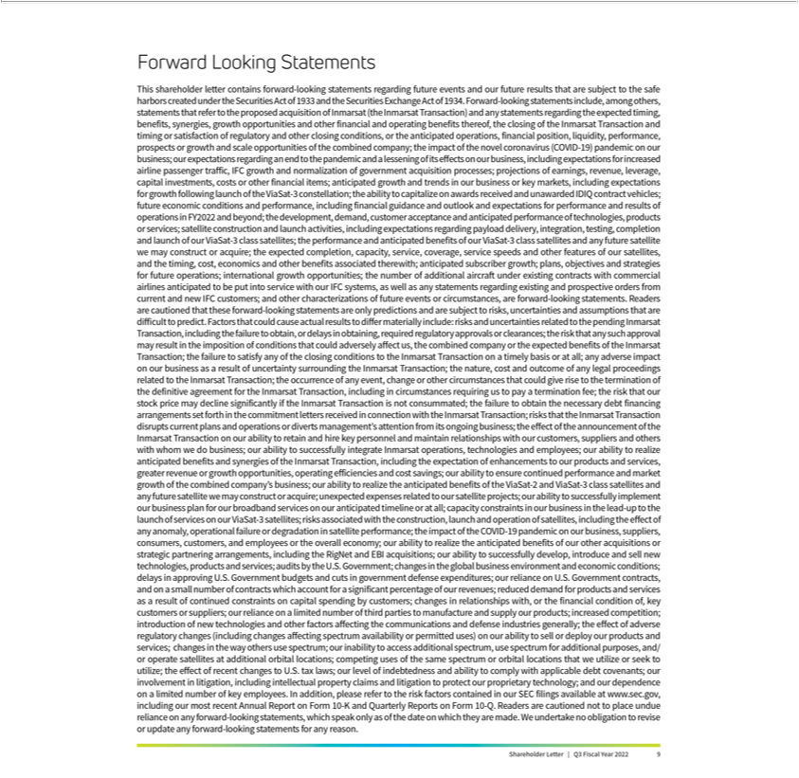

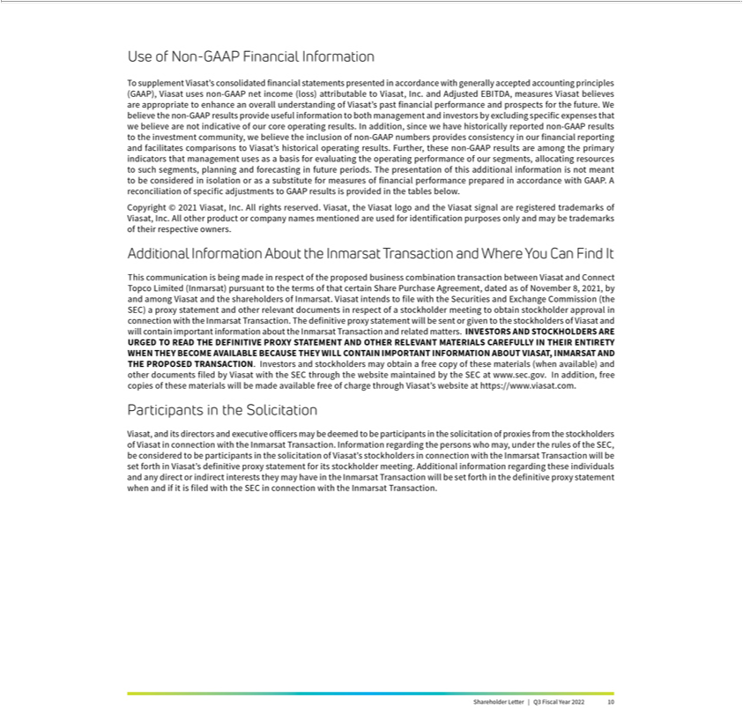

Viasat Third Quarter Fiscal Year 2022 Results

Financial Results

 | (In millions, except per | Q3 FY22 | Q3 FY21 | Year-Over-Year | First 9 Months | First 9 Months | Year-Over-Year
 | share data) |  |  | Change | FY22 | FY21 | Change
 | Revenues | $719.7 | $575.6 | 25% | $2,085.9 | $1,660.3 | 26%
 | Net (loss) income(1) | ($6.6) | $6.8 | * | $13.6 | ($3.7) | *
 | Non-GAAP net income(1) | $24.7 | $26.6 | (7)% | $83.4 | $51.8 | 61%
 | Adjusted EBITDA | $162.8 | $147.6 | 10% | $476.9 | $382.6 | 25%
 | Diluted per share net (loss)
 | income(1) | ($0.09) | $0.10 | * | $0.18 | ($0.06) | *
 | Non-GAAP diluted per share net
 | income(1), (2) | $0.33 | $0.39 | (15)% | $1.12 | $0.78 | 44%
 | Fully diluted weighted average
 | shares(2) | 73.9 | 68.7 | 8% | 74.3 | 65.7 | 13%
 | New contract awards(3) | $568.9 | $643.4 | (12)% | $1,995.6 | $2,110.9 | (5)%
 | Sales backlog(4) | $2,137.7 | $2,365.7 | (10)% | $2,137.7 | $2,365.7 | (10)%
Segment Results
 | (In millions) | Q3 FY22 | Q3 FY21 | Year-Over-Year | First 9 Months | First 9 Months | Year-Over-Year
 |  |  |  | Change | FY22 | FY21 | Change
 | Satellite Services
 | New contract awards(3) | $311.3 | $217.4 | 43% | $890.5 | $628.5 | 42%
 | Revenues | $309.7 | $220.8 | 40% | $883.9 | $638.7 | 38%
 | Operating profit(5) | $14.2 | $11.5 | 24% | $43.7 | $21.1 | 107%
 | Adjusted EBITDA | $113.1 | $88.1 | 28% | $329.6 | $244.1 | 35%
 | Commercial Networks
 | New contract awards | $89.9 | $235.1 | (62)% | $267.0 | $504.0 | (47)%
 | Revenues | $139.7 | $90.1 | 55% | $393.1 | $236.1 | 66%
 | Operating loss(5) | ($44.6) | ($39.0) | 14% | ($127.6) | ($135.8) | (6)%
 | Adjusted EBITDA | ($23.8) | ($18.8) | 27% | ($67.1) | ($79.5) | (16)%
 | Government Systems
 | New contract awards | $167.7 | $190.9 | (12)% | $838.1 | $978.4 | (14)%
 | Revenues | $270.3 | $264.7 | 2% | $808.9 | $785.5 | 3%
 | Operating profit(5) | $42.5 | $50.6 | (16)% | $133.9 | $148.0 | (10)%
 | Adjusted EBITDA | $73.6 | $78.2 | (6)% | $214.3 | $218.1 | (2)%

- Attributable to Viasat, Inc. common stockholders.
- As the three months ended December 31, 2021 and nine months ended December 31, 2020 financial information resulted in a net loss, the weighted average number of shares used to calculate basic and diluted net loss per share is the same, as diluted shares would be anti-dilutive. However, as the non-GAAP financial information for the three months ended December 31, 2021 and nine months ended December 31, 2020 resulted in non-GAAP net income, 75.5 million and 66.3 million, respectively, diluted weighted average number of shares were used instead to calculate non-GAAP diluted net income per share.

- Awards exclude future revenue under recurring consumer commitment arrangements.
- Amounts include certain backlog adjustments due to contract changes and amendments. Our backlog includes contracts with subscribers for fixed broadband services in our satellite services segment. Backlog does not include anticipated purchase orders and requests for the installation of in-flight connectivity systems or future recurring in-flight internet service revenues under our commercial in-flight internet agreements in our Commercial Networks and Satellite Services segments, respectively.

- Before corporate and amortization of acquired intangible assets.
* Percentage not meaningful.

Shareholder Letter | Q3 Fiscal Year 2022 | 11

Viasat Third Quarter Fiscal Year 2022 Results (cont.)

Condensed Consolidated Statements of Operations

(Unaudited)
(In thousands, except per share data)

 |  | Three months ended |  |  |  |  |  | Nine months ended
 |  | December 31, 2021 |  | December 31, 2020 |  |  | December 31, 2021 |  |  |  | December 31, 2020
Revenues:
Product revenues | $ | 316,143 | $ |  | 266,514 | $ |  | 918,073 | $ |  | 773,128
Service revenues |  | 403,574 |  |  | 309,045 |  |  | 1,167,858 |  |  | 887,197
Total revenues |  | 719,717 |  |  | 575,559 |  |  | 2,085,931 |  |  | 1,660,325
Operating expenses:
Cost of product revenues |  | 237,481 |  |  | 196,895 |  |  | 691,549 |  |  | 576,677
Cost of service revenues |  | 262,640 |  |  | 194,394 |  |  | 750,991 |  |  | 587,494
Selling, general and administrative |  | 170,222 |  |  | 132,394 |  |  | 481,106 |  |  | 378,884
Independent research and development |  | 37,316 |  |  | 28,803 |  |  | 112,309 |  |  | 83,970
Amortization of acquired intangible assets |  | 7,531 |  |  | 1,313 |  |  | 20,859 |  |  | 4,171
Income from operations |  | 4,527 |  |  | 21,760 |  |  | 29,117 |  |  | 29,129
Interest expense, net |  | (5,025) |  |  | (7,766) |  |  | (17,276) |  |  | (26,720)
Other income, net |  | — |  |  | — |  |  | 4,118 |  |  | —
(Loss) income before income taxes |  | (498) |  |  | 13,994 |  |  | 15,959 |  |  | 2,409
(Provision for) benefit from income taxes |  | (3,492) |  |  | (7,008) |  |  | 3,469 |  |  | (573)
Equity in income (loss) of unconsolidated
affiliate, net |  | — |  |  | 774 |  |  | (256) |  |  | 788
Net (loss) income |  | (3,990) |  |  | 7,760 |  |  | 19,172 |  |  | 2,624
Less: net income attributable to noncontrolling
interest, net of tax |  | 2,623 |  |  | 1,000 |  |  | 5,526 |  |  | 6,290
Net (loss) income attributable to Viasat, Inc. | $ | (6,613) | $ |  | 6,760 | $ |  | 13,646 | $ |  | (3,666)
Diluted net (loss) income per share attributable
to Viasat, Inc. common stockholders | $ | (0.09) | $ |  | 0.10 | $ |  | 0.18 | $ |  | (0.06)
Diluted common equivalent shares⁽²⁾
Diluted common equivalent shares⁽²⁾ |  | 73,917 |  |  | 68,668 |  |  | 74,348 |  |  | 65,704
AN ITEMIZED RECONCILIATION BETWEEN NET (LOSS) INCOME ATTRIBUTABLE TO VIASAT, INC.
ON A GAAP BASIS AND NON-GAAP BASIS IS AS FOLLOWS:
(In thousands, except per share data) |  | Three months ended |  |  |  |  |  | Nine months ended
GAAP net (loss) income attributable to Viasat, |  | December 31, 2021 |  | December 31, 2020 |  |  |  | December 31, 2021 |  |  | December 31, 2020
Inc. | $ | (6,613) | $ |  | 6,760 | $ |  | 13,646 | $ |  | (3,666)
Amortization of acquired intangible assets |  | 7,531 |  |  | 1,313 |  |  | 20,859 |  |  | 4,171
Stock-based compensation expense |  | 21,435 |  |  | 21,639 |  |  | 64,676 |  |  | 64,967
Acquisition related expenses |  | 11,862 |  |  | 1,876 |  |  | 19,352 |  |  | 1,876
Other income, net |  | — |  |  | — |  |  | (4,118) |  |  | —
Income tax effect⁽¹⁾ |  | (9,524) |  |  | (5,031) |  |  | (31,036) |  |  | (15,535)
Non-GAAP net income attributable to Viasat,
Inc. | $ | 24,691 | $ |  | 26,557 | $ |  | 83,379 | $ |  | 51,813
Non-GAAP diluted net income per share
attributable to Viasat, Inc. common
stockholders | $ | 0.33 | $ |  | 0.39 | $ |  | 1.12 | $ |  | 0.78
Diluted common equivalent shares⁽²⁾
Diluted common equivalent shares⁽²⁾ |  | 75,457 |  |  | 68,668 |  |  | 74,348 |  |  | 66,310
- The income tax effect is calculated using the tax rate applicable for the non-GAAP adjustments.
- As the three months ended December 31, 2021 and nine months ended December 31, 2020 financial information resulted in a net loss, the weighted average number of shares used to calculate basic and diluted net loss per share is the same, as diluted shares would be anti-dilutive. However, as the non-GAAP financial information for the three months ended December 31, 2021 and nine months ended December 31, 2020 resulted in non-GAAP net income, diluted weighted average number of shares were used instead to calculate non-GAAP diluted net income per share.

AN ITEMIZED RECONCILIATION BETWEEN NET (LOSS) INCOME ATTRIBUTABLE TO VIASAT, INC.

AND ADJUSTED EBITDA IS AS FOLLOWS:

(In thousands) |  | Three months ended |  |  |  |  |  | Nine months ended
GAAP net (loss) income attributable to Viasat, | December 31, 2021 |  |  | December 31, 2020 |  |  | December 31, 2021 |  |  | December 31, 2020
Inc. | $ | (6,613) | $ |  | 6,760 | $ |  | 13,646 | $ |  | (3,666)
Provision for (benefit from) income taxes |  | 3,492 |  |  | 7,008 |  |  | (3,469) |  |  | 573
Interest expense, net |  | 5,025 |  |  | 7,766 |  |  | 17,276 |  |  | 26,720
Depreciation and amortization |  | 127,628 |  |  | 102,502 |  |  | 369,488 |  |  | 292,116
Stock-based compensation expense |  | 21,435 |  |  | 21,639 |  |  | 64,676 |  |  | 64,967
Acquisition related expenses |  | 11,862 |  |  | 1,876 |  |  | 19,352 |  |  | 1,876
Other income, net |  | — |  |  | — |  |  | (4,118) |  |  | —
Adjusted EBITDA | $ | 162,829 |  | $ | 147,551 |  | $ | 476,851 |  | $ | 382,586
 |  |  |  |  |  |  |  | Shareholder Letter | Q3 Fiscal Year 2022 |  |  |  | 12

Viasat Third Quarter Fiscal Year 2022 Results (cont.)

AN ITEMIZED RECONCILIATION BETWEEN SEGMENT OPERATING PROFIT (LOSS) BEFORE

CORPORATE AND AMORTIZATION OF ACQUIRED INTANGIBLE ASSETS AND ADJUSTED EBITDA IS AS FOLLOWS:
(In thousands)

 |  | Three months ended December 31, 2021 |  |  |  |  |  |  |  |  |  |  |  |  |  | Three months ended December 31, 2020
 |  | Satellite |  |  |  | Commercial |  |  |  | Government |  |  |  |  |  | Satellite |  |  |  | Commercial |  |  | Government
Segment operating profit (loss) |  | Services |  |  |  | Networks |  |  |  | Systems |  |  | Total |  |  | Services |  |  |  | Networks |  |  | Systems |  |  |  | Total
before corporate and
amortization of acquired
intangible assets | $ | 14,152 |  | $ |  | (44,572) |  | $ |  | 42,478 |  | $ | 12,058 |  | $ | 11,457 |  | $ |  | (39,028) |  | $ | 50,644 |  | $ |  | 23,073
Depreciation ⁽³⁾ |  | 76,890 |  |  |  | 10,783 |  |  |  | 17,502 |  |  | 105,175 |  |  | 59,810 |  |  |  | 9,652 |  |  | 14,534 |  |  |  | 83,996
Stock-based compensation
expense |  | 6,850 |  |  |  | 7,360 |  |  |  | 7,225 |  |  | 21,435 |  |  | 6,815 |  |  |  | 7,327 |  |  | 7,497 |  |  |  | 21,639
Other amortization |  | 8,131 |  |  |  | 2,583 |  |  |  | 4,208 |  |  | 14,922 |  |  | 8,597 |  |  |  | 2,691 |  |  | 5,905 |  |  |  | 17,193
Acquisition related expenses |  | 7,141 |  |  |  | — |  |  |  | 4,721 |  |  | 11,862 |  |  | 665 |  |  |  | 565 |  |  | 646 |  |  |  | 1,876
Equity in income of unconsolidated
affiliate, net |  | — |  |  |  | — |  |  |  | — |  |  | — |  |  | 774 |  |  |  | — |  |  | — |  |  |  | 774
Noncontrolling interest |  | (60) |  |  |  | — |  |  |  | (2,563) |  |  | (2,623) |  |  | — |  |  |  | — |  |  | (1,000) |  |  |  | (1,000)
Adjusted EBITDA | $ | 113,104 |  |  | $ | (23,846) |  | $ |  | 73,571 |  | $ | 162,829 |  | $ | 88,118 |  | $ |  | (18,793) |  | $ | 78,226 |  | $ |  | 147,551

 |  | Nine months ended December 31, 2021 |  |  |  |  |  |  |  |  |  |  |  |  |  | Nine months ended December 31, 2020
 |  | Satellite |  |  |  | Commercial |  |  |  | Government |  |  |  |  |  | Satellite |  |  |  | Commercial |  |  | Government
Segment operating profit (loss) |  | Services |  |  |  | Networks |  |  |  | Systems |  |  | Total |  |  | Services |  |  |  | Networks |  |  | Systems |  |  |  | Total
before corporate and
amortization of acquired
intangible assets | $ | 43,711 |  | $ |  | (127,601) |  | $ |  | 133,866 |  | $ | 49,976 |  | $ | 21,083 |  | $ |  | (135,785) |  | $ | 148,002 |  | $ |  | 33,300
Depreciation ⁽³⁾ |  | 224,614 |  |  |  | 31,725 |  |  |  | 47,806 |  |  | 304,145 |  |  | 177,027 |  |  |  | 25,202 |  |  | 39,706 |  |  |  | 241,935
Stock-based compensation
expense |  | 22,470 |  |  |  | 21,169 |  |  |  | 21,037 |  |  | 64,676 |  |  | 19,545 |  |  |  | 22,931 |  |  | 22,491 |  |  |  | 64,967
Other amortization |  | 24,580 |  |  |  | 7,631 |  |  |  | 12,273 |  |  | 44,484 |  |  | 24,962 |  |  |  | 7,550 |  |  | 13,498 |  |  |  | 46,010
Acquisition related expenses |  | 14,631 |  |  |  | — |  |  |  | 4,721 |  |  | 19,352 |  |  | 665 |  |  |  | 565 |  |  | 646 |  |  |  | 1,876
Equity in (loss) income of
unconsolidated affiliate, net |  | (256) |  |  |  | — |  |  |  | — |  |  | (256) |  |  | 788 |  |  |  | — |  |  | — |  |  |  | 788
Noncontrolling interest |  | (160) |  |  |  | — |  |  |  | (5,366) |  |  | (5,526) |  |  | — |  |  |  | — |  |  | (6,290) |  |  |  | (6,290)
Adjusted EBITDA | $ | 329,590 |  |  | $ | (67,076) |  | $ |  | 214,337 |  | $ | 476,851 |  | $ | 244,070 |  | $ |  | (79,537) |  | $ | 218,053 |  | $ |  | 382,586

- Depreciation expenses not specifically recorded in a particular segment have been allocated based on other indirect allocable costs, which management believes is a reasonable method.

Condensed Consolidated Balance Sheets

(Unaudited)
(In thousands)

 |  | As of |  |  | As of |  |  |  |  | As of |  |  |  |  | As of
Assets | December 31, 2021 |  |  | March 31, 2021 |  |  | Liabilities and Equity |  | December 31, 2021 |  |  |  |  | March 31, 2021
Current assets: |  |  |  |  |  |  | Current liabilities:
Cash and cash equivalents | $ | 166,032 |  | $ | 295,949 |  | Accounts payable | $ |  | 251,335 |  |  | $ |  | 145,134
Accounts receivable, net |  | 363,013 |  |  | 238,652 |  | Accrued and other liabilities |  |  | 505,702 |  |  |  |  | 532,831
Inventories |  |  |  |  |  |  | Current portion of long-term
 |  | 353,993 |  |  | 336,672 |  | debt |  |  | 29,590 |  |  |  |  |  | 30,472
Prepaid expenses and other current assets |  | 144,833 |  |  | 119,960 |  | Total current liabilities |  |  | 786,627 |  |  |  |  | 708,437
Total current assets |  | 1,027,871 |  |  | 991,233 |  | Senior notes |  |  | 1,685,484 |  |  |  |  | 1,683,264
 |  |  |  |  |  |  | Other long-term debt |  |  | 463,908 |  |  |  |  | 119,420
 |  |  |  |  |  |  | Non-current operating lease
 |  |  |  |  |  |  | liabilities |  |  | 317,941 |  |  |  |  | 313,762
Property, equipment and satellites, net |  | 3,603,181 |  |  | 3,050,483 |  | Other liabilities |  |  | 157,104 |  |  |  |  | 137,350
Operating lease right-of-use assets |  | 344,499 |  |  | 340,456 |  | Total liabilities |  |  | 3,411,064 |  |  |  |  | 2,962,233
Other acquired intangible assets, net |  |  |  |  |  |  | Total Viasat, Inc.
 |  | 237,850 |  |  | 9,568 |  | stockholders’ equity |  |  | 2,634,450 |  |  |  |  | 2,351,469
Goodwill |  |  |  |  |  |  | Noncontrolling interest in
 |  | 190,907 |  |  | 122,300 |  | subsidiary |  |  | 41,280 |  |  |  |  |  | 35,765
Other assets |  | 682,486 |  |  | 835,427 |  | Total equity |  |  | 2,675,730 |  |  |  |  | 2,387,234
Total assets | $ | 6,086,794 |  | $ | 5,349,467 |  | Total liabilities and equity | $ |  | 6,086,794 |  |  | $ |  | 5,349,467
 |  |  |  |  |  |  |  | Shareholder Letter | Q3 Fiscal Year 2022 |  |  |  |  |  |  |  | 13

Viasat Financial Reconciliation Prior Periods

AN ITEMIZED RECONCILIATION BETWEEN NET INCOME ATTRIBUTABLE TO VIASAT, INC.

ON A GAAP BASIS AND NON-GAAP BASIS IS AS FOLLOWS:
(In thousands)

 |  |  |  | Three months ended
 | September 30, 2021 |  |  |  | June 30, 2021 |  |  |  | March 31, 2021
GAAP net income attributable to Viasat, Inc. | $ | 3,291 |  | $ |  | 16,968 |  | $ |  | 7,357
Amortization of acquired intangible assets |  | 7,399 |  |  |  | 5,929 |  |  |  | 1,311
Stock-based compensation expense |  | 21,023 |  |  |  | 22,218 |  |  |  | 19,912
Acquisition related expenses |  | 488 |  |  |  | 7,002 |  |  |  | 1,452
Other income, net |  | — |  |  |  | (4,118) |  |  |  | —
Income tax effect(1) |  | (6,784) |  |  |  | (14,728) |  |  |  | (4,844)
Non-GAAP net income attributable to Viasat, Inc. | $ | 25,417 |  | $ |  | 33,271 |  | $ |  | 25,188

- The income tax effect is calculated using the tax rate applicable for the non-GAAP adjustments.

AN ITEMIZED RECONCILIATION BETWEEN NET INCOME ATTRIBUTABLE TO VIASAT, INC.

AND ADJUSTED EBITDA IS AS FOLLOWS:
(In thousands)

 |  |  |  | Three months ended
 | September 30, 2021 |  |  |  | June 30, 2021 |  |  |  | March 31, 2021
GAAP net income attributable to Viasat, Inc. | $ | 3,291 |  | $ |  | 16,968 |  | $ |  |  | 7,357
(Benefit from) provision for income taxes |  | (2,874) |  |  |  | (4,087) |  |  |  |  | 8,868
Interest expense, net |  | 6,022 |  |  |  | 6,229 |  |  |  |  | 5,527
Depreciation and amortization |  | 127,108 |  |  |  | 114,752 |  |  |  | 104,986
Stock-based compensation expense |  | 21,023 |  |  |  | 22,218 |  |  |  | 19,912
Acquisition related expenses |  | 488 |  |  |  | 7,002 |  |  |  |  | 1,452
Other income, net |  | — |  |  |  | (4,118) |  |  |  |  | —
Adjusted EBITDA | $ | 155,058 |  | $ |  | 158,964 |  | $ |  | 148,102
 |  |  |  | Shareholder Letter | Q3 Fiscal Year 2022 |  |  |  |  |  |  | 14

