SCHEDULE 14A INFORMATION

Proxy Statement Pursuant to Section 14(a) of the

Securities Exchange Act of 1934

Filed by the Registrant ☒

Filed by a Party other than the Registrant ☐

Check the appropriate box:

- Preliminary Proxy Statement

- Confidential, for Use of the Commission Only (as permitted by Rule 14a-6(e)(2))

- Definitive Proxy Statement

- Definitive Additional Materials

- Soliciting Material under Rule 14a-12

VIASAT, INC.

(Name of Registrant as Specified In Its Charter)

(Name of Person(s) Filing Proxy Statement, if other than the Registrant)

Payment of Filing Fee (Check the appropriate box):

- No fee required.

- Fee computed on table below per Exchange Act Rules 14a-6(i)(1) and 0-11.
  - Title of each class of securities to which transaction applies:
  - Aggregate number of securities to which transaction applies:
  - Per unit price or other underlying value of transaction computed pursuant to Exchange Act Rule 0-11 (Set forth the amount on which the filing fee is calculated and state how it was determined):

  - Proposed maximum aggregate value of transaction:
  - Total fee paid:

- Fee paid previously with preliminary materials.

- Check box if any part of the fee is offset as provided by Exchange Act Rule 0-11(a)(2) and identify the filing for which the offsetting fee was paid previously. Identify the previous filing by registration statement number, or the Form or Schedule and the date of its filing.

  - Amount Previously Paid:

  - Form, Schedule or Registration Statement No.:
  - Filing Party:
  - Date Filed:


Shareholder Engagement

August 2019


Disclaimer

Forward-Looking Statements

This presentation contains forward-looking statements regarding future events and our future results that are subject to the safe harbors created under the Securities Act of 1933 and the Securities Exchange Act of 1934. These statements are based on current expectations, estimates, forecasts and projections about the industries in which we operate and the beliefs and assumptions of our management. We use words such as “anticipate,” “believe,” “continue,” “could,” “estimate,” “expect,” “goal,” “intend,” “may,” “plan,” “project,” “seek,” “should,” “target,” “will,” “would,” variations of such words and similar expressions to identify forward-looking statements. In addition, statements that refer to projections of earnings, revenue, costs or other financial items; anticipated growth and trends in our business or key markets; future economic conditions and performance; the development, customer acceptance and anticipated performance of technologies, products or services; satellite construction and launch activities; the performance and anticipated benefits of our ViaSat-2 and ViaSat-3 class satellites and any future satellite we may construct or acquire; the impacts on overall coverage area, planned services and financial results of the identified antenna deployment issue on the ViaSat-2 satellite; the expected completion, capacity, service, coverage, service speeds and other features of our satellites, and the timing, cost, economics and other benefits associated therewith; anticipated subscriber growth; plans, objectives and strategies for future operations; and other characterizations of future events or circumstances, are forward-looking statements. Readers are cautioned that these forward-looking statements are only predictions and are subject to risks, uncertainties and assumptions that are difficult to predict. Factors that could cause actual results to differ materially include: our ability to realize the anticipated benefits of the ViaSat-2 and ViaSat-3 class satellites and any future satellite we may construct or acquire; unexpected expenses related to our satellite projects; our ability to successfully implement our business plan for our broadband services on our anticipated timeline or at all; risks associated with the construction, launch and operation of satellites, including the effect of any anomaly, operational failure or degradation in satellite performance; our ability to realize the anticipated benefits of our acquisitions or strategic partnering arrangements; our ability to successfully develop, introduce and sell new technologies, products and services; audits by the U.S. government; changes in the global business environment and economic conditions; delays in approving U.S. government budgets and cuts in government defense expenditures; our reliance on U.S. government contracts, and on a small number of contracts which account for a significant percentage of our revenues; reduced demand for products and services as a result of continued constraints on capital spending by customers; changes in relationships with, or the financial condition of, key customers or suppliers; our reliance on a limited number of third parties to manufacture and supply our products; increased competition; introduction of new technologies and other factors affecting the communications and defense industries generally; the effect of adverse regulatory changes (including changes affecting spectrum availability or permitted uses) on our ability to sell or deploy our products and services; changes in the way others use spectrum; our inability to access additional spectrum, use spectrum for additional purposes, and/or operate satellites at additional orbital locations; competing uses of the same spectrum or orbital locations that we utilize or seek to utilize; the effect of recent changes to U.S. tax laws; our level of indebtedness and ability to comply with applicable debt covenants; our involvement in litigation, including intellectual property claims and litigation to protect our proprietary technology; our dependence on a limited number of key employees. In addition, please refer to the risk factors contained in our SEC filings available at www.sec.gov, including our most recent Annual Report on Form 10-K and Quarterly Reports on Form 10-Q. Readers are cautioned not to place undue reliance on any forward-looking statements, which speak only as of the date on which they are made. We undertake no obligation to revise or update any forward-looking statements for any reason.

Non-GAAP Financial Measures

This presentation includes non-GAAP financial measures such as Adjusted EBITDA to supplement Viasat’s consolidated financial statements presented on a GAAP basis. We believe these measures are appropriate to enhance an overall understanding of Viasat’s past financial performance and prospects for the future. However, the presentation of this additional information is not meant to be considered in isolation
or as a substitute for measures of financial performance prepared in accordance with GAAP. A reconciliation between the non-GAAP financial information and the most comparable GAAP financial information is provided in the Appendix.

References in this presentation to “FY” or “Fiscal Year” refer to fiscal years of Viasat, Inc., being the fiscal year ended March 31st of such year. All other references are to calendar years.

2

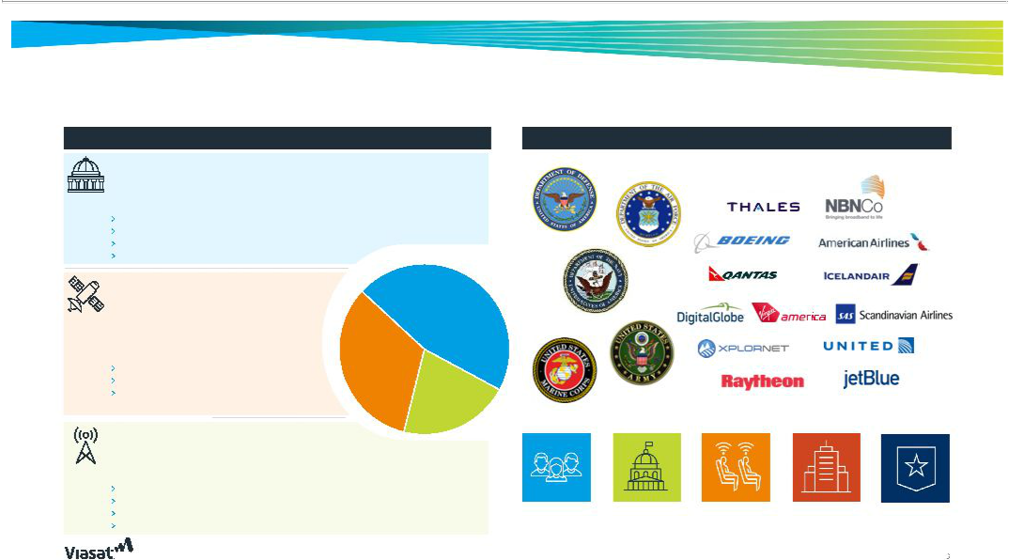
Viasat helps solve complex communication problems

Business Segments Notable Customers and End Markets

Government Systems

Satellite and tactical broadband networking creating innovative new mission and

network-centric fixed and mobile resilient government communications

Key segments:
- Government mobile broadband
- Government cybersecurity and information assurance

- Satellite communications systems
› Tactical data links FY 2019 Revenue

Satellite Services
High-speed broadband services for consumer, | Government
enterprise and mobile broadband customers | Government
enterprise and mobile broadband customers | Systems

High-speed in-flight internet and wireless in-flight entertainment

Key segments:
- Fixed broadband
- In-flight services
- Mobile broadband

46%

Satellite Services

33%

Commercial
Networks

21%

Commercial Networks

Innovates, develops and produces technology that enables broadband services

to fixed, nomadic and mobile users

Key segments:
- Mobile broadband satellite communication systems
- Fixed satellite networks
› | Antenna systems | Consumers | Government | Commercial | Enterprises | Military
› | Space-to-earth connectivity systems
› | Space-to-earth connectivity systems |  |  | Air

3

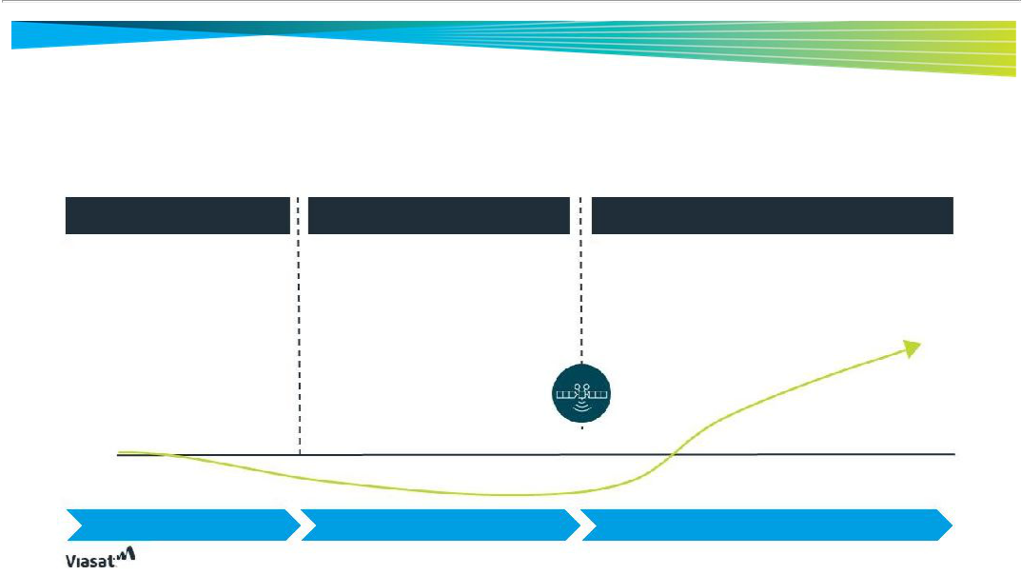
Lifecycle of a VSAT satellite demonstrates non-linear financial cadence

Substantial R&D investment and operating costs associated with the launch of commercial service temporarily puts transitory pressure on Adj. EBITDA and cash flow leading up to and in the first year after service launch, making individual years difficult to measure, but historical trends show these investments enable long-term growth and stockholder value creation

Development Phase | Construction & Pre-Service | Post Launch Phase
Development Phase | Launch Phase | Post Launch Phase
› Large upfront investment in R&D as | › Cash outflows continue as a result of high | › As satellite enters commercial service, increased revenues
specifications and technology for the | capital expenditures and opex associated | coupled with reduced capital expenditures create positive
satellite are finalized | with satellite construction | inflection point for cash flow
› Acquire favorable long-term | › No revenue for new satellite and growth is | › Expanded bandwidth capacity and geographic coverage
financing | likely muted for existing satellites as they | enables growth in service offerings within new and existing
› Contract with third-party for the | reach more mature phases | markets
› Contract with third-party for the | › Healthy cash flow from existing satellites | › Expansion pf consumer revenue base
construction and launch of the | › Healthy cash flow from existing satellites | › Expansion pf consumer revenue base
satellite | fuels multi-year investment in growth | drives Adj. EBITDA growth
 | initiatives
Cash flow | Launch of Commercial
Cash flow | Service on Satellite
breakeven
3-5 Years | 3-4 Years | Investments create assets for long-term revenue
3-5 Years | 3-4 Years | generation

4


Our business strategy has delivered strong financial results

Principal Strategy Elements

Maintain Focus on Technology Leadership

Continue Expansion into New and Adjacent Markets

Drive Efficiencies of Scale Continue International

and Operations Expansion

Pursue Growth Through

Strategic Alliances,

Partnering Arrangements

and Relationships

- Through a focus on R&D, we aim to maintain our leadership position in satellite systems, technologies and services, while expanding efforts in wireless communications, cloud networking and security

Rapid growth of in-flight connectivity (IFC) is driving revenues and market share gains

  - 1,312 tails in service ⁽⁴⁾

  - 700+ IFC terminal shipments

- Leverage opportunities to create or address new and adjacent markets as technological advancements disrupt existing business models and drive shifts in target markets or user demand

Improved capabilities in large geographic areas provide strong growth potential

- 1 million people within walking range of hotspots in Mexico

- Vertically integrated end-to-end platform of leading broadband technologies positions us to drive operating efficiencies and cost-effectively deliver our diverse portfolio of offerings

Improved operating efficiencies contributed to 44% year-over-year Adj. EBITDA growth for FY19

ViaSat-3 global satellite constellation to further drive scale and operational efficiencies

- As our unique offerings become increasingly attractive internationally, our investment in new satellites is expected to create global coverage and enables the scalable, long-term global expansion of our business

Expanded Community Wi-Fi into Mexico and Brazil in FY19 with global expansion potential

ViaSat-3 class satellites expected to provide broadband services over the Americas, EMEA and APAC regions

- Actively seek strategic relationships with companies whose financial, marketing, operational or technological resources can accelerate the introduction of new technologies, offerings or the penetration of new markets

Strategic partnering with China Satcom expected to bring IFC service to airlines over China

Collaboration with Facebook to provide internet connectivity to remote regions in Mexico

 | Revenue | 1 | Margin | 2 | New contract |  | U.S. Residential
FY’19 | Revenue | Adj. EBITDA | Margin |  | awards | 3 | subscribers
FY’19 | $2.1 billion | $339 million | 16% |  | awards |  | subscribers
 | (+30% YOY) | (+44% YOY) | (+1.7% YOY) |  | $2.4 billion |  | 586K⁴
 |  |  |  |  | (+42% YOY) |  | (+2% YOY)
(1) | Detailed reconciliation of Net Income to Adjusted EBITDA provided in Appendix
(2) | Adjusted EBITDA margin is calculated as Adjusted EBITDA divided by revenue |  |  |  |  |  | 5
(3) | Includes follow-on awards and optional renewals to existing contracts |  |  |  |  |  | 5
(4) | As of Q4 FY 2019 close

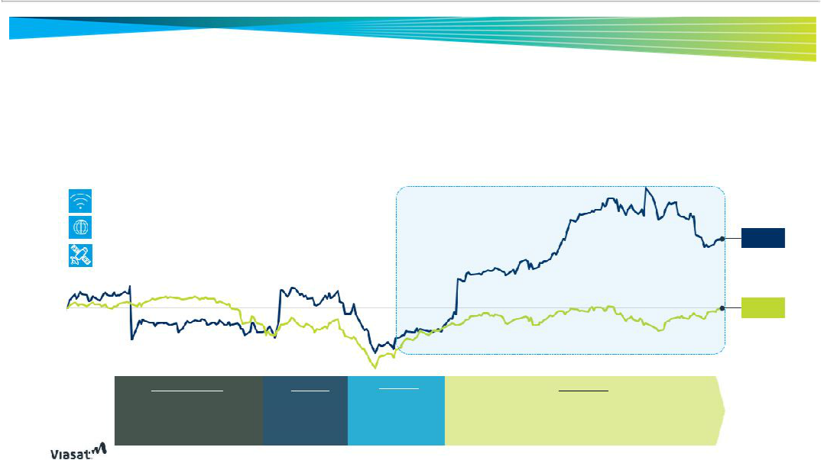
Key strategic initiatives driving performance

- Focus on driving improved economics by leveraging deep technological expertise to serve specialized markets (e.g., government, aeronautical)

- 30% year-over-year FY19 revenue growth, driven by strong execution across diversified business lines; performance demonstrates the strength of our model as offerings on the newly in-service ViaSat-2 satellite generated growth

- Record new contract awards of $2.4B for FY19, up 42% year-over-year, including $1.2B in government systems segment

Continued disruption of the IFC market |  |  | +40%
Successful expansion in key geographies |  |  | YTD TSR
Significant progress in ViaSat-3 satellite
construction
Jul-2018 |  |  | Jun-2019
August – October | Oct – Nov |  | Dec – Feb
Large planned expenditures to fund | Record contract | Overall market selloff
new satellite builds, enabling long- | awards drive | sparked by trade
term growth | strong Q2 2019 | tensions with China
 | earnings beat | and weakening
 |  | investor sentiment

Source: Capital IQ as of 8-Jul-2019

VSAT

23.6%

S&P Mid-

Cap 400

(0.4)%
Jul-2019

Feb – Today

Following a selloff in the broader market, record revenues and new contract awards prove Viasat’s business strategy is working, positioning the Company for continued success

6

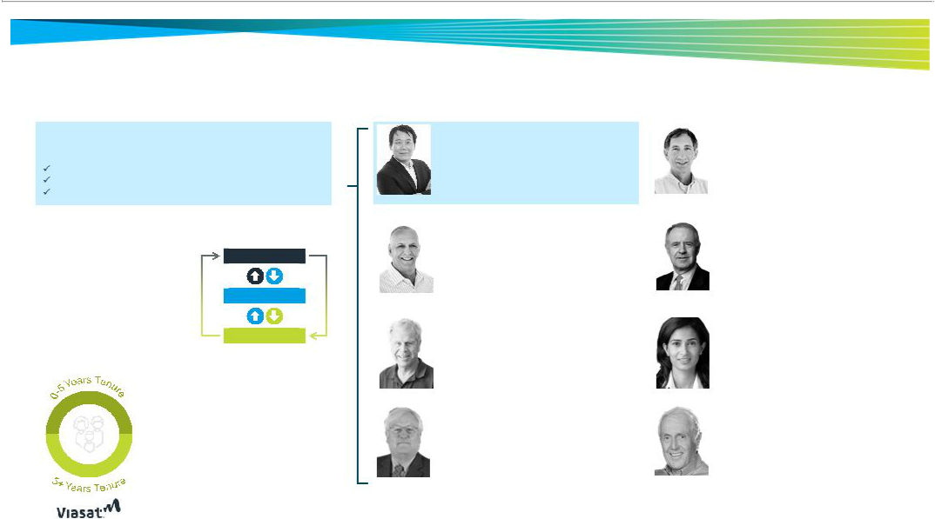
Experienced and diverse board

In 2019, we added the Lead Independent Director role to provide independent oversight and leadership through:

Serving as liaison between Chairman and rest of the Board Calling meetings of the independent directors

Presiding over all meeting where the Chairman is not present

Risk Oversight

› Comprehensive approach to risk | The Board
management assessed and
overseen by the Board
› Management provides timely, | Committees
comprehensive information to the | Committees
Board to support its role in oversight,
approval and decision-making | Management

Board Evaluation and Refreshment

- The Nomination, Evaluation and
- Corporate Governance Committee assesses the skills required of our
Four new |  | directors to align with our current
directors |  | needs, which informs refreshment
in last five | › | The Board completes an annual self-
years | › | The Board completes an annual self-
years |  | evaluation, results of which inform
- whether the Board is equipped to provide comprehensive, effective oversight

Sean Pak

Lead Independent Director

- Partner at Quinn Emanuel Urquhart & Sullivan

- Provides intellectual property development, strategy and enforcement, and technological and engineering expertise

Richard A. Baldridge

Director, President, Chief Operating Officer

- Joined Viasat in 1999; prior to Viasat, held roles at Raytheon and General Dynamics

- Provides operational and financial expertise

Robert Johnson

Independent Director

- Venture capital experience dating back to 1980

- Provides business and corporate finance expertise

John Stenbit

Independent Director

- Former Assistant Secretary of Defense at Command, Control, Communications, and Intelligence

- Provides technological, defense and national security expertise

Mark Dankberg

Chief Executive Officer and Chairman of the Board

- Co-founded Viasat Inc. in 1986

- Recognized as a leading expert and visionary in the aerospace, defense and satellite communications space

Frank Biondi, Jr.

Independent Director

- Senior managing director at WaterView Advisors

- Former Chairman/CEO at Universal Studios

- Former CEO at Viacom

- Provides leadership and Board experience

Varsha Rao

Independent Director

- Director, CEO at Nurx

- Former COO at Clover Health

- Brings international e-commerce, media, and telecommunications expertise

Harvey White

Independent Director

- Founder, Former Chairman and CEO at Leap Wireless

- Co-founder of QUALCOMM

- Provides first-hand operational, management, and leadership experience

7

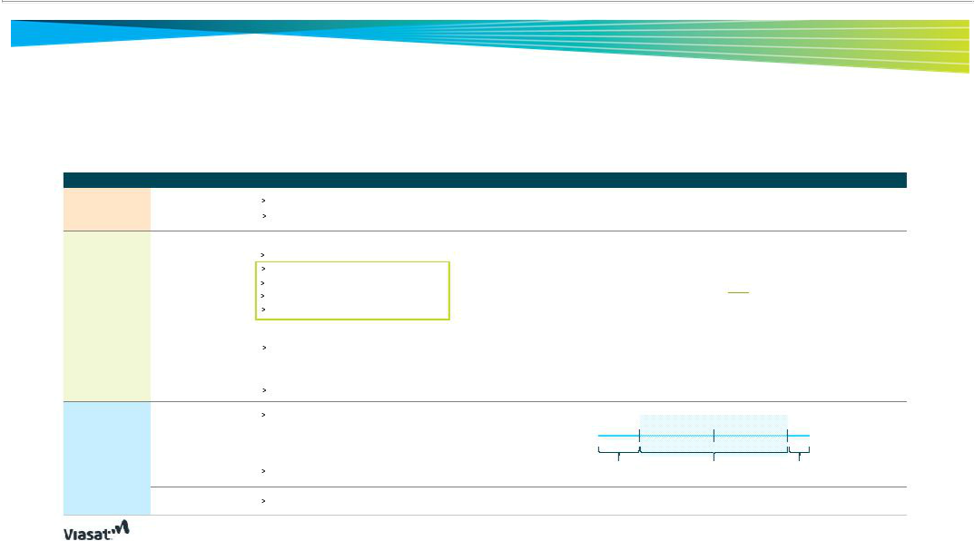
CEO FY2019 compensation program overview

Compensation linked to long-term drivers and rigorous strategic goals

Element Form

Base Salary 100% Cash

Annual Bonus 100% Cash

Factors / Metrics Used to Determine Pay / Vesting Period

External Industry and peer group data

Contributions related to performance, leadership, long-term strategy development, stockholder value creation, skills critical to VSAT success

33.3% Company Financial Performance

10.0% Non-GAAP Diluted Net Income Per Share ⁽¹⁾
12.5% Adjusted EBITDA⁽²⁾

7.5% | New Contract Awards | Fiscal 2019 targets set above fiscal 2018’s target and actual performance levels
12.5% Total Revenues
7.5% | Net Operating Asset Turnover | Fiscal 2019 Net Income and EPS were muted due to certain costs being capitalized
33.3% Leadership |  | in 2018 and expensed in 2019, as expected, after ViaSat-2 was put into service

Defining, managing and attaining corporate goals, exemplifying and promoting ethics and integrity throughout the company

33.3% Strategic

Industry positioning, short-term and long-term strategies, measurable progress in key business areas and effective pursuit of growth strategies

58% Performance-
_{Long-Term} based stock options

Incentive Plan

42% Restricted stock

units

100% TSR relative to S&P Midcap 400 over four-year period
– Target achieved at 50 ^{th} percentile
– 25 ^{th} – 90 ^{th} percentile: vest between 50% –175% of target
– 25th percentile: options forfeited

Vest ratably over four year period

Vest ratably over four year period

Percentile ₂₅ th ₅₀ th _{(target)} ₉₀ th

Awards forfeited 50% - 175% vest No additional award

(1) | Attributable to VSAT Common Stockholders
(2) | Adjusted EBITDA defined as net income (loss)attributable to Viasat, Inc. before interest, income taxes, depreciation and amortization, adjusted to exclude certain significantitems – See | 8
appendix for a reconciliation to net income


CEO FY2019 compensation decisions

Determination of base salary and annual bonus supported by measurable factors

Factors considered for the CEO’s fiscal 2019 annual salary

Successful launch of commercial broadband services on ViaSat-2

Setting new records for revenue, operating profit and Adjusted EBITDA in government systems segment

Continued expansion into the IFC market

Progress with the ViaSat-3 satellite systems and advances in the development and execution of strategies to facilitate global expansion

Factors considered for the CEO’s fiscal 2019 annual bonus

Leadership Performance

Led significant progress toward constellation of next-gen broadband satellites (i.e., ViaSat-3)

Directed commitment to creating an ethical culture; employee engagement level exceeding the industry

Recognized for contribution to the global communications industry as a distinguished innovator

Provided leadership and contributed to receipt of 2018 Platinum Cybersecurity industry award

Strategic Performance

Attained record revenue and new contract awards, up 30% and 42% year-over-year, respectively

Improved operational efficiency; all business segments reporting improved Adjusted EBITDA

Continued building awareness and credibility; expanded connectivity services in Mexico and Brazil

Continued disruption of the IFC market; 1,300+ commercial aircraft utilizing IFC systems, up 107% year-over-year

Given the long-cycle nature of our business and our focus on long-term performance, in addition to quantifiable results, achievements in strengthening our strategic positioning are a significant factor in determining executive compensation

9

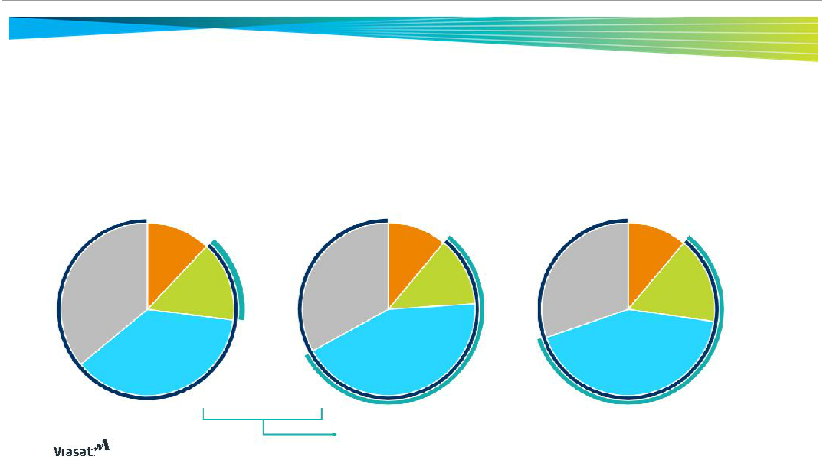
CEO compensation tied to performance

Compensation remains at-risk and is increasingly comprised of performance-based equity, reflective of our pay-for-performance philosophy

2017: 88% At-Risk

15% Performance-Based

 | Base Salary
 | 12%
Restricted | Annual
Stock Units | Bonus
36% | 15%
 | Stock
 | Options
 | 37%

2018: 89% At-Risk

56% Performance-Based

 | Base Salary
 | 11%
Restricted | Annual
Restricted | Bonus
Stock Units | Bonus
Stock Units | 13%
33% | 13%

Performance

Stock
Options

43%

2019: 89% At-Risk

58% Performance-Based

Base Salary

11%

Restricted | Annual
Stock Units | Annual
Stock Units | Bonus
30% | Bonus
30% | 16%
Performance
Stock
Options
43%

Performance-based stock options
added to FY18 compensation program

Pay mix reflective of target compensation levels | 10

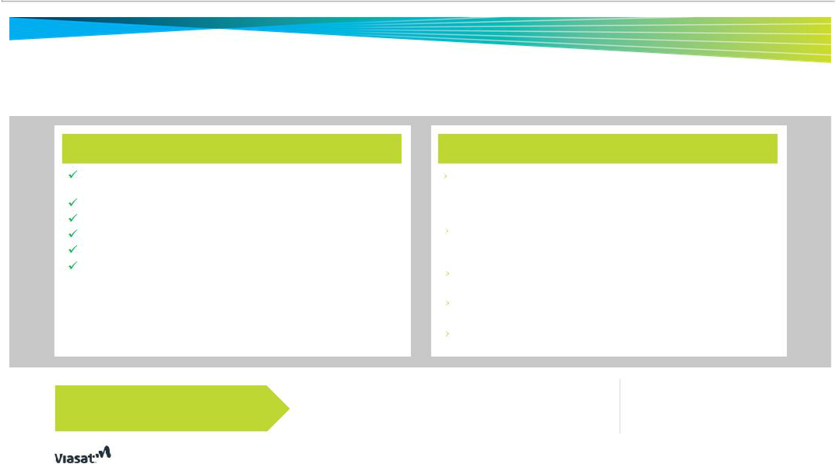
Amendment of 1996 equity participation plan

The restated equity plan combines compensation and governance

best practices

Stockholder approval required for additional shares (no evergreen provision)

One-year minimum vesting provision

Monitor grants to prevent dilution or excessive burn or overhang rates

Limitations on equity awards

Reasonable share counting provisions

Dividends and dividend equivalents may not be paid on awards subject to vesting conditions unless and until such conditions are met

X No discount stock options or stock appreciation rights

X No single trigger vesting of awards

X No share repricing

X No tax gross-ups

VSAT

Our strategy is working 9% ^{annual}_{employee}

turnover

Equity participation plan is essential to our long-term growth and shareholder value creation

Equity incentive awards are an important part of our compensation philosophy that allows us to properly tie NEO interests to the long-term interests of shareholders by allowing NEOs to benefit directly from our growth, development and financial success

Enable us to retain the services of the type of professional, technical and managerial employees considered essential to our long term success through the full lifecycle of our extended period investments

New equity is necessary for maintaining a low employee turnover rate, even outside of the NEOs

The existing plan, which was only intended to serve two years, is insufficiently funded given expected needs

Our equity incentive awards are carefully managed by our Compensation and Human Resources Committee

Industry
average Employees
VS. 22% annual 46% holding
employee equity awards

turnover⁽¹⁾

(1) Q1 2019 Radford Trends Report, reflecting employee turnover rate in similar industries | 11


Reconciliation
Appendix


Adjusted EBITDA Reconciliation
$ in millions

 | FY18 | FY19
Net Loss Attributable to Viasat, Inc. | ($67) | ($68)
(+) Benefit from Income Taxes | ($35) | ($41)
(+) Interest Expense | $2 | $50
(+) Depreciation & Amortization | $256 | $319
(+) Stock-Based Compensation Expense | $69 | $79
(+) Loss on Extinguishment of Debt | $10 | --
Adj. EBITDA | $235 | $339

Source: Company filings | 13



