SCHEDULE 14A

(RULE 14a-101)

INFORMATION REQUIRED IN PROXY STATEMENT

SCHEDULE 14A INFORMATION

Proxy Statement Pursuant to Section 14(a) of the

Securities Exchange Act of 1934 (Amendment No. )

Filed by the Registrant ☒

Filed by a Party other than the Registrant

☐

Check the appropriate box:

- Preliminary Proxy Statement

- Confidential, for Use of the Commission Only (as permitted by Rule 14a-6(e)(2))

- Definitive Proxy Statement

- Definitive Additional Materials

- Soliciting Material Pursuant to §240.14a-12

VIASAT, INC.

(Name of Registrant as Specified in its Charter)

(Name of Person(s) Filing Proxy Statement, if other than the Registrant)

Payment of Filing Fee (Check the appropriate box):

- No fee required.

- Fee computed on table below per Exchange Act Rules 14a-6(i)(1) and 0-11.

  - Title of each class of securities to which transaction applies:

  - Aggregate number of securities to which transaction applies:

  - Per unit price or other underlying value of transaction computed pursuant to Exchange Act Rule 0-11 (set forth the amount on which the filing fee is calculated and state how it was determined):

  - Proposed maximum aggregate value of transaction:

  - Total fee paid:

- Fee paid previously with preliminary materials.

- Check box if any part of the fee is offset as provided by Exchange Act Rule 0-11(a)(2) and identify the filing for which the offsetting fee was paid previously. Identify the previous filing by registration statement number, or the Form or Schedule and the date of its filing.

  - Amount Previously Paid:

  - Form, Schedule or Registration Statement No.:

- Filing Party:

- Date Filed:

Filed by Viasat, Inc.

Pursuant to Rule 14a-12 under the Securities Exchange Act of 1934

Subject Company: Viasat, Inc.

(Commission File No.: 000-21767)

This filing relates to the proposed business combination transaction between Viasat, Inc. (“Viasat”) and Connect Topco Limited (“Inmarsat”)

contemplated in that certain Share Purchase Agreement, dated as of November 8, 2021, by and among Viasat and the other parties thereto:

The following communications were made available by Inmarsat on Twitter on November 8, 2021:

Corporate Tweet #1 – 12:00pm UK Time

We are excited to announce @InmarsatGlobal is combining with @ViasatInc to create a new world leader in satellite communications #ViasatInmarsat #globalsatelliteleader [link]
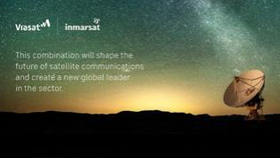

Corporate Tweet #2 – 2:00pm UK Time

“Joining with @ViasatInc is the right combination for @InmarsatGlobal at the right time”—@InmarsatGlobal CEO Rajeev Suri [link]
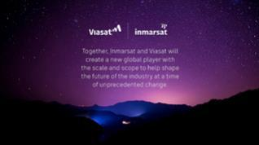

Corporate Tweet #3 - 2:15pm UK Time

“Together, @InmarsatGlobal and @ViasatInc will create a new global player with the scale and scope to help shape the future of a dynamic and growing industry”—@InmarsatGlobal CEO Rajeev Suri [link]

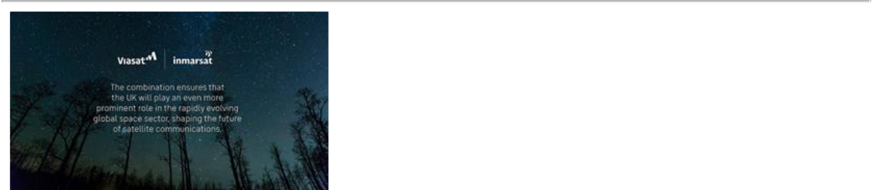

Corporate Tweet #4 - 2:30pm UK Time

“The combination will create a strong future for @InmarsatGlobal and be well positioned to offer greater choice for customers around the world, enhanced scope for partners and new opportunities for employees”—@InmarsatGlobal CEO Rajeev Suri [link]
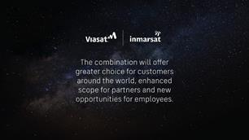

Corporate Tweet #5 - 2:45pm UK Time

“The industrial logic is compelling and ensures that the UK has a strong and sustainable presence in the critical space sector for the long term” - @InmarsatGlobal CEO Rajeev Suri [link]
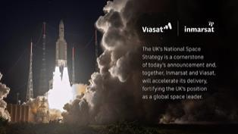

Corporate Tweet #6 – 6:00pm UK Time

Today’s combination will advance @InmarsatGlobal’s long-term future and enhance the satellite connectivity and essential communications that we provide in critical sectors #maritime #aviation #governments #ViasatInmarsat [link]

The following communication was made available by Inmarsat on LinkedIn on November 8, 2021:

Today, we are excited to announce that Inmarsat, the UK’s number-1 provider of global connectivity for maritime, aviation and government customers is combining with Viasat of the US to create a world leader in satellite communications. The combination will advance Inmarsat’s long-term future and enhance the satellite connectivity and essential communications that we provide in sectors including world shipping, maritime safety, in-flight communications and government, including defence and security.

Find out more here.

#maritime #aviation #governments #spaceindustry #satellitecommunications #innovation #industryconsolidation #globalsatelliteleader #ViasatInmarsat

The following communication was made available by Inmarsat on Facebook on November 8, 2021:

Today, we are excited to announce that Inmarsat, the UK’s number-1 provider of global connectivity for maritime, aviation and government customers is combining with Viasat of the US to create a world leader in satellite communications. The combination will advance Inmarsat’s long-term future and enhance the satellite connectivity and essential communications that we provide in sectors including world shipping, maritime safety, in-flight communications and government, including defence and security.

Find out more here.

The following communication was made available by Inmarsat on Instagram on November 8, 2021:
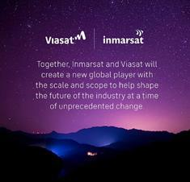

Today, we are excited to announce that Inmarsat, the UK’s number-1 provider of global connectivity for maritime, aviation and government customers is combining with Viasat of the US to create a world leader in satellite communications. The combination will advance Inmarsat’s long-term future and enhance the satellite connectivity and essential communications that we provide in sectors including world shipping, maritime safety, in-flight communications and government, including defence and security.

Find out more here: [link]

#maritime #aviation #governments #spaceindustry #satellitecommunications #innovation #industryconsolidation #globalsatelliteleader #ViasatInmarsat

The following communication was made available by Inmarsat’s CEO Rajeev Suri on LinkedIn on November 8, 2021:

LinkedIn Post

Today, the long-awaited consolidation of the world’s fragmented space industry begins with the announcement that Inmarsat, the UK’s number-1 provider of global connectivity for maritime, aviation, enterprise and government customers, is combining with Viasat of the US to create a new world leader in satellite communications.

In combination with Viasat, we now intend to enter a period of dramatic industry change. Like our satellites themselves, we can look beyond the horizon and take a new world-view of what is needed to enhance global mobility. It is a future we can look forward to with confidence.

LinkedIn Blog

Creating a New Global Leader in Satellite Communications

Today, the long-awaited consolidation of the world’s fragmented space industry finally began with the announcement that Inmarsat, the UK’s number-1 provider of global connectivity for maritime, aviation, enterprise and government customers, is combining with Viasat of the US to create a world leader in satellite communications.

This combination will advance Inmarsat’s long-term future and enhance the satellite connectivity and essential communications that we provide in sectors including worldwide shipping, maritime safety, in-flight communications for commercial and business jet aviation, industrial IoT and government, including defence and security.

The proposed transaction with Viasat reflects the value created at Inmarsat, where our world-class employees have ensured that we continue to deliver sustainable growth as demand recovers following more than a year of pandemic-related disruption.

Together – pending regulatory approvals – our combined company will be in a remarkable position to shape the future of an industry that is, as a whole, facing structural change due to a fragmented industry landscape and the arrival of new entrant players such as Starlink from the US and state-backed satellite companies in China. As the competitive structure of our industry changes, we must adapt by providing orbital connectivity at scale for users that stretch from wireless broadband networks to airlines, shipping companies, technology companies focused on the Internet of Things and government customers.

Details of the industrial rationale and the financial terms of the combination can be found here [link]. The combination will create a strong new company among more than 55 commercial satellite operators. Inmarsat will contribute leading technologies such as our next generation of high capacity, software defined satellites, our dual-payload L and Ka band satellites, ORCHESTRA and ELERA systems, all of which will be launched to meet growing demand for global, resilient, multi-orbit, multi-band broadband connectivity.

As a first-mover in the satellite industry’s overdue consolidation, we believe our combined companies will be well placed to deliver benefits from our complementary geographic strengths, our respective customer relationships and our innovation capabilities. We will have a strong multi-layered architecture encompassing GEO, HEO, LEO and terrestrial 4G and 5G. We will have a strong global presence, anchored in the USA and the UK, and industry-leading R&D capabilities. Recognising this potential, I am pleased that our consortium of private shareholders will receive equity and continue to be significant shareholders in the combined group. With their support, we have delivered significant operating efficiencies and invested in new systems to serve our customers.

I want to acknowledge the hard work, skills and commitment of Inmarsat’s people, who are regarded as best-in-class across our industry. I also want to thank Inmarsat’s partners and customers for their support as well, placing orders and utilising our services in ways that represent a vote of confidence in our advanced and exceptionally reliable technologies.

Today’s announcement marks the beginning of a new chapter in Inmarsat’s storied history – a history forged by providing vital communications to critical services, initially in the maritime world and subsequently serving multiple sectors. Our services have evolved and advanced throughout the space age, ensuring the UK is among the first-rank players in orbital technologies. The recently published UK national space strategy underlines the importance of this sector, of which we are proud to be a part.

In combination with Viasat, we now intend to enter a period of dramatic industry change. Like our satellites themselves, we can look beyond the horizon and take a new world-view of what is needed to enhance global mobility. It is a future we can look forward to with confidence.

Images for Use on LinkedIn:
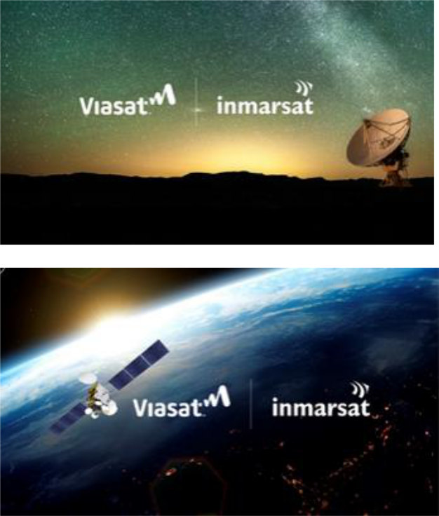

Additional Information About the Transaction and Where to Find It

This communication is being made in respect of the proposed business combination transaction between Viasat and Inmarsat pursuant to the terms of that certain Share Purchase Agreement, dated as of November 8, 2021, by and among Viasat and the shareholders of Inmarsat. Viasat intends to file with the Securities and Exchange Commission (the “SEC”) a proxy statement and other relevant documents in respect of a stockholder meeting to obtain stockholder approval in connection with the transaction. The definitive proxy statement will be sent or given to the stockholders of Viasat and will contain important information about the transaction and related matters. INVESTORS AND STOCKHOLDERS ARE URGED TO READ THE

DEFINITIVE PROXY STATEMENT AND OTHER RELEVANT MATERIALS CAREFULLY IN THEIR ENTIRETY WHEN THEY BECOME AVAILABLE BECAUSE THEY WILL CONTAIN IMPORTANT INFORMATION ABOUT VIASAT, INMARSAT AND THE PROPOSED TRANSACTION. Investors and stockholders may obtain a free copy of these materials (when available) and other documents filed by Viasat with the SEC through the website maintained by the SEC at www.sec.gov. In addition, free copies of these materials will be made available free of charge through Viasat’s website at https://www.viasat.com.

Participants in the Solicitation

Viasat, and its directors and executive officers may be deemed to be participants in the solicitation of proxies from the stockholders of Viasat in connection with the transaction. Information regarding the persons who may, under the rules of the SEC, be considered to be participants in the solicitation of Viasat’s stockholders in connection with the transaction will be set forth in Viasat’s definitive proxy statement for its stockholder meeting. Additional information regarding these individuals and any direct or indirect interests they may have in the transaction will be set forth in the definitive proxy statement when and if it is filed with the SEC in connection with the transaction.

Cautionary Statement Regarding Forward-Looking Statements

This communication contains forward-looking statements regarding future events that are subject to the safe harbors created under the Securities Act of 1933 and the Securities Exchange Act of 1934. These statements are based on current expectations, estimates, forecasts and projections about the industries in which Viasat and Inmarsat operate and the beliefs and assumptions of their respective management. The parties use words such as “anticipate,” “believe,” “continue,” “could,” “estimate,” “expect,” “goal,” “intend,” “may,” “plan,” “project,” “seek,” “should,” “target,” “will,” “would,” variations of such words and similar expressions to identify forward-looking statements. Forward looking statements include, among others, statements that refer to the benefits of and realization of synergies from the transaction, including expected resulting enhancements to the combined company’s systems, products and services and the anticipated operations, financial position, liquidity, performance, prospects or growth and scale opportunities of Viasat, Inmarsat or the combined company; integration activities; the anticipated value of the combined business to Viasat and stakeholders; the expected performance of Viasat’s and Inmarsat’s technologies; expected impact of the transaction on Viasat’s results of operations and financial condition; anticipated growth and trends in the business or key markets; the closing of the transaction, including the need for stockholder approval and the satisfaction of regulatory and other closing conditions; and plans, objectives and strategies for future operations. Readers are cautioned that actual results could differ materially from those expressed in any forward-looking statements. Factors that could cause actual results to differ include: risks and uncertainties related to the transaction, including the failure to obtain, or delays in obtaining, required regulatory approvals or clearances; the risk that any such approval may result in the imposition of conditions that could adversely affect Viasat, the combined company or the expected benefits of the transaction; the failure to satisfy any of the closing conditions to the transaction on a timely basis or at all; any adverse impact on the business of Viasat or Inmarsat as a result of uncertainty surrounding the transaction; the nature, cost and outcome of any legal proceedings related to the transaction; the occurrence of any event, change or other circumstances that could give rise to the termination of the definitive agreement for the transaction, including in circumstances requiring Viasat to pay a termination fee; the risk that Viasat’s stock price may decline significantly if the transaction is not consummated; the failure to obtain the necessary debt financing arrangements set forth in the commitment letters received in connection with the transaction; risks that the transaction disrupts current plans and operations or diverts management’s attention from its ongoing business; the effect of the announcement of the transaction on the ability of Viasat to retain and hire key personnel and maintain relationships with its customers, suppliers and others with whom it does business; the ability of Viasat to successfully integrate Inmarsat operations, technologies and employees;

the ability to realize anticipated benefits and synergies of the transaction, including the expectation of enhancements to Viasat’s products and services, greater revenue or growth opportunities, operating efficiencies and cost savings; the ability to ensure continued performance and market growth of the combined company’s business; changes in the global business environment and economic conditions; the availability and cost of credit; risks associated with the construction, launch and operation of satellites, including the effect of any anomaly, operational failure or degradation in satellite performance; Viasat’s or the combined company’s ability to successfully develop, introduce and sell new technologies, products and services; changes in relationships with key customers, suppliers, distributors, resellers and others as a result of the transaction or otherwise; Viasat’s and Inmarsat’s reliance on a limited number of third parties to manufacture and supply their respective products; the risk of litigation or regulatory actions to Viasat and/or Inmarsat; inability to retain key personnel; the impact of the COVID-19 pandemic on Viasat’s or Inmarsat’s business, suppliers, consumers, customers, and employees or the overall economy; Viasat’s and the combined company’s level of indebtedness and ability to comply with applicable debt covenants; and other factors affecting the communications industry generally. In addition, please refer to the risk factors contained in Viasat’s SEC filings available at www.sec.gov, including Viasat’s most recent Annual Report on Form 10-K and Quarterly Reports on Form 10-Q and such reports that are subsequently filed with the SEC, including the definitive proxy statement to be filed with the SEC in connection with the transaction. Readers are cautioned not to place undue reliance on any forward-looking statements, which speak only as of the date on which they are made. Viasat undertakes no obligation to update or revise any forward-looking statements for any reason.

