UNITED STATES
SECURITIES AND EXCHANGE COMMISSION
WASHINGTON, D.C. 20549

FORM 8-K
CURRENT REPORT
Pursuant to Section 13 or 15(d) of
the Securities Exchange Act of 1934
Date of Report (Date of Earliest Event Reported): November 5, 2026


VIASAT, INC.
(Exact Name of Registrant as Specified in its Charter)

Delaware |  | 000-21767 |  | 33-0174996
(State or Other Jurisdiction of  Incorporation) |  | (Commission File No.) |  | (I.R.S. Employer  Identification No.)
6155 El Camino Real
Carlsbad, California 92009
(Address of Principal Executive Offices, Including Zip Code)

(760) 476-2200
(Registrant’s Telephone Number, Including Area Code)

Check the appropriate box below if the Form 8-K filing is intended to simultaneously satisfy the filing obligation of the registrant under any of the following provisions:
☐ Written communications pursuant to Rule 425 under the Securities Act (17 CFR 230.425)
☐ Soliciting material pursuant to Rule 14a-12 under the Exchange Act (17 CFR 240.14a-12)
☐ Pre-commencement communications pursuant to Rule 14d-2(b) under the Exchange Act (17 CFR 240.14d-2(b))
☐ Pre-commencement communications pursuant to Rule 13e-4(c) under the Exchange Act (17 CFR 240.13e-4(c))

(Title of Each Class) |  | (Trading Symbol) |  | (Name of Each Exchange  on which Registered)
Common Stock, par value $0.0001 per share |  | VSAT |  | The Nasdaq Stock Market LLC
Indicate by check mark whether the registrant is an emerging growth company as defined in Rule 405 of the Securities Act of 1933 (§230.405 of this chapter) or Rule 12b-2 of the Securities Exchange Act of 1934 (§240.12b-2 of this chapter).
Emerging growth company ☐
If an emerging growth company, indicate by check mark if the registrant has elected not to use the extended transition period for complying with any new or revised financial accounting standards provided pursuant to Section 13(a) of the Exchange Act. ☐

Item 2.02 | Results of Operations and Financial Condition.
On November 5, 2026, Viasat, Inc. released its financial results for the second quarter of fiscal year 2027 in a letter to shareholders that is available on the investor relations section of its website. A copy of the press release announcing the release of financial results is furnished herewith as Exhibit 99.1 and a copy of the letter to shareholders is furnished herewith as Exhibit 99.2.
The information contained herein and in the accompanying exhibits shall not be incorporated by reference into any filing of the registrant, whether made before or after the date hereof, regardless of any general incorporation language in such filing, unless expressly incorporated by specific reference to such filing. The information in this report, including the exhibit hereto, shall not be deemed to be “filed” for purposes of Section 18 of the Securities Exchange Act of 1934, as amended, or otherwise subject to the liabilities of that section or Sections 11 and 12(a)(2) of the Securities Act of 1933, as amended.

Item 9.01 | Financial Statements and Exhibits.

(d) | Exhibits

Exhibit  Number |  | Description of Exhibit
99.1 |  | Press Release dated November 5, 2026 issued by Viasat, Inc.
99.2 |  | Viasat, Inc. second quarter of fiscal year 2027 letter to shareholders dated November 5, 2026
104 |  | Cover Page Interactive Data File (embedded within the Inline XBRL document)

1

SIGNATURES
Pursuant to the requirements of the Securities Exchange Act of 1934, the registrant has duly caused this report to be signed on its behalf by the undersigned hereunto duly authorized.

Date: November 5, 2026 |  | Viasat, Inc.
 |  | By: |  | /s/ Brett Church
 |  |  |  | Brett Church
 |  |  |  | Associate General Counsel

2
Exhibit 99.1


Viasat Releases Second Quarter Fiscal Year 2027 Financial Results
CARLSBAD, Calif., November 5, 2026 — Viasat, Inc. (NASDAQ: VSAT), a global leader in satellite communications technology, today published its second quarter fiscal year 2027 financial results. A letter to shareholders and accompanying webcast slides are available on the Investor Relations section of the company’s website.
Conference Call Details
As previously announced, Viasat management will host a conference call to discuss the results today, Thursday, November 5, 2026 at 2:30 p.m. PT (5:30 p.m. ET).
Access Information:
 |  |  | Dial-in: (800) 715-9871 (U.S./Canada toll-free) or (646) 307-1963

 |  |  | Conference ID: 7750494

 |  |  | Live webcast: Available on Viasat’s Investor Relations website.
A replay of the call will be archived on the Investor Relations site.
# # #
About Viasat
Viasat is a global technology company that believes everyone and everything in the world can be connected. With offices in 24 countries around the world, our mission shapes how consumers, businesses, governments and militaries around the world communicate and connect. Viasat is developing the ultimate global communications network to power high-quality, reliable, secure, affordable, fast connections to positively impact people’s lives anywhere they are—on the ground, in the air or at sea, while building a sustainable future in space. In May 2023, Viasat completed its acquisition of Inmarsat, combining the teams, technologies and resources of the two companies to create a new global communications partner. Learn more at www.viasat.com, the Viasat News Room or follow us on LinkedIn, X, Instagram, Facebook, Bluesky, Threads, and YouTube.
Copyright © 2026 Viasat, Inc. All rights reserved. Viasat, the Viasat logo and the Viasat Signal are registered trademarks in the U.S. and in other countries of Viasat, Inc. All other product or company names mentioned are used for identification purposes only and may be trademarks of their respective owners.
Viasat, Inc. Contacts
David Pendery / Scott Goryl Corporate Communications, PR@viasat.com
Lisa Curran / Peter Lopez, Investor Relations, IR@viasat.com
Exhibit 99.2


VIASAT Q2 FY27 Shareholder Letter

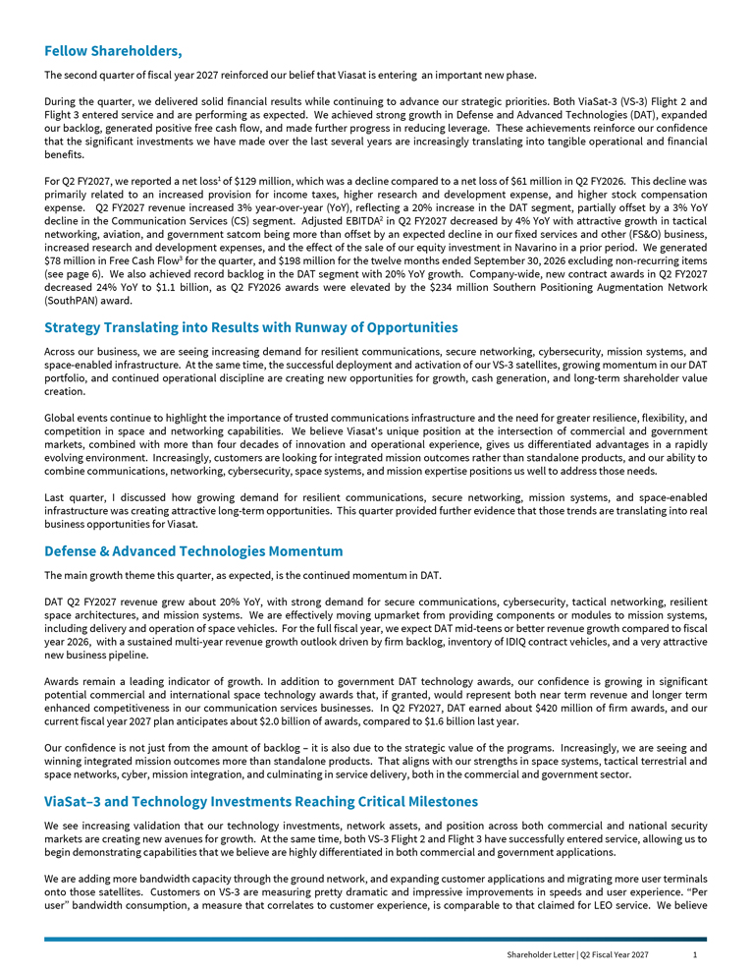
Fellow Shareholders, The second quarter of fiscal year 2027 reinforced our belief that Viasat is entering an important new phase. During the quarter, we delivered solid financial results while continuing to advance our strategic priorities. Both ViaSat-3 (VS-3) Flight 2 and Flight 3 entered service and are performing as expected. We achieved strong growth in Defense and Advanced Technologies (DAT), expanded our backlog, generated positive free cash flow, and made further progress in reducing leverage. These achievements reinforce our confidence that the significant investments we have made over the last several years are increasingly translating into tangible operational and financial benefits. For Q2 FY2027, we reported a net loss1 of $129 million, which was a decline compared to a net loss of $61 million in Q2 FY2026. This decline was primarily related to an increased provision for income taxes, higher research and development expense, and higher stock compensation expense. Q2 FY2027 revenue increased 3% year-over-year (YoY), reflecting a 20% increase in the DAT segment, partially offset by a 3% YoY decline in the Communication Services (CS) segment. Adjusted EBITDA2 in Q2 FY2027 decreased by 4% YoY with attractive growth in tactical networking, aviation, and government satcom being more than offset by an expected decline in our fixed services and other (FS&O) business, increased research and development expenses, and the effect of the sale of our equity investment in Navarino in a prior period. We generated $78 million in Free Cash Flow3 for the quarter, and $198 million for the twelve months ended September 30, 2026 excluding non-recurring items (see page 6). We also achieved record backlog in the DAT segment with 20% YoY growth. Company-wide, new contract awards in Q2 FY2027 decreased 24% YoY to $1.1 billion, as Q2 FY2026 awards were elevated by the $234 million Southern Positioning Augmentation Network (SouthPAN) award. Strategy Translating into Results with Runway of Opportunities Across our business, we are seeing increasing demand for resilient communications, secure networking, cybersecurity, mission systems, and space-enabled infrastructure. At the same time, the successful deployment and activation of our VS-3 satellites, growing momentum in our DAT portfolio, and continued operational discipline are creating new opportunities for growth, cash generation, and long-term shareholder value creation. Global events continue to highlight the importance of trusted communications infrastructure and the need for greater resilience, flexibility, and competition in space and networking capabilities. We believe Viasat’s unique position at the intersection of commercial and government markets, combined with more than four decades of innovation and operational experience, gives us differentiated advantages in a rapidly evolving environment. Increasingly, customers are looking for integrated mission outcomes rather than standalone products, and our ability to combine communications, networking, cybersecurity, space systems, and mission expertise positions us well to address those needs. Last quarter, I discussed how growing demand for resilient communications, secure networking, mission systems, and space-enabled infrastructure was creating attractive long-term opportunities. This quarter provided further evidence that those trends are translating into real business opportunities for Viasat. Defense & Advanced Technologies Momentum The main growth theme this quarter, as expected, is the continued momentum in DAT. DAT Q2 FY2027 revenue grew about 20% YoY, with strong demand for secure communications, cybersecurity, tactical networking, resilient space architectures, and mission systems. We are effectively moving upmarket from providing components or modules to mission systems, including delivery and operation of space vehicles. For the full fiscal year, we expect DAT mid-teens or better revenue growth compared to fiscal year 2026, with a sustained multi-year revenue growth outlook driven by firm backlog, inventory of IDIQ contract vehicles, and a very attractive new business pipeline. Awards remain a leading indicator of growth. In addition to government DAT technology awards, our confidence is growing in significant potential commercial and international space technology awards that, if granted, would represent both near term revenue and longer term enhanced competitiveness in our communication services businesses. In Q2 FY2027, DAT earned about $420 million of firm awards, and our current fiscal year 2027 plan anticipates about $2.0 billion of awards, compared to $1.6 billion last year. Our confidence is not just from the amount of backlog – it is also due to the strategic value of the programs. Increasingly, we are seeing and winning integrated mission outcomes more than standalone products. That aligns with our strengths in space systems, tactical terrestrial and space networks, cyber, mission integration, and culminating in service delivery, both in the commercial and government sector. ViaSat–3 and Technology Investments Reaching Critical Milestones We see increasing validation that our technology investments, network assets, and position across both commercial and national security markets are creating new avenues for growth. At the same time, both VS-3 Flight 2 and Flight 3 have successfully entered service, allowing us to begin demonstrating capabilities that we believe are highly differentiated in both commercial and government applications. We are adding more bandwidth capacity through the ground network, and expanding customer applications and migrating more user terminals onto those satellites. Customers on VS-3 are measuring pretty dramatic and impressive improvements in speeds and user experience. “Per user” bandwidth consumption, a measure that correlates to customer experience, is comparable to that claimed for LEO service. We believe Shareholder Letter | Q2 Fiscal Year 2027 1


that our VS-3 satellites can help shape industry sentiment and benefit our business results through both revenue generation and operating economics. AMARA, our multi-orbit aviation service offering continues to represent a very attractive growth opportunity. Multiple airlines are evaluating AMARA deployments. In particular, estimated integrated IFC/IFE is still only about 1/3 penetrated and we see considerable interest in more choices among airlines – as well as in other satellite service segments. We are also building confidence in our approach to integrate connectivity and entertainment in ways that help airlines optimize and benefit from passenger engagement. We are also making progress on substantially growing our L- and S-Band Mobile Satellite Services (MSS) addressable market – building around interoperable, 3GPP and 5G/6G NTN networking standards that enable the highly anticipated direct-to-device (D2D) services market. Our approach enables us to bring unique value propositions to D2D as well as to other large evolving or emerging MSS markets building on our existing government and commercial business base. Advancing this strategy, in September we executed a binding agreement with Space42 to establish Equatys, the first standards based shared mobile satellite network infrastructure company. Creating More Paths to Value Overall, we are focused on reducing capital intensity and generating cash. We are transitioning from a period of significant infrastructure investment into one more focused on monetization, utilization, debt reduction and returns. We are further refining state-of-the-art VS-3 technology and converting it into funded turn-key satellite programs that can drive near term government and commercial revenue and can help contain ongoing capital investments that grow our differentiated dual-use, vertically integrated portfolio. Basically, we believe the capital-intensive VS-3 phase is behind us. That offers more strategic flexibility. Each opportunity is considered in terms of returns, cash generation, and alignment with shareholder interests. Most opportunities build on the unique complement of assets we already have, including global spectrum access, orbital and ground infrastructure, technologies, and customer relationships. Our approach is straightforward: remain strategically engaged through a market attractiveness lens, invest selectively, maintain disciplined return thresholds, and partner where appropriate. We are not speculating. We are pursuing opportunities we believe can create durable value while maintaining our focus on free cash flow, capital discipline, and shareholder alignment. Looking Ahead As we look to the remainder of fiscal year 2027 and beyond, three themes continue to strengthen our confidence in Viasat’s future. First, our technology investments and growing base of customer-funded development programs in networking, cybersecurity, mission systems, and space technologies are translating into stronger awards, larger backlog, and expanding growth opportunities across both government and commercial markets. Increasingly, we are seeing customers seek integrated mission outcomes rather than standalone products. That trend aligns directly with Viasat’s strengths across communications, networking, cybersecurity, mission integration, and space systems. These opportunities are becoming an increasingly important driver of Viasat’s overall financial performance and lower capital intensity. Second, the successful completion of the VS-3 deployment program marks an important transition for the company. Over the last several years, we invested heavily in satellite infrastructure, spectrum assets, advanced security capabilities, and networking technologies. We believe those investments have created a foundation for the next stage of growth. Our focus now is increasingly on utilization, monetization, customer adoption, and translating those assets into revenue growth, improved operating performance, and cash generation. Third, growing contribution from DAT, improving capital efficiency, and declining capital expenditures are supporting stronger free cash flow generation and continued deleveraging. We are transitioning from a period dominated by infrastructure investment to one characterized by increasing financial flexibility and strategic optionality. We remain disciplined in evaluating opportunities through the lens of returns, cash generation, capital efficiency, and long-term shareholder value. We know we operate in very dynamic competitive and geo-political environments. We also believe Viasat is entering a fundamentally different phase, characterized by expanding growth opportunities, lower capital intensity, and increasing financial and strategic flexibility. We are maintaining our Strategic Review Committee to regularly assess our opportunities and ensure we are aligned in pursuit of customer outcomes and increasing shareholder value. Thanks for your continued trust in our team. Sincerely, Mark Dankberg Shareholder Letter | Q2 Fiscal Year 2027 2

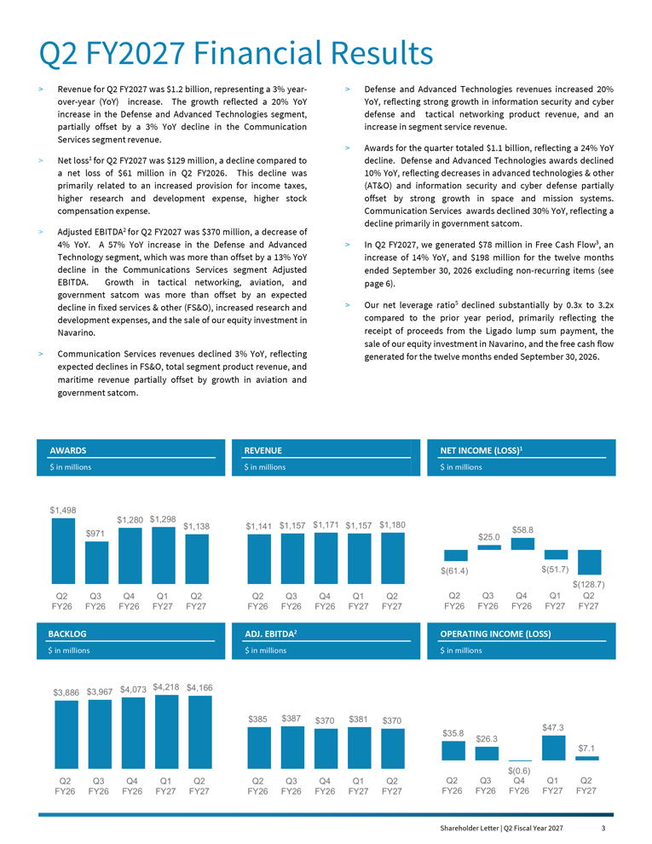
Q2 FY2027 Financial Results > Revenue for Q2 FY2027 was $1.2 billion, representing a 3% yearover- year (YoY) increase. The growth reflected a 20% YoY increase in the Defense and Advanced Technologies segment, partially offset by a 3% YoY decline in the Communication Services segment revenue. > Net loss1 for Q2 FY2027 was $129 million, a decline compared to a net loss of $61 million in Q2 FY2026. This decline was primarily related to an increased provision for income taxes, higher research and development expense, higher stock compensation expense. > Adjusted EBITDA2 for Q2 FY2027 was $370 million, a decrease of 4% YoY. A 57% YoY increase in the Defense and Advanced Technology segment, which was more than offset by a 13% YoY decline in the Communications Services segment Adjusted EBITDA. Growth in tactical networking, aviation, and government satcom was more than offset by an expected decline in fixed services & other (FS&O), increased research and development expenses, and the sale of our equity investment in Navarino. > Communication Services revenues declined 3% YoY, reflecting expected declines in FS&O, total segment product revenue, and maritime revenue partially offset by growth in aviation and government satcom. > Defense and Advanced Technologies revenues increased 20% YoY, reflecting strong growth in information security and cyber defense and tactical networking product revenue, and an increase in segment service revenue. > Awards for the quarter totaled $1.1 billion, reflecting a 24% YoY decline. Defense and Advanced Technologies awards declined 10% YoY, reflecting decreases in advanced technologies & other (AT&O) and information security and cyber defense partially offset by strong growth in space and mission systems. Communication Services awards declined 30% YoY, reflecting a decline primarily in government satcom. > In Q2 FY2027, we generated $78 million in Free Cash Flow3, an increase of 14% YoY, and $198 million for the twelve months ended September 30, 2026 excluding non-recurring items (see page 6). > Our net leverage ratio5 declined substantially by 0.3x to 3.2x compared to the prior year period, primarily reflecting the receipt of proceeds from the Ligado lump sum payment, the sale of our equity investment in Navarino, and the free cash flow generated for the twelve months ended September 30, 2026. AWARDS $ in millions REVENUE $ in millions NET INCOME (LOSS)1 $ in millions $1,498 $971 $1,280 $1,298 $1,138 Q2 FY26 Q3 FY26 Q4 FY26 Q1 FY27 Q2 FY27 $(61.4) $25.0 $58.8 $(51.7) $(128.7) Q2 FY26 Q3 FY26 Q4 FY26 Q1 FY27 Q2 FY27 $1,141 $1,157 $1,171 $1,157 $1,180 Q2 FY26 Q3 FY26 Q4 FY26 Q1 FY27 Q2 FY27 BACKLOG $ in millions ADJ. EBITDA2 $ in millions OPERATING INCOME (LOSS) $ in millions $3,886 $3,967 $4,073 $4,218 $4,166 Q2 FY26 Q3 FY26 Q4 FY26 Q1 FY27 Q2 FY27 $385 $387 $370 $381 $370 Q2 FY26 Q3 FY26 Q4 FY26 Q1 FY27 Q2 FY27 $35.8 $26.3 $(0.6) $47.3 $7.1 Q2 FY26 Q3 FY26 Q4 FY26 Q1 FY27 Q2 FY27 Shareholder Letter | Q2 Fiscal Year 2027 3

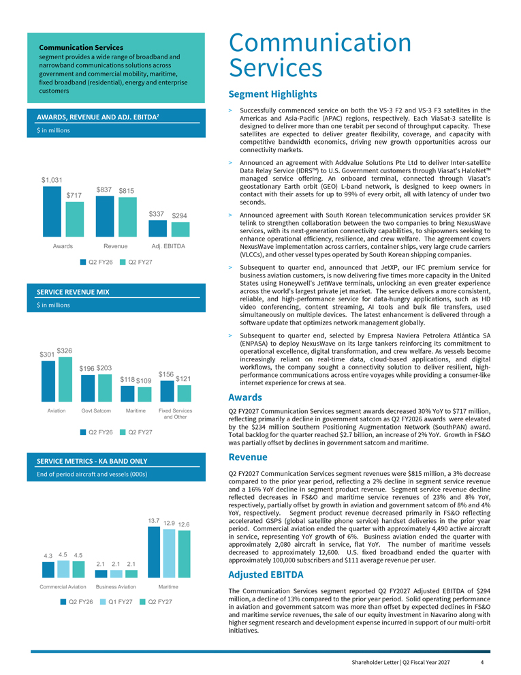
Communication Services Segment Highlights > Successfully commenced service on both the VS-3 F2 and VS-3 F3 satellites in the Americas and Asia-Pacific (APAC) regions, respectively. Each ViaSat-3 satellite is designed to deliver more than one terabit per second of throughput capacity. These satellites are expected to deliver greater flexibility, coverage, and capacity with competitive bandwidth economics, driving new growth opportunities across our connectivity markets. > Announced an agreement with Addvalue Solutions Pte Ltd to deliver Inter-satellite Data Relay Service (IDRS) to U.S. Government customers through Viasat’s HaloNet managed service offering. An onboard terminal, connected through Viasat’s geostationary Earth orbit (GEO) L-band network, is designed to keep owners in contact with their assets for up to 99% of every orbit, all with latency of under two seconds. > Announced agreement with South Korean telecommunication services provider SK telink to strengthen collaboration between the two companies to bring NexusWave services, with its next-generation connectivity capabilities, to shipowners seeking to enhance operational efficiency, resilience, and crew welfare. The agreement covers NexusWave implementation across carriers, container ships, very large crude carriers (VLCCs), and other vessel types operated by South Korean shipping companies. > Subsequent to quarter end, announced that JetXP, our IFC premium service for business aviation customers, is now delivering five times more capacity in the United States using Honeywell’s JetWave terminals, unlocking an even greater experience across the world’s largest private jet market. The service delivers a more consistent, reliable, and high-performance service for data-hungry applications, such as HD video conferencing, content streaming, AI tools and bulk file transfers, used simultaneously on multiple devices. The latest enhancement is delivered through a software update that optimizes network management globally. > Subsequent to quarter end, selected by Empresa Naviera Petrolera Atlántica SA (ENPASA) to deploy NexusWave on its large tankers reinforcing its commitment to operational excellence, digital transformation, and crew welfare. As vessels become increasingly reliant on real-time data, cloud-based applications, and digital workflows, the company sought a connectivity solution to deliver resilient, highperformance communications across entire voyages while providing a consumer-like internet experience for crews at sea. Awards Q2 FY2027 Communication Services segment awards decreased 30% YoY to $717 million, reflecting primarily a decline in government satcom as Q2 FY2026 awards were elevated by the $234 million Southern Positioning Augmentation Network (SouthPAN) award. Total backlog for the quarter reached $2.7 billion, an increase of 2% YoY. Growth in FS&O was partially offset by declines in government satcom and maritime. Revenue Q2 FY2027 Communication Services segment revenues were $815 million, a 3% decrease compared to the prior year period, reflecting a 2% decline in segment service revenue and a 16% YoY decline in segment product revenue. Segment service revenue decline reflected decreases in FS&O and maritime service revenues of 23% and 8% YoY, respectively, partially offset by growth in aviation and government satcom of 8% and 4% YoY, respectively. Segment product revenue decreased primarily in FS&O reflecting accelerated GSPS (global satellite phone service) handset deliveries in the prior year period. Commercial aviation ended the quarter with approximately 4,490 active aircraft in service, representing YoY growth of 6%. Business aviation ended the quarter with approximately 2,080 aircraft in service, flat YoY. The number of maritime vessels decreased to approximately 12,600. U.S. fixed broadband ended the quarter with approximately 100,000 subscribers and $111 average revenue per user. Adjusted EBITDA The Communication Services segment reported Q2 FY2027 Adjusted EBITDA of $294 million, a decline of 13% compared to the prior year period. Solid operating performance in aviation and government satcom was more than offset by expected declines in FS&O and maritime service revenues, the sale of our equity investment in Navarino along with higher segment research and development expense incurred in support of our multi-orbit initiatives. Shareholder Letter | Q2 Fiscal Year 2027 4 $1,031 $837 $337 $717 $815 $294 Q2 FY26 Q2 FY27 Awards Revenue Adj. EBITDA $301 $196 $118 $156 $326 $203 $109 $121 Q2 FY26 Q2 FY27 Aviation Govt Satcom Maritime Fixed Services and Other 4.3 2.1 13.7 4.5 2.1 12.9 4.5 2.1 12.6 Q2 FY26 Q1 FY27 Q2 FY27 Commercial Aviation Business Aviation Maritime SERVICE METRICS - KA BAND ONLY End of period aircraft and vessels (000s) SERVICE REVENUE MIX $ in millions AWARDS, REVENUE AND ADJ. EBITDA2 $ in millions Communication Services segment provides a wide range of broadband and narrowband communications solutions across government and commercial mobility, maritime, fixed broadband (residential), energy and enterprise customers

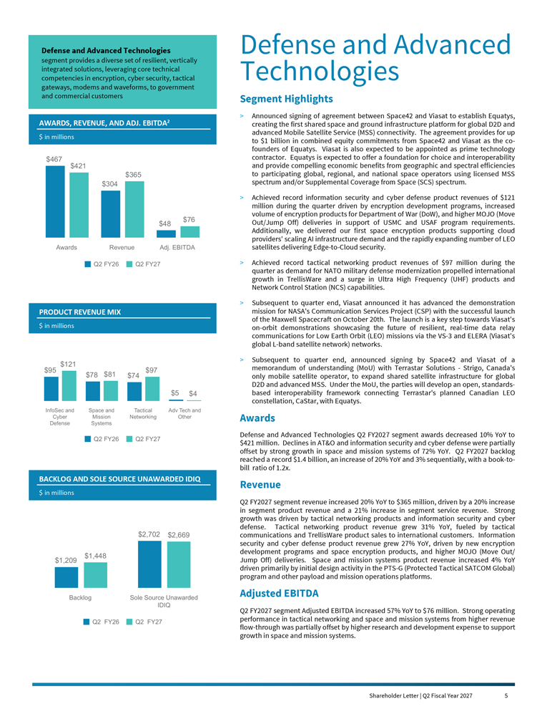
Defense and Advanced Technologies Segment Highlights > Announced signing of agreement between Space42 and Viasat to establish Equatys, creating the first shared space and ground infrastructure platform for global D2D and advanced Mobile Satellite Service (MSS) connectivity. The agreement provides for up to $1 billion in combined equity commitments from Space42 and Viasat as the cofounders of Equatys. Viasat is also expected to be appointed as prime technology contractor. Equatys is expected to offer a foundation for choice and interoperability and provide compelling economic benefits from geographic and spectral efficiencies to participating global, regional, and national space operators using licensed MSS spectrum and/or Supplemental Coverage from Space (SCS) spectrum. > Achieved record information security and cyber defense product revenues of $121 million during the quarter driven by encryption development programs, increased volume of encryption products for Department of War (DoW), and higher MOJO (Move Out/Jump Off) deliveries in support of USMC and USAF program requirements. Additionally, we delivered our first space encryption products supporting cloud providers’ scaling AI infrastructure demand and the rapidly expanding number of LEO satellites delivering Edge-to-Cloud security. > Achieved record tactical networking product revenues of $97 million during the quarter as demand for NATO military defense modernization propelled international growth in TrellisWare and a surge in Ultra High Frequency (UHF) products and Network Control Station (NCS) capabilities. > Subsequent to quarter end, Viasat announced it has advanced the demonstration mission for NASA’s Communication Services Project (CSP) with the successful launch of the Maxwell Spacecraft on October 20th. The launch is a key step towards Viasat’s on-orbit demonstrations showcasing the future of resilient, real-time data relay communications for Low Earth Orbit (LEO) missions via the VS-3 and ELERA (Viasat’s global L-band satellite network) networks. > Subsequent to quarter end, announced signing by Space42 and Viasat of a memorandum of understanding (MoU) with Terrastar Solutions - Strigo, Canada’s only mobile satellite operator, to expand shared satellite infrastructure for global D2D and advanced MSS. Under the MoU, the parties will develop an open, standardsbased interoperability framework connecting Terrastar’s planned Canadian LEO constellation, CaStar, with Equatys. Awards Defense and Advanced Technologies Q2 FY2027 segment awards decreased 10% YoY to $421 million. Declines in AT&O and information security and cyber defense were partially offset by strong growth in space and mission systems of 72% YoY. Q2 FY2027 backlog reached a record $1.4 billion, an increase of 20% YoY and 3% sequentially, with a book-tobill ratio of 1.2x. Revenue Q2 FY2027 segment revenue increased 20% YoY to $365 million, driven by a 20% increase in segment product revenue and a 21% increase in segment service revenue. Strong growth was driven by tactical networking products and information security and cyber defense. Tactical networking product revenue grew 31% YoY, fueled by tactical communications and TrellisWare product sales to international customers. Information security and cyber defense product revenue grew 27% YoY, driven by new encryption development programs and space encryption products, and higher MOJO (Move Out/ Jump Off) deliveries. Space and mission systems product revenue increased 4% YoY driven primarily by initial design activity in the PTS-G (Protected Tactical SATCOM Global) program and other payload and mission operations platforms. Adjusted EBITDA Q2 FY2027 segment Adjusted EBITDA increased 57% YoY to $76 million. Strong operating performance in tactical networking and space and mission systems from higher revenue flow-through was partially offset by higher research and development expense to support growth in space and mission systems. Shareholder Letter | Q2 Fiscal Year 2027 5 $467 $304 $48 $421 $365 $76 Q2 FY26 Q2 FY27 Awards Revenue Adj. EBITDA $95 $78 $74 $5 $121 $81 $97 $4 Q2 FY26 Q2 FY27 InfoSec and Cyber Defense Space and Mission Systems Tactical Networking Adv Tech and Other BACKLOG AND SOLE SOURCE UNAWARDED IDIQ $ in millions $1,209 $2,702 $1,448 $2,669 Q2 FY26 Q2 FY27 Backlog Sole Source Unawarded IDIQ PRODUCT REVENUE MIX $ in millions AWARDS, REVENUE, AND ADJ. EBITDA2 $ in millions Defense and Advanced Technologies segment provides a diverse set of resilient, vertically integrated solutions, leveraging core technical competencies in encryption, cyber security, tactical gateways, modems and waveforms, to government and commercial customers

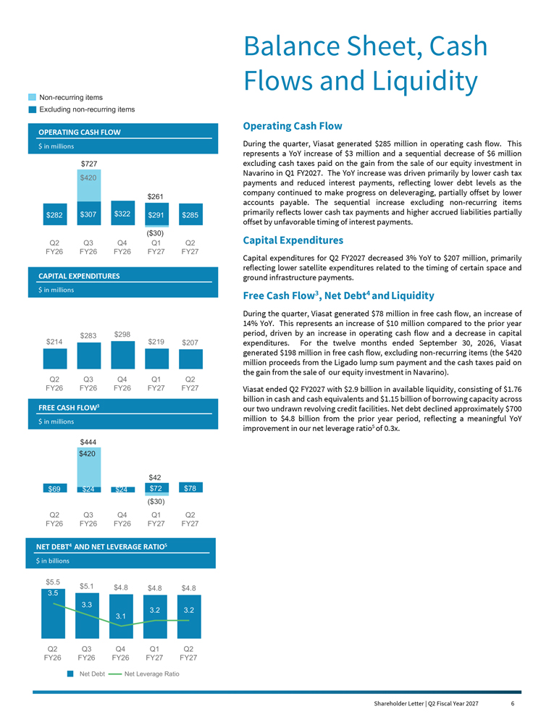
Balance Sheet, Cash Flows and Liquidity Operating Cash Flow During the quarter, Viasat generated $285 million in operating cash flow. This represents a YoY increase of $3 million and a sequential decrease of $6 million excluding cash taxes paid on the gain from the sale of our equity investment in Navarino in Q1 FY2027. The YoY increase was driven primarily by lower cash tax payments and reduced interest payments, reflecting lower debt levels as the company continued to make progress on deleveraging, partially offset by lower accounts payable. The sequential increase excluding non-recurring items primarily reflects lower cash tax payments and higher accrued liabilities partially offset by unfavorable timing of interest payments. Capital Expenditures Capital expenditures for Q2 FY2027 decreased 3% YoY to $207 million, primarily reflecting lower satellite expenditures related to the timing of certain space and ground infrastructure payments. Free Cash Flow3, Net Debt4 and Liquidity During the quarter, Viasat generated $78 million in free cash flow, an increase of 14% YoY. This represents an increase of $10 million compared to the prior year period, driven by an increase in operating cash flow and a decrease in capital expenditures. For the twelve months ended September 30, 2026, Viasat generated $198 million in free cash flow, excluding non-recurring items (the $420 million proceeds from the Ligado lump sum payment and the cash taxes paid on the gain from the sale of our equity investment in Navarino). Viasat ended Q2 FY2027 with $2.9 billion in available liquidity, consisting of $1.76 billion in cash and cash equivalents and $1.15 billion of borrowing capacity across our two undrawn revolving credit facilities. Net debt declined approximately $700 million to $4.8 billion from the prior year period, reflecting a meaningful YoY improvement in our net leverage ratio5 of 0.3x. Shareholder Letter | Q2 Fiscal Year 2027 6 OPERATING CASH FLOW $ in millions $282 $307 $322 $291 $285 $420 Q2 FY26 Q3 FY26 Q4 FY26 Q1 FY27 Q2 FY27 CAPITAL EXPENDITURES $ in millions $214 $283 $298 $219 $207 Q2 FY26 Q3 FY26 Q4 FY26 Q1 FY27 Q2 FY27 NET DEBT4 AND NET LEVERAGE RATIO5 $ in billions FREE CASH FLOW3 $ in millions $69 $78 Q2 FY26 Q3 FY26 Q4 FY26 Q1 FY27 Q2 FY27 $727 $420 Non-recurring items Excluding non-recurring items ($30) $261 $42 ($30) $24 $72 $444 $5.5 $5.1 $4.8 3.5 $4.8 $4.8 3.3 3.1 3.2 3.2 Net Debt Net Leverage Ratio Q2 FY26 Q3 FY26 Q4 FY26 Q1 FY27 Q2 FY27 $24


Outlook As we look ahead, we remain encouraged by the trends we are seeing across our portfolio. The first half of fiscal year 2027 unfolded largely consistent with our expectations, including stronger-than-anticipated momentum in Defense and Advanced Technologies offsetting greater pressure in portions of Communication Services. Importantly, we believe the underlying drivers of our strategy are becoming increasingly visible in our results. The combination of growing demand for resilient communications, secure networking, cybersecurity, mission systems, and space-enabled infrastructure continues to expand our opportunity set across both government and commercial markets. We continue to expect a stronger second half of the fiscal year supported by our backlog, recent contract awards, expanding pipeline, and the ongoing integration of new capabilities across our portfolio. Momentum in Defense and Advanced Technologies remains particularly encouraging. Record segment backlog and strong award activity provide further evidence that our technology investments are aligned with evolving customer priorities. Revenue and Adjusted EBITDA: We continue to expect mid-single-digit YoY revenue growth in FY2027 and now anticipate Adjusted EBITDA to be about flat YoY, with stronger growth in second half of the fiscal year supported by our backlog, new orders, and ongoing pipeline. Communication Services Segment: We now expect FY2027 segment revenue to be flattish, driven by continued growth in aviation services, offset by a decline in FS&O. Defense and Advanced Technologies Segment: We now expect FY2027 segment revenue growth in the mid-to-high teens YoY, driven primarily by strong growth in information security and cyber defense, as well as tactical networking and space and mission systems. Net Debt: We expect net leverage ratio to decrease slightly by the end of FY2027. Capital Expenditures: We now expect FY2027 capital expenditures of between $850 million and $900 million, including approximately $250 to $300 million for Inmarsat related capital expenditures. Operating and Free Cash Flow: For FY2027, we continue to expect operating cash flow to be flat YoY with free cash flow generated now expected to improve to more than $225 million. Our free cash flow guidance excludes the benefit of the Ligado lump sum payments in both periods, as they are non-recurring. Competition is increasing in certain parts of our portfolio, and we expect market dynamics to continue evolving. However, we believe those challenges are more than balanced by the opportunities created through growing government demand, increasing convergence between commercial and national security markets, expansion of multi-orbit architectures, and new applications enabled by our spectrum access, satellite, networking, and cybersecurity assets. We believe Viasat is uniquely positioned at the intersection of these trends. Looking beyond fiscal year 2027, we believe the investments we have made over the past several years are creating a stronger foundation for growth, cash generation, and value creation. Our priorities remain clear: drive growth in attractive markets, monetize our strategic assets, improve capital efficiency, maintain financial discipline, and create sustainable long-term value for our shareholders. Thank you for your continued confidence, partnership, and support. Shareholder Letter | Q2 Fiscal Year 2027 7


Endnotes 1. Net income (loss) as used herein is defined as net income (loss) attributable to Viasat, Inc. common stockholders. 2. Adjusted EBITDA is defined as net income (loss) attributable to Viasat, Inc. before interest, income taxes, depreciation and amortization, as further adjusted to exclude certain non-cash items and non-recurring expenses such as stock-based compensation expense, acquisition and transaction related expenses, loss or gain on disposition of certain assets and/or related businesses, product lines or other similar investments, loss or gain on debt extinguishment, non-recurring impairment of satellites and networking assets, and loss or gain on unrealized foreign currency. A reconciliation of Adjusted EBITDA to its closest GAAP equivalent is provided at the end of this letter under “Non- GAAP Financial Reconciliation.” See “Use of Non-GAAP Financial Information” for additional information. 3. Free cash flow is defined as net cash provided by (used in) operating activities less capital expenditures (purchase of property, equipment and satellites, and other assets). A reconciliation of free cash flow to its closest GAAP equivalent is provided at the end of this letter under “Non-GAAP Financial Reconciliation.” See “Use of Non-GAAP Financial Information” for additional financial information. 4. Net debt is defined as total debt less cash and cash equivalents and short-term investments. A reconciliation of net debt to its closest GAAP equivalent is provided at the end of this letter under “Non-GAAP Financial Reconciliation.” See “Use of Non-GAAP Financial Information” for additional financial information. 5. Net leverage ratio is defined as the ratio of net debt to LTM Adjusted EBITDA. A reconciliation of net leverage ratio to its closest GAAP equivalent is provided at the end of this letter under “Non-GAAP Financial Reconciliation.” See “Use of Non-GAAP Financial Information” for additional financial information. 6. Non-GAAP net income (loss) attributable to Viasat, Inc. excludes the effects of amortization of acquired intangible assets, stock-based compensation expense, acquisition and transaction related expenses, loss or gain on disposition of certain assets and/or related businesses, product lines or other similar investments, loss or gain on debt extinguishment, non-recurring impairment of satellites and networking assets, loss or gain on unrealized foreign currency and income tax effect. Shareholder Letter | Q2 Fiscal Year 2027 8


Forward-Looking Statements This shareholder letter contains forward-looking statements regarding future events and our future results that are subject to the safe harbors created under the Securities Act of 1933 and the Securities Exchange Act of 1934. Forward-looking statements include, among others, statements regarding projections of earnings, revenue, awards, backlog, Adjusted EBITDA, net leverage, net debt, operating cash flow, free cash flow, capital expenditures, investments, costs, return on capital or other financial items, including financial guidance and outlook and expectations for performance and results of operations in FY2027 and beyond; anticipated trends in our business or key markets; growth opportunities and the acceleration and durability of growth in our businesses, including potential space technology awards and growth in our multi-orbit aviation service and L- and S-Band MSS offerings; statements regarding Equatys, including our role as prime technology contractor and our expected funding commitments; ability to successfully compete in our target markets, and durability or strengthening of competitive advantages; building shareholder value and strategic initiatives, including with respect to reductions in capital intensity and debt; the construction, completion, testing, launch, commencement of service, expected performance and benefits of satellites and satellite payloads (including satellites planned or under construction) and the timing thereof; the expected capacity, coverage, service speeds and other features of our satellites, and the cost, economics and benefits associated therewith; anticipated subscriber growth; development, introduction and integration of multi-orbit capabilities and terminals; the ability to capitalize on backlog and awards received and unawarded IDIQ contract vehicles; future economic conditions; the development, customer acceptance and anticipated performance of our technologies, products or services, including offerings on our VS-3 satellites; our plans, objectives and strategies for future operations; our ability to drive capital efficiency and improve resource utilization; the number of additional aircraft or vessels anticipated to be put into service with our connectivity systems; and other characterizations of future events or circumstances, are forward-looking statements. Readers are cautioned that these forward-looking statements are only predictions and are subject to risks, uncertainties and assumptions that are difficult to predict. Factors that could cause actual results to differ materially include: our ability to realize the anticipated benefits of any existing or future satellite; unexpected expenses related to our satellite projects; risks associated with the construction, launch and operation of satellites, including the effect of any anomaly, launch, operational or deployment failure or degradation in satellite performance; capacity constraints in our business in the lead-up to the launch of services on new satellites; increasing levels of competition in our target markets; our ability to successfully implement our business plan on our anticipated timeline or at all, including our ability to secure awards in our DAT segment at the levels we project; our ability to successfully develop, introduce and sell new technologies, products and services; audits by the U.S. Government; changes in the global business environment and economic conditions (including U.S. Government shutdowns); delays in approving U.S. Government budgets and cuts in government defense expenditures; our reliance on U.S. Government contracts, and on a small number of contracts which account for a significant percentage of our revenues; reduced demand for products and services as a result of continued constraints on capital spending by customers; changes in relationships with, or the financial condition of, key customers or suppliers; our reliance on a limited number of third parties to manufacture and supply our products; introduction of new technologies and other factors affecting the communications and defense industries generally; the effect of adverse regulatory changes (including changes affecting spectrum availability or permitted uses) on our ability to sell or deploy our products and services; changes in the way others use spectrum; our inability to access additional spectrum, use spectrum for additional purposes, and/or operate satellites at additional orbital locations; competing uses of the same spectrum or orbital locations that we utilize or seek to utilize; the effect of changes to global tax laws; our level of indebtedness and ability to comply with applicable debt covenants; our involvement in litigation, including intellectual property claims and litigation to protect our proprietary technology; any dispute with Ligado regarding the terms of the Ligado settlement; and our dependence on a limited number of key employees. In addition, please refer to the risk factors contained in our SEC filings available at www.sec.gov, including our most recent Annual Report on Form 10-K and Quarterly Reports on Form 10-Q. Readers are cautioned not to place undue reliance on any forward-looking statements, which speak only as of the date on which they are made. We undertake no obligation to revise or update any forward-looking statements for any reason. Shareholder Letter | Q2 Fiscal Year 2027 9

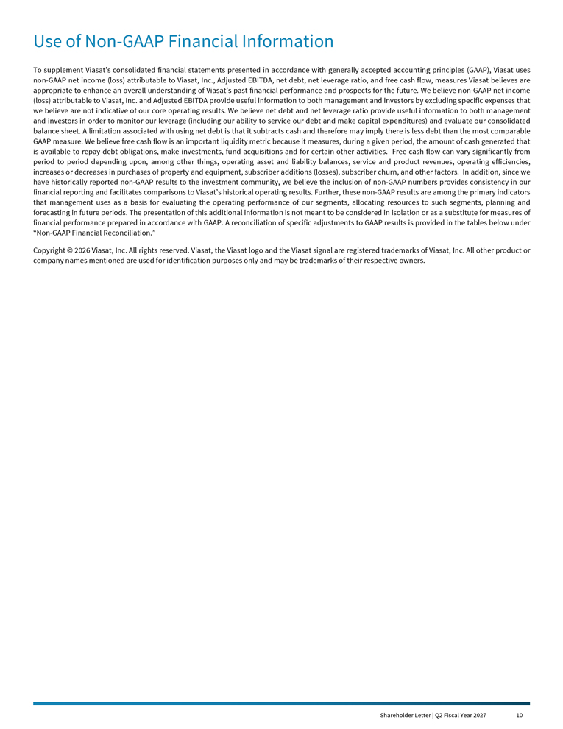
Use of Non-GAAP Financial Information To supplement Viasat’s consolidated financial statements presented in accordance with generally accepted accounting principles (GAAP), Viasat uses non-GAAP net income (loss) attributable to Viasat, Inc., Adjusted EBITDA, net debt, net leverage ratio, and free cash flow, measures Viasat believes are appropriate to enhance an overall understanding of Viasat’s past financial performance and prospects for the future. We believe non-GAAP net income (loss) attributable to Viasat, Inc. and Adjusted EBITDA provide useful information to both management and investors by excluding specific expenses that we believe are not indicative of our core operating results. We believe net debt and net leverage ratio provide useful information to both management and investors in order to monitor our leverage (including our ability to service our debt and make capital expenditures) and evaluate our consolidated balance sheet. A limitation associated with using net debt is that it subtracts cash and therefore may imply there is less debt than the most comparable GAAP measure. We believe free cash flow is an important liquidity metric because it measures, during a given period, the amount of cash generated that is available to repay debt obligations, make investments, fund acquisitions and for certain other activities. Free cash flow can vary significantly from period to period depending upon, among other things, operating asset and liability balances, service and product revenues, operating efficiencies, increases or decreases in purchases of property and equipment, subscriber additions (losses), subscriber churn, and other factors. In addition, since we have historically reported non-GAAP results to the investment community, we believe the inclusion of non-GAAP numbers provides consistency in our financial reporting and facilitates comparisons to Viasat’s historical operating results. Further, these non-GAAP results are among the primary indicators that management uses as a basis for evaluating the operating performance of our segments, allocating resources to such segments, planning and forecasting in future periods. The presentation of this additional information is not meant to be considered in isolation or as a substitute for measures of financial performance prepared in accordance with GAAP. A reconciliation of specific adjustments to GAAP results is provided in the tables below under “Non-GAAP Financial Reconciliation.” Copyright © 2026 Viasat, Inc. All rights reserved. Viasat, the Viasat logo and the Viasat signal are registered trademarks of Viasat, Inc. All other product or company names mentioned are used for identification purposes only and may be trademarks of their respective owners. Shareholder Letter | Q2 Fiscal Year 2027 10

Second Quarter Fiscal Year 2027 Results
Financial Results

(Unaudited)  (In millions, except per  share data) |  | Q2FY27 |  |  |  | Q2FY26 |  |  |  | Year-Over-Year  Change |  |  |  | First 6 Months  FY27 |  |  |  | First 6 Months  FY26 |  |  |  | Year-Over-Year  Change
Revenues |  |  | $1,180.0 |  |  |  | $1,140.9 |  |  |  | 3% |  |  |  | $2,336.5 |  |  |  | $2,311.9 |  |  |  | 1%
Net income (loss) (1) |  |  | ($128.7) |  |  |  | ($61.4) |  |  |  | 109% |  |  |  | ($180.4) |  |  |  | ($117.9) |  |  |  | 53%
Non-GAAP net income (loss) (1), (6) |  |  | ($44.9) |  |  |  | $12.6 |  |  |  | * |  |  |  | ($20.4) |  |  |  | $35.7 |  |  |  | *
Adjusted EBITDA (7) |  |  | $369.9 |  |  |  | $384.7 |  |  |  | (4)% |  |  |  | $751.1 |  |  |  | $793.2 |  |  |  | (5)%
Diluted per share net income (loss) (1) |  |  | ($0.93) |  |  |  | ($0.45) |  |  |  | 107% |  |  |  | ($1.31) |  |  |  | ($0.88) |  |  |  | 49%
Non-GAAP diluted per share net income (loss) (1), (2) |  |  | ($0.32) |  |  |  | $0.09 |  |  |  | * |  |  |  | ($0.15) |  |  |  | $0.26 |  |  |  | *
Fully diluted weighted average shares (2) |  |  | 138.6 |  |  |  | 135.1 |  |  |  | 3% |  |  |  | 137.9 |  |  |  | 133.4 |  |  |  | 3%
New contract awards (3) |  |  | $1,137.8 |  |  |  | $1,497.7 |  |  |  | (24)% |  |  |  | $2,435.9 |  |  |  | $2,680.5 |  |  |  | (9)%
Backlog (4) |  |  | $4,166.4 |  |  |  | $3,886.4 |  |  |  | 7% |  |  |  | $4,166.4 |  |  |  | $3,886.4 |  |  |  | 7%
Segment Results
(Unaudited)  (In millions) |  |  | Q2FY27 |  |  |  | Q2FY26 |  |  |  | Year-Over-Year  Change |  |  |  | First 6 Months  FY27 |  |  |  | First 6 Months  FY26 |  |  |  | Year-Over-Year  Change
Communication Services
New contract awards (3) |  |  | $716.7 |  |  |  | $1,031.0 |  |  |  | (30)% |  |  |  | $1,490.8 |  |  |  | $1,785.4 |  |  |  | (17)%
Revenues |  |  | $814.5 |  |  |  | $836.7 |  |  |  | (3)% |  |  |  | $1,639.6 |  |  |  | $1,664.0 |  |  |  | (1)%
Operating profit (loss) (5) |  |  | $23.5 |  |  |  | $71.4 |  |  |  | (67)% |  |  |  | $86.0 |  |  |  | $112.3 |  |  |  | (23)%
Adjusted EBITDA (8) |  |  | $294.1 |  |  |  | $336.5 |  |  |  | (13)% |  |  |  | $605.4 |  |  |  | $658.0 |  |  |  | (8)%
Defense and Advanced Technologies
New contract awards (3) |  |  | $421.2 |  |  |  | $466.8 |  |  |  | (10)% |  |  |  | $945.1 |  |  |  | $895.0 |  |  |  | 6%
Revenues |  |  | $365.5 |  |  |  | $304.2 |  |  |  | 20% |  |  |  | $696.9 |  |  |  | $647.9 |  |  |  | 8%
Operating profit (loss) (5) |  |  | $48.6 |  |  |  | $29.5 |  |  |  | 65% |  |  |  | $98.5 |  |  |  | $101.0 |  |  |  | (2)%
Adjusted EBITDA (8) |  |  | $75.9 |  |  |  | $48.2 |  |  |  | 57% |  |  |  | $145.7 |  |  |  | $135.2 |  |  |  | 8%

(1) | Attributable to Viasat, Inc. common stockholders.

(2) | As the three and six months ended September 30, 2026 and September 30, 2025 financial information resulted in a net loss, the weighted average number of shares used to calculate basic and diluted net loss per share is the same, as diluted shares would be anti-dilutive. However, as the non-GAAP financial information for the three and six months ended September 30, 2025 resulted in non-GAAP net income, 137.5 million and 136.5 million, respectively, diluted weighted average number of shares were used instead to calculate non-GAAP diluted net income per share.

(3) | Awards exclude future revenue under recurring consumer commitment arrangements.

(4) | Amounts include certain backlog adjustments due to contract changes and amendments. Our backlog includes contracts with subscribers for fixed broadband services in our Communication Services segment. Backlog does not include anticipated purchase orders and requests for the installation of in-flight connectivity systems or future recurring in-flight internet service revenues under our commercial in-flight internet agreements in our Communication Services segment.

(5) | Before corporate.

(6) | Beginning in the first quarter of fiscal year 2027, the Company revised its calculation of Non-GAAP net income (loss) to exclude unrealized foreign currency loss (gain), net, which is included within “Other, net” in the reconciliation of net income (loss) attributable to Viasat, Inc. to Non-GAAP net income (loss) attributable to Viasat, Inc. This amount reflects non-cash period-end remeasurement of foreign currency-denominated monetary assets and liabilities and is not considered by management to be indicative of core operating performance. For the three months ended September 30, 2026 and September 30, 2025, unrealized foreign currency loss (gain), net was a gain of $1.4 million and a gain of $0.9 million, respectively. For the six months ended September 30, 2026 and September 30, 2025, unrealized foreign currency loss (gain), net was a gain of $2.3 million and a loss of $8.8 million, respectively. Prior period amounts have not been revised to conform to the current presentation because the overall effect for the fiscal year was not material. As a result, Non-GAAP net income (loss) for the three and six months ended September 30, 2025 includes unrealized foreign currency loss (gain), net, and had it been excluded, Non-GAAP net income (loss) attributable to Viasat, Inc., including the income tax effect, would have been $12.0 million and $42.3 million, respectively.

(7) | Beginning in the first quarter of fiscal year 2027, the Company revised its calculation of Adjusted EBITDA to exclude unrealized foreign currency loss (gain), net, which is included within “Other, net” in the reconciliation of net income (loss) attributable to Viasat, Inc. to Adjusted EBITDA. This amount reflects non-cash period-end remeasurement of foreign currency-denominated monetary assets and liabilities and is not considered by management to be indicative of core operating performance. For the three months ended September 30, 2026 and September 30, 2025, unrealized foreign currency loss (gain), net was a gain of $1.4 million and a gain of $0.9 million, respectively. For the six months ended September 30, 2026 and September 30, 2025, unrealized foreign currency loss (gain), net was a gain of $2.3 million and a loss of $8.8 million, respectively. Prior period amounts have not been revised to conform to the current presentation because the overall effect for the fiscal year was not material. As a result, Adjusted EBITDA for the three and six months ended September 30, 2025 includes unrealized foreign currency loss (gain), net, and had it been excluded, Adjusted EBITDA would have been $383.8 million and $801.9 million, respectively.

(8) | Beginning in the first quarter of fiscal year 2027, the Company excludes unrealized foreign currency loss (gain), net from Adjusted EBITDA for the Communication Services and Defense and Advanced Technologies segments. For the three months ended September 30, 2026 and September 30, 2025, unrealized foreign currency loss (gain), net for the Communication Services segment was a gain of $1.1 million and a gain of $0.9 million, respectively, and for the Defense and Advanced Technologies segment was a gain of $0.3 million and nil, respectively. For the six months ended September 30, 2026 and September 30, 2025, unrealized foreign currency loss (gain), net for the Communication Services segment was a gain of $2.0 million and a loss of $8.8 million, respectively, and for the Defense and Advanced Technologies segment was a gain of $0.3 million and nil, respectively. Prior period amounts have not been revised to conform to the current presentation because the overall effect for the fiscal year was not material. Accordingly, Adjusted EBITDA for the Communication Services and Defense and Advanced Technologies segments for the three and six months ended September 30, 2025 includes unrealized foreign currency loss (gain), net, and had it been excluded, Adjusted EBITDA would have been $335.6 million, $666.8 million and $48.2 million, $135.2 million, respectively.

* | Percentage not meaningful.
Note: Some totals may not foot due to rounding.

Shareholder Letter | Q2 Fiscal Year 2027 11

Second Quarter Fiscal Year 2027 Results (cont.)

Condensed Consolidated Statements of Operations
(Unaudited)
(In thousands, except per share data)

 |  | Three months ended |  |  |  |  |  |  |  | Six months ended
 |  | September 30, 2026 |  |  |  | September 30, 2025 |  |  |  | September 30, 2026 |  |  |  | September 30, 2025
Revenues:
Service revenues |  | $ | 820,595 |  |  | $ | 821,510 |  |  | $ | 1,653,033 |  |  | $ | 1,647,880
Product revenues |  |  | 359,401 |  |  |  | 319,383 |  |  |  | 683,506 |  |  |  | 664,067
Total revenues |  |  | 1,179,996 |  |  |  | 1,140,893 |  |  |  | 2,336,539 |  |  |  | 2,311,947
Operating expenses:
Cost of service revenues |  |  | 526,197 |  |  |  | 514,893 |  |  |  | 1,039,331 |  |  |  | 1,043,127
Cost of product revenues |  |  | 274,853 |  |  |  | 241,108 |  |  |  | 505,421 |  |  |  | 474,490
Selling, general and administrative |  |  | 247,022 |  |  |  | 241,785 |  |  |  | 502,046 |  |  |  | 504,617
Independent research and development |  |  | 59,768 |  |  |  | 42,263 |  |  |  | 105,259 |  |  |  | 76,456
Amortization of acquired intangible assets |  |  | 65,007 |  |  |  | 65,069 |  |  |  | 130,025 |  |  |  | 130,810
Income (loss) from operations |  |  | 7,149 |  |  |  | 35,775 |  |  |  | 54,457 |  |  |  | 82,447
Interest (expense) income, net |  |  | (86,595 | ) |  |  | (80,962 | ) |  |  | (153,508 | ) |  |  | (167,029 | )
(Loss) gain on extinguishment of debt, net |  |  | — |  |  |  | — |  |  |  | — |  |  |  | (288 | )
Other income (expense), net |  |  | 92 |  |  |  | — |  |  |  | (214 | ) |  |  | (5,164 | )
Income (loss) before income taxes |  |  | (79,354 | ) |  |  | (45,187 | ) |  |  | (99,265 | ) |  |  | (90,034 | )
(Provision for) benefit from income taxes |  |  | (40,786 | ) |  |  | (10,862 | ) |  |  | (63,897 | ) |  |  | (17,472 | )
Equity in income (loss) of unconsolidated affiliates, net |  |  | 263 |  |  |  | 4,222 |  |  |  | 491 |  |  |  | 7,955
Net income (loss) |  |  | (119,877 | ) |  |  | (51,827 | ) |  |  | (162,671 | ) |  |  | (99,551 | )
Less: net income (loss) attributable to noncontrolling interest, net of tax |  |  | 8,778 |  |  |  | 9,617 |  |  |  | 17,725 |  |  |  | 18,327
Net income (loss) attributable to Viasat, Inc. |  | $ | (128,655 | ) |  | $ | (61,444 | ) |  | $ | (180,396 | ) |  | $ | (117,878 | )
Diluted net income (loss) per share attributable to Viasat, Inc. common stockholders |  | $ | (0.93 | ) |  | $ | (0.45 | ) |  | $ | (1.31 | ) |  | $ | (0.88 | )
Diluted common equivalent shares (1) |  |  | 138,641 |  |  |  | 135,119 |  |  |  | 137,893 |  |  |  | 133,356
AN ITEMIZED RECONCILIATION BETWEEN NET INCOME (LOSS) ATTRIBUTABLE TO VIASAT, INC.
ON A GAAP BASIS AND NON-GAAP BASIS IS AS FOLLOWS:
(Unaudited)
(In thousands, except per share data) |  | Three months ended |  |  |  |  |  |  |  | Six months ended
 |  | September 30, 2026 |  |  |  | September 30, 2025 |  |  |  | September 30, 2026 |  |  |  | September 30, 2025
GAAP net income (loss) attributable to Viasat, Inc. |  | $ | (128,655 | ) |  | $ | (61,444 | ) |  | $ | (180,396 | ) |  | $ | (117,878 | )
Amortization of acquired intangible assets |  |  | 65,007 |  |  |  | 65,069 |  |  |  | 130,025 |  |  |  | 130,810
Stock-based compensation expense |  |  | 34,168 |  |  |  | 20,122 |  |  |  | 58,359 |  |  |  | 34,829
Acquisition and transaction related expenses (2) |  |  | 3,133 |  |  |  | 5,080 |  |  |  | 7,189 |  |  |  | 14,805
Loss (gain) on extinguishment of debt, net |  |  | — |  |  |  | — |  |  |  | — |  |  |  | 288
Other, net (5) |  |  | (1,479 | ) |  |  | — |  |  |  | (2,104 | ) |  |  | 5,164
Income tax effect (3) |  |  | (17,038 | ) |  |  | (16,196 | ) |  |  | (33,427 | ) |  |  | (32,293 | )
Non-GAAP net income (loss) attributable to Viasat, Inc. (6) |  | $ | (44,864 | ) |  | $ | 12,631 |  |  | $ | (20,354 | ) |  | $ | 35,725
Non-GAAP diluted net income (loss) per share attributable to Viasat, Inc. common stockholders |  | $ | (0.32 | ) |  | $ | 0.09 |  |  | $ | (0.15 | ) |  | $ | 0.26
Diluted common equivalent shares (1) |  |  | 138,641 |  |  |  | 137,528 |  |  |  | 137,893 |  |  |  | 136,465
AN ITEMIZED RECONCILIATION BETWEEN NET INCOME (LOSS) ATTRIBUTABLE TO VIASAT, INC.
AND ADJUSTED EBITDA IS AS FOLLOWS:
(Unaudited)
(In thousands) |  | Three months ended |  |  |  |  |  |  |  | Six months ended
 |  | September 30, 2026 |  |  |  | September 30, 2025 |  |  |  | September 30, 2026 |  |  |  | September 30, 2025
GAAP net income (loss) attributable to Viasat, Inc. |  | $ | (128,655 | ) |  | $ | (61,444 | ) |  | $ | (180,396 | ) |  | $ | (117,878 | )
Provision for (benefit from) income taxes |  |  | 40,786 |  |  |  | 10,862 |  |  |  | 63,897 |  |  |  | 17,472
Interest expense (income), net |  |  | 86,595 |  |  |  | 80,962 |  |  |  | 153,508 |  |  |  | 167,029
Depreciation and amortization (4) |  |  | 335,379 |  |  |  | 329,128 |  |  |  | 650,620 |  |  |  | 671,472
Stock-based compensation expense |  |  | 34,168 |  |  |  | 20,122 |  |  |  | 58,359 |  |  |  | 34,829
Acquisition and transaction related expenses (2) |  |  | 3,133 |  |  |  | 5,080 |  |  |  | 7,189 |  |  |  | 14,805
Loss (gain) on extinguishment of debt, net |  |  | — |  |  |  | — |  |  |  | — |  |  |  | 288
Other, net (5) |  |  | (1,479 | ) |  |  | — |  |  |  | (2,104 | ) |  |  | 5,164
Adjusted EBITDA (7) |  | $ | 369,927 |  |  | $ | 384,710 |  |  | $ | 751,073 |  |  | $ | 793,181

(1) | As the three and six months ended September 30, 2026 and September 30, 2025 financial information resulted in a net loss, the weighted average number of shares used to calculate basic and diluted net loss per share is the same, as diluted shares would be anti-dilutive. However, as the non-GAAP financial information for the three and six months ended September 30, 2025 resulted in non-GAAP net income, diluted weighted average number of shares were used instead to calculate non-GAAP diluted net income per share.

(2) | Costs typically consist of acquisition, integration, and disposition related costs.

(3) | The income tax effect is calculated using the tax rate applicable for the non-GAAP adjustments.

(4) | Including amortization of capitalized cloud computing implementation costs.

(5) | For the three and six months ended September 30, 2026, “Other, net” primarily consists of unrealized foreign currency loss (gain), net. Beginning in the first quarter of fiscal year 2027, the Company excludes unrealized foreign currency loss (gain), net from Non-GAAP net income (loss) attributable to Viasat, Inc. and Adjusted EBITDA because this item reflects non-cash period-end remeasurement of foreign currency-denominated monetary assets and liabilities and is not considered by management to be indicative of core operating performance. Prior period amounts have not been revised to conform to the current presentation because the overall effect for the fiscal year was not material. For the three months ended September 30, 2026 and September 30, 2025, unrealized foreign currency loss (gain), net was a gain of $1.4 million and a gain of $0.9 million, respectively. For the six months ended September 30, 2026 and September 30, 2025, unrealized foreign currency loss (gain), net was a gain of $2.3 million and a loss of $8.8 million, respectively.

(6) | Non-GAAP net income (loss) for the three and six months ended September 30, 2025 includes unrealized foreign currency loss (gain), net, and had it been excluded, Non-GAAP net income (loss) attributable to Viasat, Inc., including the income tax effect, would have been $12.0 million and $42.3 million, respectively. See endnote (6) to the shareholder letter for a definition of Non-GAAP net income (loss).

(7) | Adjusted EBITDA for the three and six months ended September 30, 2025 includes unrealized foreign currency loss (gain), net, and had it been excluded, Adjusted EBITDA would have been $383.8 million and $801.9 million, respectively.

Shareholder Letter | Q2 Fiscal Year 2027 12

Second Quarter Fiscal Year 2027 Results (cont.)

AN ITEMIZED RECONCILIATION BETWEEN SEGMENT OPERATING PROFIT (LOSS) BEFORE CORPORATE
AND ADJUSTED EBITDA IS AS FOLLOWS:
(Unaudited)
(In thousands)

 |  | $ |  |  |  | $ |  |  |  | $ |  |  |  | $ |  |  |  | $ |  |  |  | $
 |  | Three months ended September 30, 2026 |  |  |  |  |  |  |  |  |  |  |  | Three months ended September 30, 2025
 |  | Communication  Services  Segment |  |  |  | Defense and  Advanced  Technologies  Segment |  |  |  | Total |  |  |  | Communication  Services  Segment |  |  |  | Defense and  Advanced  Technologies  Segment |  |  |  | Total
Segment operating profit (loss) before corporate |  | $ | 23,539 |  |  | $ | 48,617 |  |  | $ | 72,156 |  |  | $ | 71,385 |  |  | $ | 29,459 |  |  | $ | 100,844
Depreciation (8) |  |  | 234,762 |  |  |  | 13,754 |  |  |  | 248,516 |  |  |  | 240,219 |  |  |  | 12,451 |  |  |  | 252,670
Stock-based compensation expense |  |  | 19,128 |  |  |  | 15,040 |  |  |  | 34,168 |  |  |  | 12,490 |  |  |  | 7,632 |  |  |  | 20,122
Other than acquired intangible assets amortization (4) |  |  | 15,172 |  |  |  | 6,684 |  |  |  | 21,856 |  |  |  | 4,739 |  |  |  | 6,650 |  |  |  | 11,389
Acquisition and transaction related expenses (2) |  |  | 2,184 |  |  |  | 949 |  |  |  | 3,133 |  |  |  | 3,480 |  |  |  | 1,600 |  |  |  | 5,080
Equity in income (loss) of unconsolidated affiliates, net |  |  | 263 |  |  |  | — |  |  |  | 263 |  |  |  | 4,222 |  |  |  | — |  |  |  | 4,222
Noncontrolling interest and other (9) |  |  | (980 | ) |  |  | (9,185 | ) |  |  | (10,165 | ) |  |  | (30 | ) |  |  | (9,587 | ) |  |  | (9,617 | )
Adjusted EBITDA (10) |  | $ | 294,068 |  |  | $ | 75,859 |  |  | $ | 369,927 |  |  | $ | 336,505 |  |  | $ | 48,205 |  |  | $ | 384,710
 |  | Six months ended September 30, 2026 |  |  |  |  |  |  |  |  |  |  |  | Six months ended September 30, 2025
 |  | Communication  Services  Segment |  |  |  | Defense and  Advanced  Technologies  Segment |  |  |  | Total |  |  |  | Communication  Services  Segment |  |  |  | Defense and  Advanced  Technologies  Segment |  |  |  | Total
Segment operating profit (loss) before corporate |  | $ | 85,968 |  |  | $ | 98,514 |  |  | $ | 184,482 |  |  | $ | 112,261 |  |  | $ | 100,996 |  |  | $ | 213,257
Depreciation (8) |  |  | 455,955 |  |  |  | 26,269 |  |  |  | 482,224 |  |  |  | 486,968 |  |  |  | 23,403 |  |  |  | 510,371
Stock-based compensation expense |  |  | 33,281 |  |  |  | 25,078 |  |  |  | 58,359 |  |  |  | 20,802 |  |  |  | 14,027 |  |  |  | 34,829
Other than acquired intangible assets amortization (4) |  |  | 26,406 |  |  |  | 11,965 |  |  |  | 38,371 |  |  |  | 18,748 |  |  |  | 11,543 |  |  |  | 30,291
Acquisition and transaction related expenses (2) |  |  | 5,074 |  |  |  | 2,115 |  |  |  | 7,189 |  |  |  | 11,354 |  |  |  | 3,451 |  |  |  | 14,805
Equity in income (loss) of unconsolidated affiliates, net |  |  | 491 |  |  |  | — |  |  |  | 491 |  |  |  | 7,955 |  |  |  | — |  |  |  | 7,955
Noncontrolling interest and other (9) |  |  | (1,815 | ) |  |  | (18,228 | ) |  |  | (20,043 | ) |  |  | (60 | ) |  |  | (18,267 | ) |  |  | (18,327 | )
Adjusted EBITDA (10) |  | $ | 605,360 |  |  | $ | 145,713 |  |  | $ | 751,073 |  |  | $ | 658,028 |  |  | $ | 135,153 |  |  | $ | 793,181

(8) | Depreciation expenses not specifically recorded in a particular segment have been allocated based on other indirect allocable costs, which management believes is a reasonable method.

(9) | Beginning in the first quarter of fiscal year 2027, the Company excludes unrealized foreign currency loss (gain), net from Adjusted EBITDA, which is included within “Noncontrolling interest and other” in the reconciliation of segment operating profit (loss) before corporate to Adjusted EBITDA. Prior period amounts have not been revised to conform to the current presentation because the overall effect for the fiscal year was not material. For the three months ended September 30, 2026 and September 30, 2025, unrealized foreign currency loss (gain), net for the Communication Services segment was a gain of $1.1 million and a gain of $0.9 million, respectively, and for the Defense and Advanced Technologies segment was a gain of $0.3 million and nil, respectively. For the six months ended September 30, 2026 and September 30, 2025, unrealized foreign currency loss (gain), net for the Communication Services segment was a gain of $2.0 million and a loss of $8.8 million, respectively, and for the Defense and Advanced Technologies segment was a gain of $0.3 million and nil, respectively.

(10) | Adjusted EBITDA for the Communication Services segment for the three and six months ended September 30, 2025 includes unrealized foreign currency loss (gain), net, and had it been excluded, Adjusted EBITDA would have been $335.6 million and $666.8 million, respectively. Adjusted EBITDA for the Defense and Advanced Technologies segment for the three and six months ended September 30, 2025 includes unrealized foreign currency loss (gain), net, and had it been excluded, Adjusted EBITDA would have been $48.2 million and $135.2 million, respectively.

Shareholder Letter | Q2 Fiscal Year 2027 13

Second Quarter Fiscal Year 2027 Results (cont.)

Condensed Consolidated Balance Sheets
(Unaudited)
(In thousands)

 |  | As of |  |  |  | As of
Assets |  | September 30, 2026 |  |  |  | March 31, 2026
Current assets:
Cash and cash equivalents |  | $ | 1,758,947 |  |  | $ | 1,746,835
Accounts receivable, net |  |  | 735,410 |  |  |  | 753,430
Inventories |  |  | 308,784 |  |  |  | 281,220
Prepaid expenses and other current assets |  |  | 334,595 |  |  |  | 342,522
Total current assets |  |  | 3,137,736 |  |  |  | 3,124,007
Property, equipment and satellites, net |  |  | 7,178,352 |  |  |  | 7,272,637
Operating lease right-of-use assets |  |  | 428,228 |  |  |  | 427,994
Acquired intangible assets, net |  |  | 1,866,896 |  |  |  | 1,997,436
Goodwill |  |  | 1,624,401 |  |  |  | 1,625,013
Other assets |  |  | 793,382 |  |  |  | 779,509
Total assets |  | $ | 15,028,995 |  |  | $ | 15,226,596

 |  | As of |  |  |  | As of
Liabilities and Equity |  | September 30, 2026 |  |  |  | March 31, 2026
Current liabilities:
Accounts payable |  | $ | 278,600 |  |  | $ | 288,154
Accrued and other liabilities |  |  | 961,676 |  |  |  | 951,192
Current portion of long-term debt |  |  | 659,078 |  |  |  | 57,753
Total current liabilities |  |  | 1,899,354 |  |  |  | 1,297,099
Senior notes |  |  | 3,071,712 |  |  |  | 3,664,848
Other long-term debt |  |  | 2,709,289 |  |  |  | 2,726,004
Non-current operating lease liabilities |  |  | 426,948 |  |  |  | 430,082
Other liabilities |  |  | 2,330,061 |  |  |  | 2,379,301
Total liabilities |  |  | 10,437,364 |  |  |  | 10,497,334
Total Viasat, Inc. stockholders’ equity |  |  | 4,505,104 |  |  |  | 4,660,301
Noncontrolling interest in subsidiary |  |  | 86,527 |  |  |  | 68,961
Total equity |  |  | 4,591,631 |  |  |  | 4,729,262
Total liabilities and equity |  | $ | 15,028,995 |  |  | $ | 15,226,596

Shareholder Letter | Q2 Fiscal Year 2027 14

Non-GAAP Financial Reconciliation

AN ITEMIZED RECONCILIATION BETWEEN NET INCOME (LOSS) ATTRIBUTABLE TO VIASAT, INC.
AND ADJUSTED EBITDA, AND TOTAL DEBT TO NET DEBT IS AS FOLLOWS:
(Unaudited)
(In thousands)

 |  | Three months ended
 |  | September 30, 2026 |  |  |  | June 30, 2026 |  |  |  | March 31, 2026 |  |  |  | December 31, 2025 |  |  |  | September 30, 2025
GAAP net income (loss) attributable to Viasat, Inc. |  | $ | (128,655 | ) |  | $ | (51,741 | ) |  | $ | 58,824 |  |  | $ | 24,968 |  |  | $ | (61,444 | )
Provision for (benefit from) income taxes |  |  | 40,786 |  |  |  | 23,111 |  |  |  | 40,081 |  |  |  | 58,670 |  |  |  | 10,862
Interest expense (income), net |  |  | 86,595 |  |  |  | 66,913 |  |  |  | 65,484 |  |  |  | (78,112 | ) |  |  | 80,962
Depreciation and amortization (4) |  |  | 335,379 |  |  |  | 315,241 |  |  |  | 347,327 |  |  |  | 340,360 |  |  |  | 329,128
Stock-based compensation expense |  |  | 34,168 |  |  |  | 24,191 |  |  |  | 22,142 |  |  |  | 24,099 |  |  |  | 20,122
Acquisition and transaction related expenses (2) |  |  | 3,133 |  |  |  | 4,056 |  |  |  | 4,062 |  |  |  | 5,525 |  |  |  | 5,080
Loss (gain) on extinguishment of debt, net |  |  | — |  |  |  | — |  |  |  | — |  |  |  | 11,647 |  |  |  | —
Other, net (11) |  |  | (1,479 | ) |  |  | (625 | ) |  |  | (168,062 | ) |  |  | (114 | ) |  |  | —
Adjusted EBITDA (12) |  | $ | 369,927 |  |  | $ | 381,146 |  |  | $ | 369,858 |  |  | $ | 387,043 |  |  | $ | 384,710
NET DEBT |  | As of
(In thousands) |  | September 30, 2026 |  |  |  | June 30, 2026 |  |  |  | March 31, 2026 |  |  |  | December 31, 2025 |  |  |  | September 30, 2025
Total debt |  | $ | 6,559,726 |  |  | $ | 6,570,503 |  |  | $ | 6,585,115 |  |  | $ | 6,406,911 |  |  | $ | 6,731,043
Less: cash and cash equivalents |  |  | 1,758,947 |  |  |  | 1,735,819 |  |  |  | 1,746,835 |  |  |  | 1,346,136 |  |  |  | 1,230,074
Net debt |  | $ | 4,800,779 |  |  | $ | 4,834,684 |  |  | $ | 4,838,280 |  |  | $ | 5,060,775 |  |  | $ | 5,500,969
NET LEVERAGE RATIO (NON-GAAP) (13)
(In thousands) |  | September 30, 2026 |  |  |  | June 30, 2026 |  |  |  | March 31, 2026 |  |  |  | December 31, 2025 |  |  |  | September 30, 2025
Net debt |  | $ | 4,800,779 |  |  | $ | 4,834,684 |  |  | $ | 4,838,280 |  |  | $ | 5,060,775 |  |  | $ | 5,500,969
LTM Adjusted EBITDA |  |  | 1,507,974 |  |  |  | 1,522,757 |  |  |  | 1,550,082 |  |  |  | 1,555,017 |  |  |  | 1,561,234
Net leverage ratio |  |  | 3.2 |  |  |  | 3.2 |  |  |  | 3.1 |  |  |  | 3.3 |  |  |  | 3.5
AN ITEMIZED RECONCILIATION BETWEEN NET CASH PROVIDED BY (USED IN) OPERATING ACTIVITIES
AND FREE CASH FLOW IS AS FOLLOWS:
(Unaudited)
(In thousands)

 |  | Three months ended
 |  | September 30, 2026 |  |  |  | June 30, 2026 |  |  |  | March 31, 2026 |  |  |  | December 31, 2025 |  |  |  | September 30, 2025
Net cash provided by (used in) operating activities |  | $ | 284,955 |  |  | $ | 260,550 |  |  | $ | 322,295 |  |  | $ | 726,888 |  |  | $ | 282,242
Purchase of property, equipment and satellites, and other assets (capital expenditures) |  |  | (206,689 | ) |  |  | (218,928 | ) |  |  | (298,341 | ) |  |  | (282,721 | ) |  |  | (213,699 | )
Free cash flow |  | $ | 78,266 |  |  | $ | 41,622 |  |  | $ | 23,954 |  |  | $ | 444,167 |  |  | $ | 68,543

(11) | Beginning in the first quarter of fiscal year 2027, the Company revised its calculation of Adjusted EBITDA to exclude unrealized foreign currency loss (gain), net, which is included within “Other, net.” For the three months ended September 30, 2026 and June 30, 2026, unrealized foreign currency loss (gain), net was a gain of $1.4 million and a gain of $0.9 million, respectively. Prior period amounts have not been revised to conform to the current presentation because the overall effect for the fiscal year was not material. For the three months ended March 31, 2026, December 31, 2025, and September 30, 2025, unrealized foreign currency loss (gain), net was a gain of $4.9 million, a gain of $1.1 million, and a gain of $0.9 million, respectively, and not included herein. For the three months ended March 31, 2026, “Other, net” consisted of a gain on the disposition of an equity method investment.

(12) | Adjusted EBITDA for the three months ended March 31, 2026, December 31, 2025, and September 30, 2025, would have been $364.9 million, $385.9 million, and $383.8 million, respectively, had unrealized foreign currency loss (gain), net been excluded.

(13) | The most comparable GAAP measure to net debt to LTM Adjusted EBITDA (net leverage ratio) is total debt to LTM net income (loss) attributable to Viasat, Inc. For September 30, 2026, June 30, 2026, March 31, 2026, December 31, 2025, and September 30, 2025, the total debt to LTM net income (loss) ratio was (67.9)x, (223.5)x, (193.2)x, (18.9)x, and (12.9)x, respectively, based on total debt of approximately $6.6 billion, $6.6 billion, $6.6 billion, $6.4 billion, and $6.7 billion, respectively, divided by LTM net loss attributable to Viasat, Inc. of approximately $96.6 million, $29.4 million, $34.1 million, $339.0 million, and $522.3 million, respectively.

Shareholder Letter | Q2 Fiscal Year 2027 15

Selected Segment Financial Information

(Unaudited)
(In thousands)

 |  | Three months ended |  |  |  |  |  |  |  | Six months ended
 |  | September 30, 2026 |  |  |  | September 30, 2025 |  |  |  | September 30, 2026 |  |  |  | September 30, 2025
Revenues:
Communication services
Aviation services |  | $ | 325,840 |  |  | $ | 300,732 |  |  | $ | 650,221 |  |  | $ | 593,624
Government satcom services |  |  | 203,103 |  |  |  | 195,800 |  |  |  | 414,837 |  |  |  | 387,568
Maritime services |  |  | 108,661 |  |  |  | 117,594 |  |  |  | 218,163 |  |  |  | 235,395
Fixed services and other services |  |  | 120,532 |  |  |  | 155,691 |  |  |  | 247,957 |  |  |  | 330,428
Total services |  |  | 758,136 |  |  |  | 769,817 |  |  |  | 1,531,178 |  |  |  | 1,547,015
Total products |  |  | 56,390 |  |  |  | 66,838 |  |  |  | 108,431 |  |  |  | 117,011
Total communication services revenues |  |  | 814,526 |  |  |  | 836,655 |  |  |  | 1,639,609 |  |  |  | 1,664,026
Defense and advanced technologies
Total services |  |  | 62,459 |  |  |  | 51,693 |  |  |  | 121,855 |  |  |  | 100,865
Information security and cyber defense products |  |  | 120,520 |  |  |  | 94,928 |  |  |  | 214,511 |  |  |  | 197,076
Space and mission systems products |  |  | 81,310 |  |  |  | 78,231 |  |  |  | 148,170 |  |  |  | 166,204
Tactical networking products |  |  | 96,982 |  |  |  | 74,193 |  |  |  | 189,552 |  |  |  | 142,472
Advanced technologies and other products |  |  | 4,199 |  |  |  | 5,193 |  |  |  | 22,842 |  |  |  | 41,304
Total products |  |  | 303,011 |  |  |  | 252,545 |  |  |  | 575,075 |  |  |  | 547,056
Total defense and advanced technologies revenues |  |  | 365,470 |  |  |  | 304,238 |  |  |  | 696,930 |  |  |  | 647,921
Elimination of intersegment revenues |  |  | — |  |  |  | — |  |  |  | — |  |  |  | —
Total revenues |  | $ | 1,179,996 |  |  | $ | 1,140,893 |  |  | $ | 2,336,539 |  |  | $ | 2,311,947

Shareholder Letter | Q2 Fiscal Year 2027 16

