SCHEDULE 14A INFORMATION
Proxy Statement Pursuant to Section 14(a) of the
Securities Exchange Act of 1934
Filed by the Registrant ☒
Filed by a Party other than the Registrant ☐
Check the appropriate box:
☐ Preliminary Proxy Statement
☐ Confidential, for Use of the Commission Only (as permitted by Rule 14a-6(e)(2))
☐ Definitive Proxy Statement
☒ Definitive Additional Materials
☐ Soliciting Material under Rule 14a-12


VIASAT, INC.
(Name of Registrant as Specified in its Charter)
(Name of Person(s) Filing Proxy Statement, if other than the Registrant)
Payment of Filing Fee (Check all boxes that apply):
☒ No fee required
☐ Fee paid previously with preliminary materials
☐ Fee computed on table in exhibit required by Item 25(b) per Exchange Act Rules 14a-6(i)(1) and 0-11


Q4FY22 SHAREHOLDER LETTER VIASAT TM

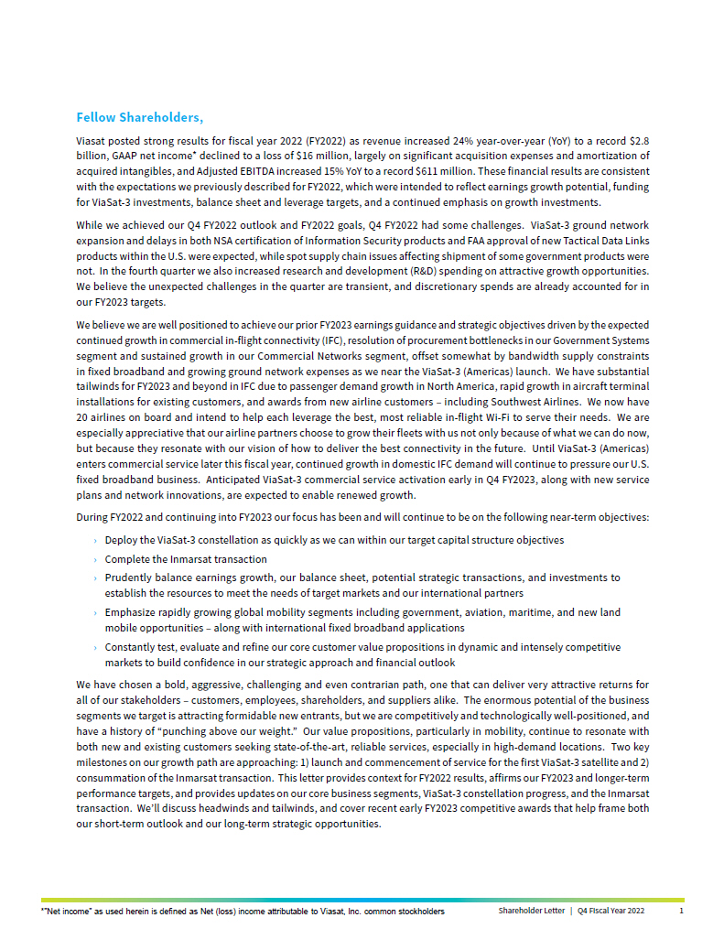
Fellow Shareholders, Viasat posted strong results for fiscal year 2022 (FY2022) as revenue increased 24% year-over-year (YoY) to a record $2.8 billion, GAAP net income* declined to a loss of $16 million, largely on significant acquisition expenses and amortization of acquired intangibles, and Adjusted EBITDA increased 15% YoY to a record $611 million. These financial results are consistent with the expectations we previously described for FY2022, which were intended to reflect earnings growth potential, funding for ViaSat-3 investments, balance sheet and leverage targets, and a continued emphasis on growth investments. While we achieved our Q4 FY2022 outlook and FY2022 goals, Q4 FY2022 had some challenges. ViaSat-3 ground network expansion and delays in both NSA certification of Information Security products and FAA approval of new Tactical Data Links products within the U.S. were expected, while spot supply chain issues affecting shipment of some government products were not. In the fourth quarter we also increased research and development (R&D) spending on attractive growth opportunities. We believe the unexpected challenges in the quarter are transient, and discretionary spends are already accounted for in our FY2023 targets. We believe we are well positioned to achieve our prior FY2023 earnings guidance and strategic objectives driven by the expected continued growth in commercial in-flight connectivity (IFC), resolution of procurement bottlenecks in our Government Systems segment and sustained growth in our Commercial Networks segment, offset somewhat by bandwidth supply constraints in fixed broadband and growing ground network expenses as we near the ViaSat-3 (Americas) launch. We have substantial tailwinds for FY2023 and beyond in IFC due to passenger demand growth in North America, rapid growth in aircraft terminal installations for existing customers, and awards from new airline customers  including Southwest Airlines. We now have 20 airlines on board and intend to help each leverage the best, most reliable in-flight Wi-Fi to serve their needs. We are especially appreciative that our airline partners choose to grow their fleets with us not only because of what we can do now, but because they resonate with our vision of how to deliver the best connectivity in the future. Until ViaSat-3 (Americas) enters commercial service later this fiscal year, continued growth in domestic IFC demand will continue to pressure our U.S. fixed broadband business. Anticipated ViaSat-3 commercial service activation early in Q4 FY2023, along with new service plans and network innovations, are expected to enable renewed growth. During FY2022 and continuing into FY2023 our focus has been and will continue to be on the following near-term objectives:  Deploy the ViaSat-3 constellation as quickly as we can within our target capital structure objectives  Complete the Inmarsat transaction Prudently balance earnings growth, our balance sheet, potential strategic transactions, and investments to establish the resources to meet the needs of target markets and our international partners  Emphasize rapidly growing global mobility segments including government, aviation, maritime, and new land mobile opportunities  along with international fixed broadband applications  Constantly test, evaluate and refine our core customer value propositions in dynamic and intensely competitive markets to build confidence in our strategic approach and financial outlook We have chosen a bold, aggressive, challenging and even contrarian path, one that can deliver very attractive returns for all of our stakeholders  customers, employees, shareholders, and suppliers alike. The enormous potential of the business segments we target is attracting formidable new entrants, but we are competitively and technologically well-positioned, and have a history of punching above our weight. Our value propositions, particularly in mobility, continue to resonate with both new and existing customers seeking state-of-the-art, reliable services, especially in high-demand locations. Two key milestones on our growth path are approaching: 1) launch and commencement of service for the first ViaSat-3 satellite and 2) consummation of the Inmarsat transaction. This letter provides context for FY2022 results, affirms our FY2023 and longer-term performance targets, and provides updates on our core business segments, ViaSat-3 constellation progress, and the Inmarsat transaction. Well discuss headwinds and tailwinds, and cover recent early FY2023 competitive awards that help frame both our short-term outlook and our long-term strategic opportunities. *Net income as used herein is defined as Net (loss) income attributable to Viasat, Inc. common stockholders Shareholder Letter | Q4 Fiscal Year 2022 1

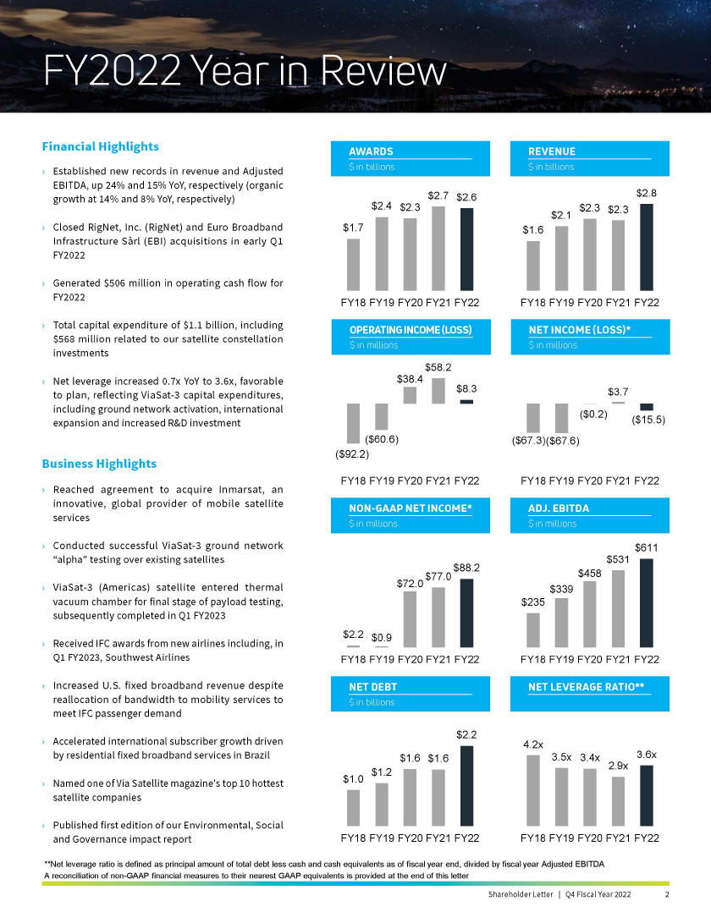
FY2022 Year in Review Financial Highlights AWARDS $ in billions $1.7 $2.4 $2.3 $2.7 $2.6 REVENUE $ in billions $1.6 $2.1 $2.3 $2.3 $2.8 Established new records in revenue and Adjusted EBITDA, up 24% and 15% YoY, respectively (organic growth at 14% and 8% YoY, respectively) Closed RigNet, Inc. (RigNet) and Euro Broadband Infrastructure Sàrl (EBI) acquisitions in early Q1 FY2022 Generated $506 million in operating cash flow for FY2022 FY18 FY19 FY20 FY21 FY22 FY18 FY19 FY20 FY21 FY22 Total capital expenditure of $1.1 billion, including $568 million related to our satellite constellation investments OPERATING INCOME (LOSS) $ in millions ($92.2) ($60.6) $38.4 $58.2 $8.3 NET INCOME (LOSS)* $ in millions ($67.3) ($67.6) ($0.2) $3.7 ($15.5) Net leverage increased 0.7x YoY to 3.6x, favorable to plan, reflecting ViaSat-3 capital expenditures,including ground network activation, international expansion and increased R&D investment FY18 FY19 FY20 FY21 FY22 FY18 FY19 FY20 FY21 FY22 Business Highlights Reached agreement to acquire Inmarsat, an innovative, global provider of mobile satellite services NON-GAAP NET INCOME* $ in millions ADJ. EBITDA $ in millions Conducted successful ViaSat-3 ground network alpha testing over existing satellites $2.2 $0.9 $72.0 $77.0 $88.2 $235 $339 $458 $531 $611 ViaSat-3 (Americas) satellite entered thermal vacuum chamber for final stage of payload testing, subsequently completed in Q1 FY2023 Received IFC awards from new airlines including, in Q1 FY2023, Southwest Airlines FY18 FY19 FY20 FY21 FY22 FY18 FY19 FY20 FY21 FY22 Increased U.S. fixed broadband revenue despite reallocation of bandwidth to mobility services to meet IFC passenger demand NET DEBT NET LEVERAGE RATIO** $ in billions Accelerated international subscriber growth driven by residential fixed broadband services in Brazil $1.0 $1.2 $1.6 $1.6 $2.2 4.2x 3.5x 3.4x 2.9x 3.6x Named one of Via Satellite magazines top 10 hottest satellite companies Published first edition of our Environmental, Social and Governance impact report FY18 FY19 FY20 FY21 FY22 FY18 FY19 FY20 FY21 FY22 **Net leverage ratio is defined as principal amount of total debt less cash and cash equivalents as of fiscal year end, divided by fiscal year Adjusted EBITDA A reconciliation of non-GAAP financial measures to their nearest GAAP equivalents is provided at the end of this letter Shareholder Letter | Q4 Fiscal Year 2022 2

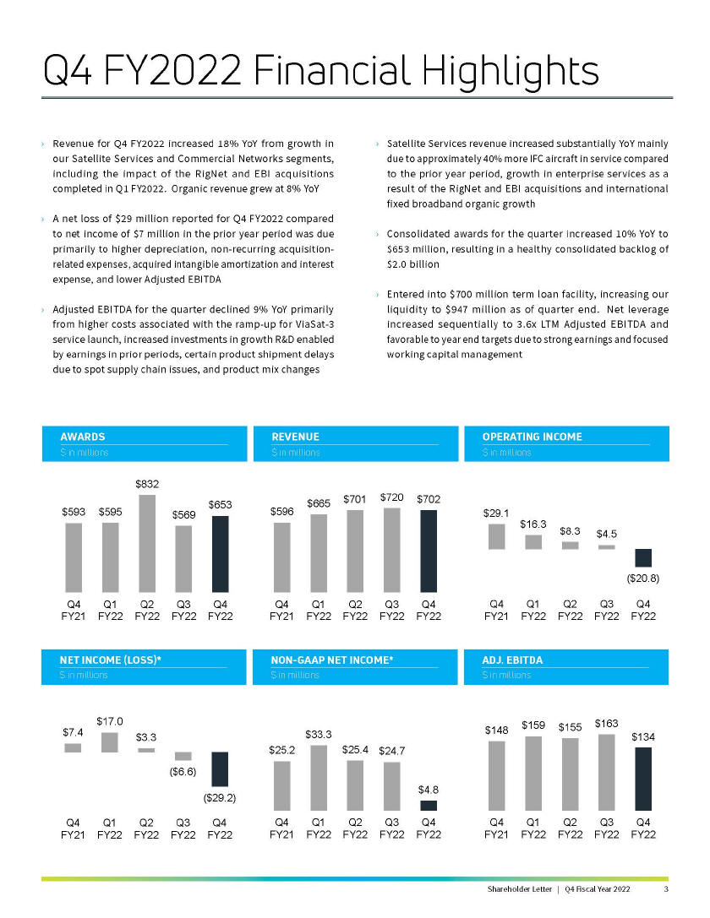
Q4 FY2022 Financial Highlights Revenue for Q4 FY2022 increased 18% YoY from growth in our Satellite Services and Commercial Networks segments, including the impact of the RigNet and EBI acquisitions completed in Q1 FY2022. Organic revenue grew at 8% YoY A net loss of $29 million reported for Q4 FY2022 compared to net income of $7 million in the prior year period was due primarily to higher depreciation, non-recurring acquisition- related expenses, acquired intangible amortization and interest expense, and lower Adjusted EBITDA Adjusted EBITDA for the quarter declined 9% YoY primarily from higher costs associated with the ramp-up for ViaSat-3 service launch, increased investments in growth R&D enabled by earnings in prior periods, certain product shipment delays due to spot supply chain issues, and product mix changes Satellite Services revenue increased substantially YoY mainly due to approximately 40% more IFC aircraft in service compared to the prior year period, growth in enterprise services as a result of the RigNet and EBI acquisitions and international fixed broadband organic growth Consolidated awards for the quarter increased 10% YoY to $653 million, resulting in a healthy consolidated backlog of $2.0 billion Entered into $700 million term loan facility, increasing our liquidity to $947 million as of quarter end. Net leverage increased sequentially to 3.6x LTM Adjusted EBITDA and favorable to year end targets due to strong earnings and focused working capital management AWARDS $ in millions REVENUE $ in millions OPERATING INCOME $ in millions $593 $595 $832 $569 $653 Q4 FY21 Q1 FY22 Q2 FY22 Q3 FY22 Q4 FY22 $596 $665 $701 $720 $702 Q4 FY21 Q1 FY22 Q2 FY22 Q3 FY22 Q4 FY22 $29.1 $16.3 $8.3 $4.5 ($20.8) Q4 FY21 Q1 FY22 Q2 FY22 Q3 FY22 Q4 FY22 NET INCOME (LOSS)* $ in millions NON-GAAP NET INCOME* $ in millions ADJ. EBITDA $ in millions $7.4 $17.0 $3.3 ($6.6) ($29.2) Q4 FY21 Q1 FY22 Q2 FY22 Q3 FY22 Q4 FY22 $25.2 $33.3 $25.4 $24.7 $4.8 Q4 FY21 Q1 FY22 Q2 FY22 Q3 FY22 Q4 FY22 $148 $159 $155 $163 $134 Q4 FY21 Q1 FY22 Q2 FY22 Q3 FY22 Q4 FY22 Shareholder Letter | Q4 Fiscal Year 2022 3

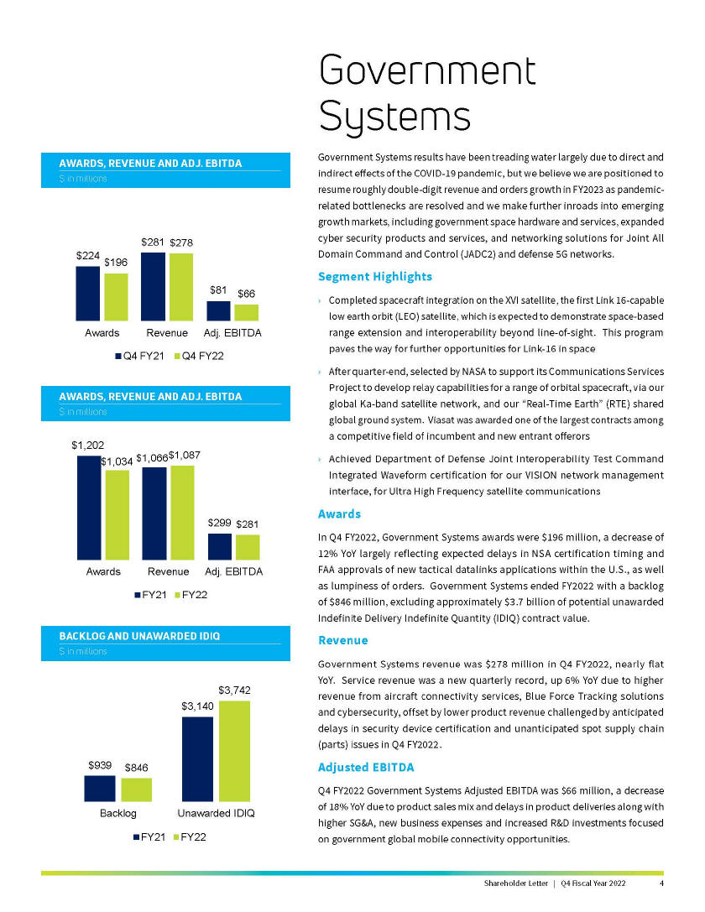
Government Systems AWARDS, REVENUE AND ADJ. EBITDA $ in millions $224 $196 $281 $278 $81 $66 Awards Revenue Adj. EBITDA Q4 FY21 Q4 FY22 AWARDS, REVENUE AND ADJ. EBITDA $ in millions $1,202 $1,034 $1,066 $1,087 $299 $281 Awards Revenue Adj. EBITDA FY21 FY22 BACKLOG AND UNAWARDED IDIQ $ in millions $939 $3,140 $846 $3,742 Backlog Unawarded IDIQ FY21 FY22 Government Systems results have been treading water largely due to direct and indirect effects of the COVID-19 pandemic, but we believe we are positioned to resume roughly double-digit revenue and orders growth in FY2023 as pandemic-related bottlenecks are resolved and we make further inroads into emerging growth markets, including government space hardware and services, expanded cyber security products and services, and networking solutions for Joint All Domain Command and Control (JADC2) and defense 5G networks. Segment Highlights Completed spacecraft integration on the XVI satellite, the first Link 16-capable low earth orbit (LEO) satellite, which is expected to demonstrate space-based range extension and interoperability beyond line-of-sight. This program paves the way for further opportunities for Link-16 in space After quarter-end, selected by NASA to support its Communications Services Project to develop relay capabilities for a range of orbital spacecraft, via our global Ka-band satellite network, and our Real-Time Earth (RTE) shared global ground system. Viasat was awarded one of the largest contracts among a competitive field of incumbent and new entrant offerors Achieved Department of Defense Joint Interoperability Test Command Integrated Waveform certification for our VISION network management interface, for Ultra High Frequency satellite communications Awards In Q4 FY2022, Government Systems awards were $196 million, a decrease of 12% YoY largely reflecting expected delays in NSA certification timing and FAA approvals of new tactical datalinks applications within the U.S., as well as lumpiness of orders. Government Systems ended FY2022 with a backlog of $846 million, excluding approximately $3.7 billion of potential unawarded Indefinite Delivery Indefinite Quantity (IDIQ) contract value. Revenue Government Systems revenue was $278 million in Q4 FY2022, nearly flat YoY. Service revenue was a new quarterly record, up 6% YoY due to higher revenue from aircraft connectivity services, Blue Force Tracking solutions and cybersecurity, offset by lower product revenue challenged by anticipated delays in security device certification and unanticipated spot supply chain (parts) issues in Q4 FY2022. Adjusted EBITDA Q4 FY2022 Government Systems Adjusted EBITDA was $66 million, a decrease of 18% YoY due to product sales mix and delays in product deliveries along with higher SG&A, new business expenses and increased R&D investments focused on government global mobile connectivity opportunities. Shareholder Letter | Q4 Fiscal Year 2022 4

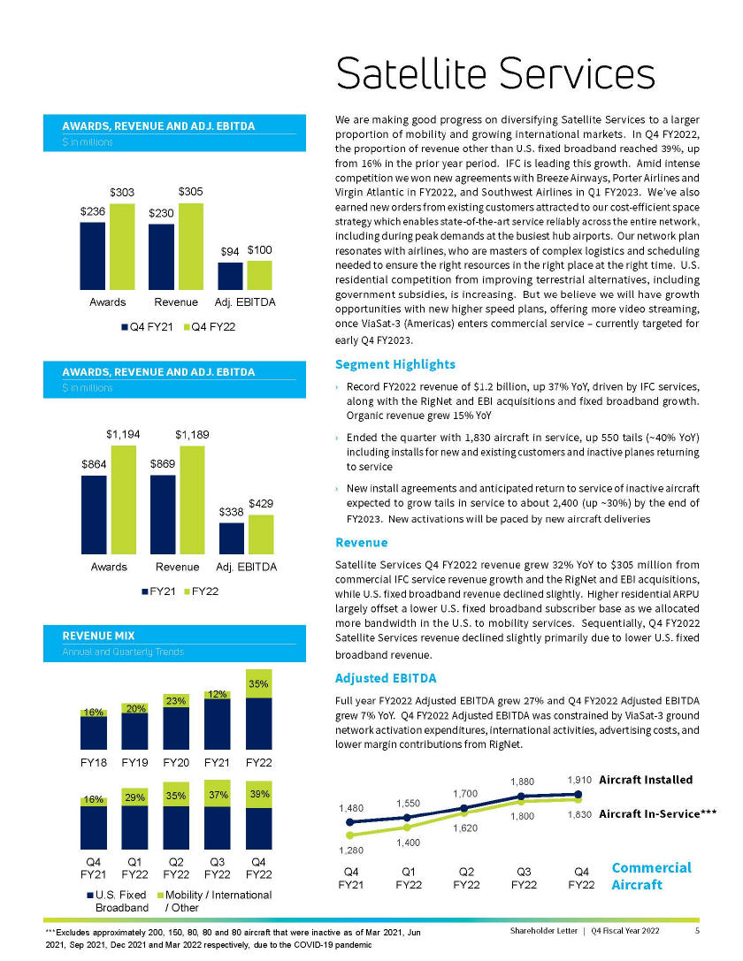
AWARDS, REVENUE AND ADJ. EBITDA $ in millions $236 $303 $230 $305 $94 $100 Awards Revenue Adj. EBITDA Q4 FY21 Q4 FY22 AWARDS, REVENUE AND ADJ. EBITDA $ in millions $864 $1,194 $869 $1,189 $338 $429 Awards Revenue Adj. EBITDA FY21 FY22 REVENUE MIX Annual and Quarterly Trends 16% 20% 23% 12% 35% FY18 FY19 FY20 FY21 FY22 16% 29% 35% 37% 39% Q4 FY21 Q1 FY22 Q2 FY22 Q3 FY22 Q4 FY22 U.S. Fixed Broadband Mobility / International / Other Satellite Services We are making good progress on diversifying Satellite Services to a larger proportion of mobility and growing international markets. In Q4 FY2022, the proportion of revenue other than U.S. fixed broadband reached 39%, up from 16% in the prior year period. IFC is leading this growth. Amid intense competition we won new agreements with Breeze Airways, Porter Airlines and Virgin Atlantic in FY2022, and Southwest Airlines in Q1 FY2023. Weve also earned new orders from existing customers attracted to our cost-efficient space strategy which enables state-of-the-art service reliably across the entire network, including during peak demands at the busiest hub airports. Our network plan resonates with airlines, who are masters of complex logistics and scheduling needed to ensure the right resources in the right place at the right time. U.S. residential competition from improving terrestrial alternatives, including government subsidies, is increasing. But we believe we will have growth opportunities with new higher speed plans, offering more video streaming, once ViaSat-3 (Americas) enters commercial service - currently targeted for early Q4 FY2023. Segment Highlights Record FY2022 revenue of $1.2 billion, up 37% YoY, driven by IFC services, along with the RigNet and EBI acquisitions and fixed broadband growth. Organic revenue grew 15% YoY Ended the quarter with 1,830 aircraft in service, up 550 tails (~40% YoY) including installs for new and existing customers and inactive planes returning to service New install agreements and anticipated return to service of inactive aircraft expected to grow tails in service to about 2,400 (up ~30%) by the end of FY2023. New activations will be paced by new aircraft deliveries Revenue Satellite Services Q4 FY2022 revenue grew 32% YoY to $305 million from commercial IFC service revenue growth and the RigNet and EBI acquisitions, while U.S. fixed broadband revenue declined slightly. Higher residential ARPU largely offset a lower U.S. fixed broadband subscriber base as we allocated more bandwidth in the U.S. to mobility services. Sequentially, Q4 FY2022 Satellite Services revenue declined slightly primarily due to lower U.S. fixed broadband revenue. Adjusted EBITDA Full year FY2022 Adjusted EBITDA grew 27% and Q4 FY2022 Adjusted EBITDA grew 7% YoY. Q4 FY2022 Adjusted EBITDA was constrained by ViaSat-3 ground network activation expenditures, international activities, advertising costs, and lower margin contributions from RigNet. 1,480 1,550 1,700 1,880 1,910 1,280 1,400 1,620 1,800 1,830 Q4 FY21 Q1 FY22 Q2 FY22 Q3 FY22 Q4 FY22 Aircraft Installed Aircraft In-Service*** Commercial Aircraft ***Excludes approximately 200, 150, 80, 80 and 80 aircraft that were inactive as of Mar 2021, Jun 2021, Sep 2021, Dec 2021 and Mar 2022 respectively, due to the COVID-19 pandemic Shareholder Letter | Q4 Fiscal Year 2022 5

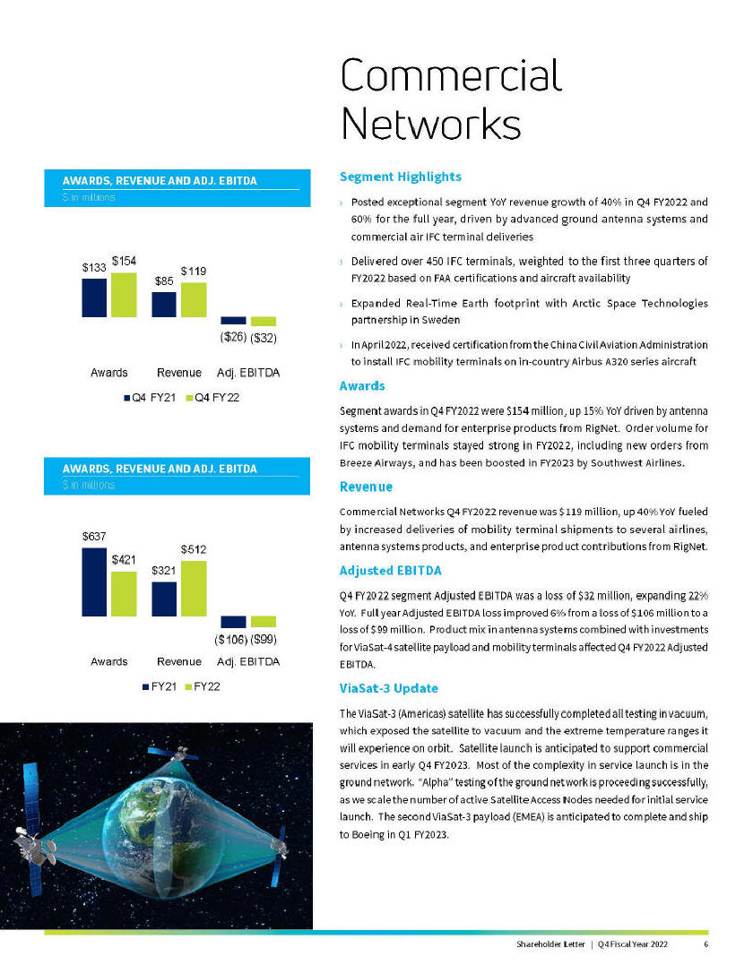
AWARDS, REVENUE AND ADJ. EBITDA $ in millions $133 $154 $85 $119 ($26) ($32) Awards Revenue Adj. EBITDA Q4 FY21 Q4 FY22 AWARDS, REVENUE AND ADJ. EBITDA $ in millions $637 $421 $321 $512 ($106) ($99) Awards Revenue Adj. EBITDA FY21 FY22 Commercial Networks Segment Highlights Posted exceptional segment YoY revenue growth of 40% in Q4 FY2022 and 60% for the full year, driven by advanced ground antenna systems and commercial air IFC terminal deliveries Delivered over 450 IFC terminals, weighted to the first three quarters of FY2022 based on FAA certifications and aircraft availability Expanded Real-Time Earth footprint with Arctic Space Technologies partnership in Sweden In April 2022, received certification from the China Civil Aviation Administration to install IFC mobility terminals on in-country Airbus A320 series aircraft Awards Segment awards in Q4 FY2022 were $154 million, up 15% YoY driven by antenna systems and demand for enterprise products from RigNet. Order volume for IFC mobility terminals stayed strong in FY2022, including new orders from Breeze Airways, and has been boosted in FY2023 by Southwest Airlines. Revenue Commercial Networks Q4 FY2022 revenue was $119 million, up 40% YoY fueled by increased deliveries of mobility terminal shipments to several airlines, antenna systems products, and enterprise product contributions from RigNet. Adjusted EBITDA Q4 FY2022 segment Adjusted EBITDA was a loss of $32 million, expanding 22% YoY. Full year Adjusted EBITDA loss improved 6% from a loss of $106 million to a loss of $99 million. Product mix in antenna systems combined with investments for ViaSat-4 satellite payload and mobility terminals affected Q4 FY2022 Adjusted EBITDA. ViaSat-3 Update The ViaSat-3 (Americas) satellite has successfully completed all testing in vacuum, which exposed the satellite to vacuum and the extreme temperature ranges it will experience on orbit. Satellite launch is anticipated to support commercial services in early Q4 FY2023. Most of the complexity in service launch is in the ground network. Alpha testing of the ground network is proceeding successfully, as we scale the number of active Satellite Access Nodes needed for initial service launch. The second ViaSat-3 payload (EMEA) is anticipated to complete and ship to Boeing in Q1 FY2023. Shareholder Letter | Q4 Fiscal Year 2022 6

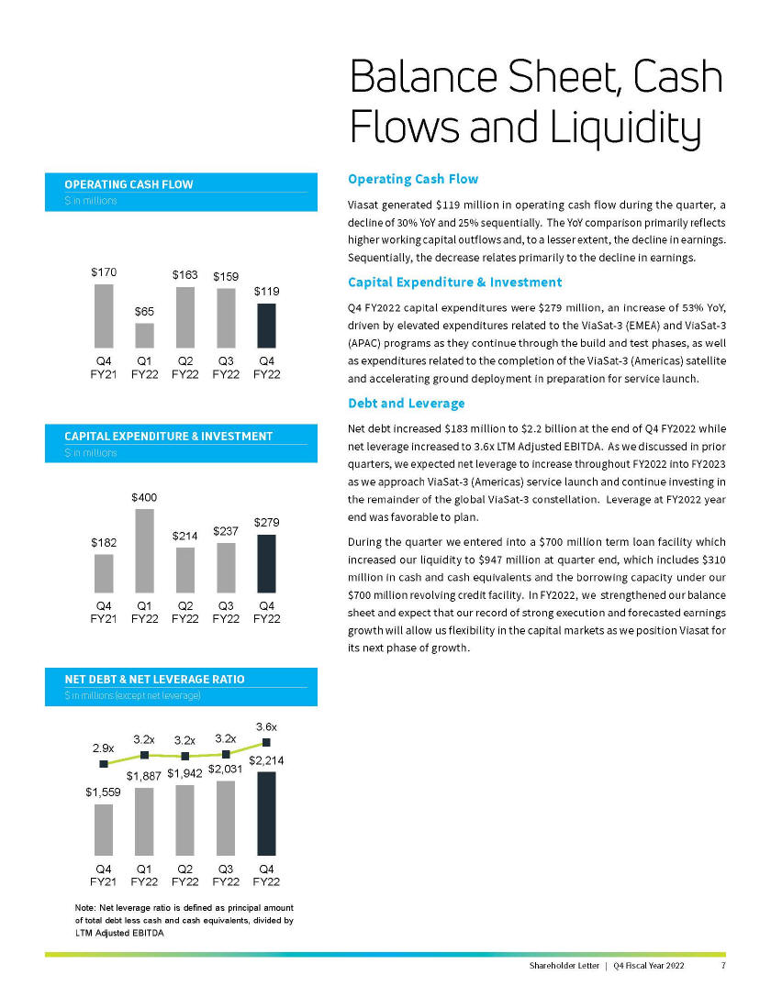
OPERATING CASH FLOW $ in millions $170 $65 $163 $159 $119 Q4 FY21 Q1 FY22 Q2 FY22 Q3 FY22 Q4 FY22 CAPITAL EXPENDITURE & INVESTMENT $ in millions $182 $400 $214 $237 $279 Q4 FY21 Q1 FY22 Q2 FY22 Q3 FY22 Q4 FY22 NET DEBT & NET LEVERAGE RATIO $ in millions (except net leverage) 2.9x 3.2x 3.2x 3.2x 3.6x $1,559 $1,887 $1,942 $2,031 $2,214 Q4 FY21 Q1 FY22 Q2 FY22 Q3 FY22 Q4 FY22 Note: Net leverage ratio is defined as principal amount of total debt less cash and cash equivalents, divided by LTM Adjusted EBITDA Balance Sheet, Cash Flows and Liquidity Operating Cash Flow Viasat generated $119 million in operating cash flow during the quarter, a decline of 30% YoY and 25% sequentially. The YoY comparison primarily reflects higher working capital outflows and, to a lesser extent, the decline in earnings. Sequentially, the decrease relates primarily to the decline in earnings. Capital Expenditure & Investment Q4 FY2022 capital expenditures were $279 million, an increase of 53% YoY, driven by elevated expenditures related to the ViaSat-3 (EMEA) and ViaSat-3 (APAC) programs as they continue through the build and test phases, as well as expenditures related to the completion of the ViaSat-3 (Americas) satellite and accelerating ground deployment in preparation for service launch. Debt and Leverage Net debt increased $183 million to $2.2 billion at the end of Q4 FY2022 while net leverage increased to 3.6x LTM Adjusted EBITDA. As we discussed in prior quarters, we expected net leverage to increase throughout FY2022 into FY2023 as we approach ViaSat-3 (Americas) service launch and continue investing in the remainder of the global ViaSat-3 constellation. Leverage at FY2022 year end was favorable to plan. During the quarter we entered into a $700 million term loan facility which increased our liquidity to $947 million at quarter end, which includes $310 million in cash and cash equivalents and the borrowing capacity under our $700 million revolving credit facility. In FY2022, we strengthened our balance sheet and expect that our record of strong execution and forecasted earnings growth will allow us flexibility in the capital markets as we position Viasat for its next phase of growth. Shareholder Letter | Q4 Fiscal Year 2022 7

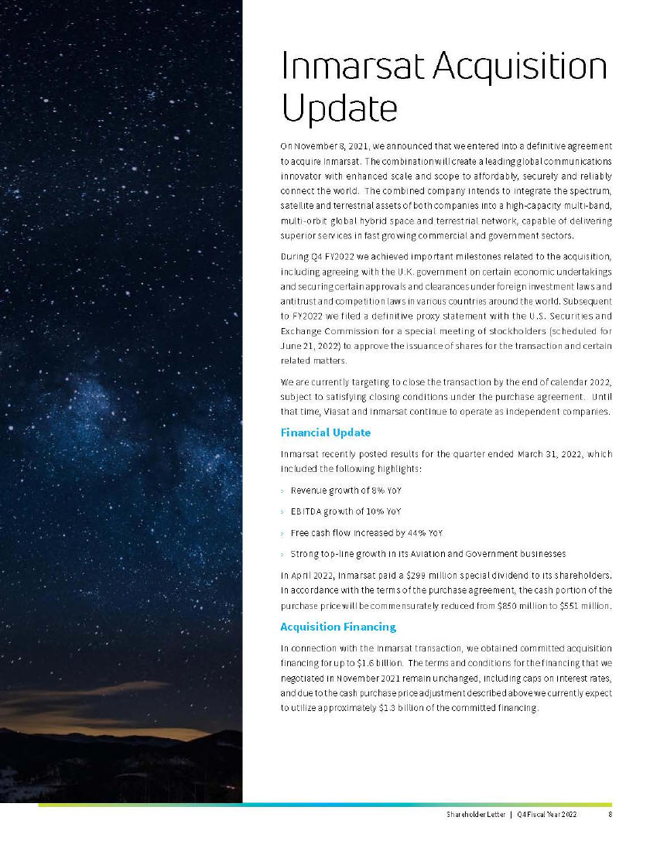
Inmarsat Acquisition Update On November 8, 2021, we announced that we entered into a definitive agreement to acquire Inmarsat. The combination will create a leading global communications innovator with enhanced scale and scope to affordably, securely and reliably connect the world. The combined company intends to integrate the spectrum, satellite and terrestrial assets of both companies into a high-capacity multi-band, multi-orbit global hybrid space and terrestrial network, capable of delivering superior services in fast growing commercial and government sectors. During Q4 FY2022 we achieved important milestones related to the acquisition, including agreeing with the U.K. government on certain economic undertakings and securing certain approvals and clearances under foreign investment laws and antitrust and competition laws in various countries around the world. Subsequent to FY2022 we filed a definitive proxy statement with the U.S. Securities and Exchange Commission for a special meeting of stockholders (scheduled for June 21, 2022) to approve the issuance of shares for the transaction and certain related matters. We are currently targeting to close the transaction by the end of calendar 2022, subject to satisfying closing conditions under the purchase agreement. Until that time, Viasat and Inmarsat continue to operate as independent companies. Financial Update Inmarsat recently posted results for the quarter ended March 31, 2022, which included the following highlights: Revenue growth of 8% YoY EBITDA growth of 10% YoY Free cash flow increased by 44% YoY Strong top-line growth in its Aviation and Government businesses In April 2022, Inmarsat paid a $299 million special dividend to its shareholders. In accordance with the terms of the purchase agreement, the cash portion of the purchase price will be commensurately reduced from $850 million to $551 million. Acquisition Financing In connection with the Inmarsat transaction, we obtained committed acquisition financing for up to $1.6 billion. The terms and conditions for the financing that we negotiated in November 2021 remain unchanged, including caps on interest rates, and due to the cash purchase price adjustment described above we currently expect to utilize approximately $1.3 billion of the committed financing. Shareholder Letter|Q4 Fiscal Year 2022 8

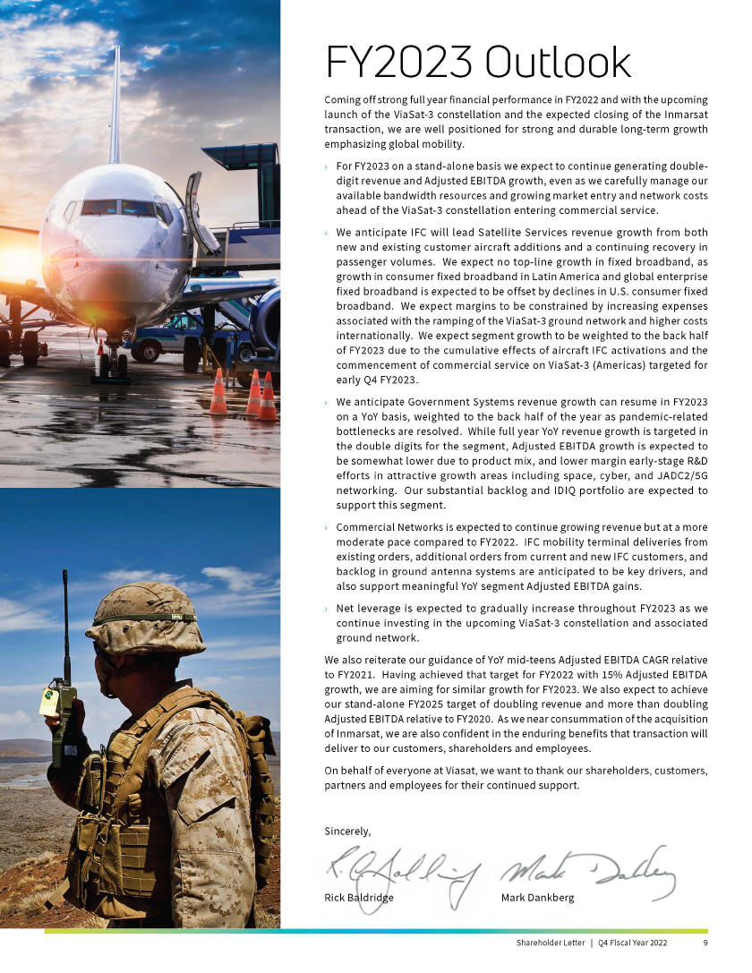
FY2023 Outlook Coming off strong full year financial performance in FY2022 and with the upcoming launch of the ViaSat-3 constellation and the expected closing of the Inmarsat transaction, we are well positioned for strong and durable long-term growth emphasizing global mobility. For FY2023 on a stand-alone basis we expect to continue generating double-digit revenue and Adjusted EBITDA growth, even as we carefully manage our available bandwidth resources and growing market entry and network costs ahead of the ViaSat-3 constellation entering commercial service. We anticipate IFC will lead Satellite Services revenue growth from both new and existing customer aircraft additions and a continuing recovery in passenger volumes. We expect no top-line growth in fixed broadband, as growth in consumer fixed broadband in Latin America and global enterprise fixed broadband is expected to be offset by declines in U.S. consumer fixed broadband. We expect margins to be constrained by increasing expenses associated with the ramping of the ViaSat-3 ground network and higher costs internationally. We expect segment growth to be weighted to the back half of FY2023 due to the cumulative effects of aircraft IFC activations and the commencement of commercial service on ViaSat-3 (Americas) targeted for early Q4 FY2023. We anticipate Government Systems revenue growth can resume in FY2023 on a YoY basis, weighted to the back half of the year as pandemic-related bottlenecks are resolved. While full year YoY revenue growth is targeted in the double digits for the segment, Adjusted EBITDA growth is expected to be somewhat lower due to product mix, and lower margin early-stage R&D efforts in attractive growth areas including space, cyber, and JADC2/5G networking. Our substantial backlog and IDIQ portfolio are expected to support this segment. Commercial Networks is expected to continue growing revenue but at a more moderate pace compared to FY2022. IFC mobility terminal deliveries from existing orders, additional orders from current and new IFC customers, and backlog in ground antenna systems are anticipated to be key drivers, and also support meaningful YoY segment Adjusted EBITDA gains. Net leverage is expected to gradually increase throughout FY2023 as we continue investing in the upcoming ViaSat-3 constellation and associated ground network. We also reiterate our guidance of YoY mid-teens Adjusted EBITDA CAGR relative to FY2021. Having achieved that target for FY2022 with 15% Adjusted EBITDA growth, we are aiming for similar growth for FY2023. We also expect to achieve our stand-alone FY2025 target of doubling revenue and more than doubling Adjusted EBITDA relative to FY2020. As we near consummation of the acquisition of Inmarsat, we are also confident in the enduring benefits that transaction will deliver to our customers, shareholders and employees. On behalf of everyone at Viasat, we want to thank our shareholders, customers, partners and employees for their continued support. Shareholder Letter|Q4 Fiscal Year 2022 9

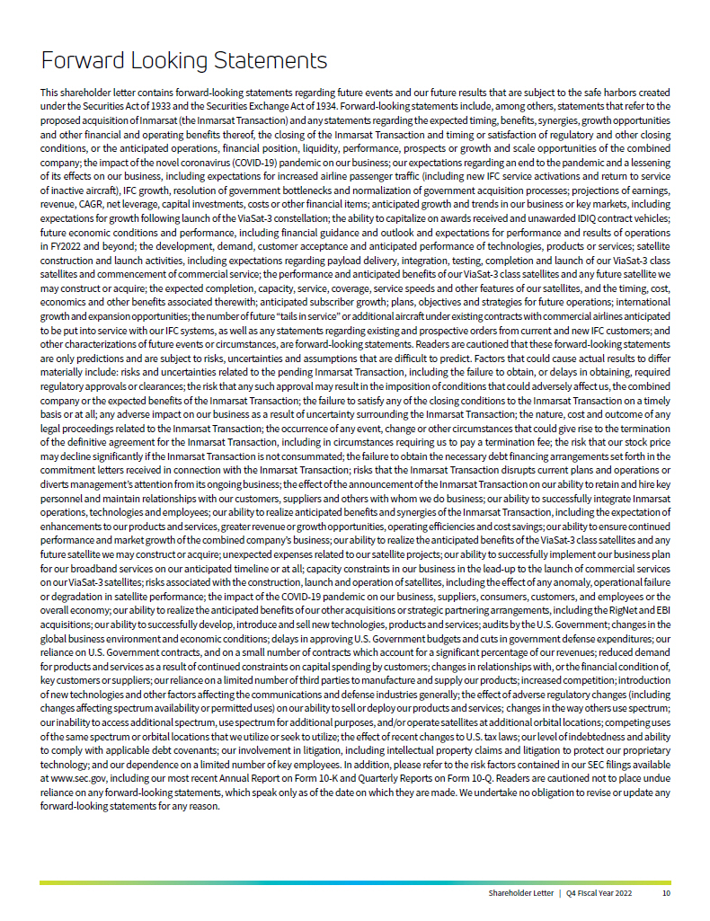
Forward Looking Statements This shareholder letter contains forward-looking statements regarding future events and our future results that are subject to the safe harbors created under the Securities Act of 1933 and the Securities Exchange Act of 1934. Forward-looking statements include, among others, statements that refer to the proposed acquisition of Inmarsat (the Inmarsat Transaction) and any statements regarding the expected timing, benefits, synergies, growth opportunities and other financial and operating benefits thereof, the closing of the Inmarsat Transaction and timing or satisfaction of regulatory and other closing conditions, or the anticipated operations, financial position, liquidity, performance, prospects or growth and scale opportunities of the combined company; the impact of the novel coronavirus (COVID-19) pandemic on our business; our expectations regarding an end to the pandemic and a lessening of its effects on our business, including expectations for increased airline passenger traffic (including new IFC service activations and return to service of inactive aircraft), IFC growth, resolution of government bottlenecks and normalization of government acquisition processes; projections of earnings, revenue, CAGR, net leverage, capital investments, costs or other financial items; anticipated growth and trends in our business or key markets, including expectations for growth following launch of the ViaSat-3 constellation; the ability to capitalize on awards received and unawarded IDIQ contract vehicles; future economic conditions and performance, including financial guidance and outlook and expectations for performance and results of operations in FY2022 and beyond; the development, demand, customer acceptance and anticipated performance of technologies, products or services; satellite construction and launch activities, including expectations regarding payload delivery, integration, testing, completion and launch of our ViaSat-3 class satellites and commencement of commercial service; the performance and anticipated benefits of our ViaSat-3 class satellites and any future satellite we may construct or acquire; the expected completion, capacity, service, coverage, service speeds and other features of our satellites, and the timing, cost, economics and other benefits associated therewith; anticipated subscriber growth; plans, objectives and strategies for future operations; international growth and expansion opportuni ties; the number of future tails in service or additional aircraft under existing contracts with commercial airlines anticipated to be put into service with our IFC systems, as well as any statements regarding existing and prospective orders from current and new IFC customers; and other characterizations of future events or circumstances, are forward-looking statements. Readers are cautioned that these forward-looking statements are only predictions and are subject to risks, uncertainties and assumptions that are difficult to predict. Factors that could cause actual results to differ materially include: risks and uncertainties related to the pending Inmarsat Transaction, including the failure to obtain, or delays in obtaining, required regulatory approvals or clearances; the risk that any such approval may result in the imposition of conditions that could adversely affect us, the combined company or the expected benefits of the Inmarsat Transaction; the failure to satisfy any of the closing conditions to the Inmarsat Transaction on a timely basis or at all; any adverse impact on our business as a result of uncertainty surrounding the Inmarsat Transaction; the nature, cost and outcome of any legal proceedings related to the Inmarsat Transaction; the occurrence of any event, change or other circumstances that could give rise to the termination of the definitive agreement for the Inmarsat Transaction, including in circumstances requiring us to pay a termination fee; the risk that our stock price may decline significantly if the Inmarsat Transaction is not consummated; the failure to obtain the necessary debt financing arrangements set forth in the commitment letters received in connection with the Inmarsat Transaction; risks that the Inmarsat Transaction disrupts current plans and operations or diverts managements attention from its ongoing business; the effect of the announcement of the Inmarsat Transaction on our ability to retain and hire key personnel and maintain relationships with our customers, suppliers and others with whom we do business; our ability to successfully integrate Inmarsat operations, technologies and employees; our ability to realize anticipated benefits and synergies of the Inmarsat Transaction, including the expectation of enhancements to our products and services, greater revenue or growth opportunities, operating efficiencies and cost savings; our ability to ensure continued perform ance and market growth of the combined companys business; our ability to realize the anticipated benefits of the ViaSat-3 class satellites and any future satellite we may construct or acquire; unexpected expenses related to our satellite projects; our ability to successfully implement our business plan for our broadband services on our anticipated timeline or at all; capacity constraints in our business in the lead-up to the launch of commercial services on our ViaSat-3 satellites; risks associated with the construction, launch and operation of satellites, including the effect of any anomaly, operational failure or degradation in satellite performance; the impact of the COVID-19 pandemic on our business, suppliers, consumers, customers, and employees or the overall economy; our ability to realize the anticipated benefits of our other acquisitions or strategic partnering arrangements, including the RigNet and EBI acquisitions; our ability to successfully develop, introduce and sell new technologies, products and services; audits by the U.S. Government; changes in the global business environment and economic conditions; delays in approving U.S. Government budgets and cuts in government defense expenditures; our reliance on U.S. Government contracts, and on a small number of contracts which account for a significant percentage of our revenues; reduced demand for products and services as a result of continued constraints on capital spending by customers; changes in relationships with, or the financial condition of, key customers or suppliers; our reliance on a limited number of third parties to manufacture and supply our products; increased competition; introduction of new technologies and other factors affecting the communications and defense industries generally; the effect of adverse regulatory changes (including changes affecting spectrum availability or permitted uses) on our ability to sell or deploy our products and services; changes in the way others use spectrum; our inability to access additional spectrum, use spectrum for additional purposes, and/or operate satellites at additional orbital locations; competing uses of the same spectrum or orbital locations that we utilize or seek to utilize; the effect of recent changes to U.S. tax laws; our level of indebtedness and ability to comply with applicable debt covenants; our involvement in litigation, including intellectual property claims and litigation to protect our proprietary technology; and our dependence on a limited number of key employees. In addition, please refer to the risk factors contained in our SEC filings available at www.sec.gov, including our most recent Annual Report on Form 10-K and Quarterly Reports on Form 10-Q. Readers are cautioned not to place undue reliance on any forward-looking statements, which speak only as of the date on which they are made. We undertake no obligation to revise or update any forward-looking statements for any reason. Shareholder Letter | Q4 Fiscal Year 2022 10

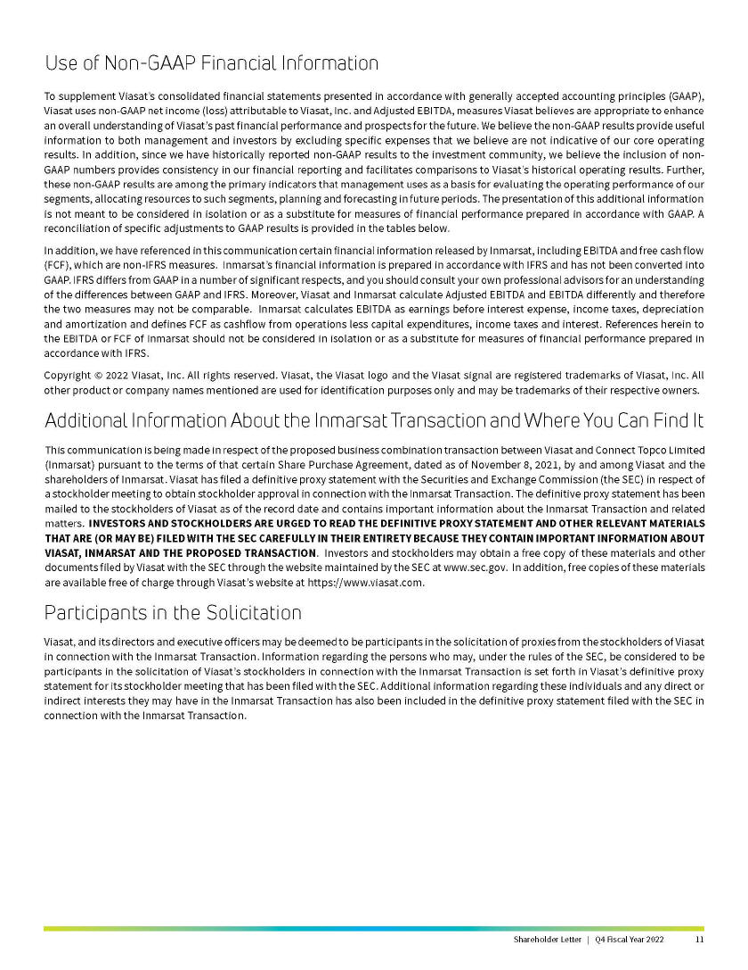
Use of Non-GAAP Financial Information To supplement Viasats consolidated financial statements presented in accordance with generally accepted accounting principles (GAAP), Viasat uses non-GAAP net income (loss) attributable to Viasat, Inc. and Adjusted EBITDA, measures Viasat believes are appropriate to enhance an overall understanding of Viasats past financial performance and prospects for the future. We believe the non-GAAP results provide useful information to both management and investors by excluding specific expenses that we believe are not indicative of our core operating results. In addition, since we have historically reported non-GAAP results to the investment community, we believe the inclusion of non-GAAP numbers provides consistency in our financial reporting and facilitates comparisons to Viasats historical operating results. Further, these non-GAAP results are among the primary indicators that management uses as a basis for evaluating the operating performance of our segments, allocating resources to such segments, planning and forecasting in future periods. The presentation of this additional information is not meant to be considered in isolation or as a substitute for measures of financial performance prepared in accordance with GAAP. A reconciliation of specific adjustments to GAAP results is provided in the tables below. In addition, we have referenced in this communication certain financial information released by Inmarsat, including EBITDA and free cash flow (FCF), which are non-IFRS measures. Inmarsats financial information is prepared in accordance with IFRS and has not been converted into GAAP. IFRS differs from GAAP in a number of significant respects, and you should consult your own professional advisors for an understanding of the differences between GAAP and IFRS. Moreover, Viasat and Inmarsat calculate Adjusted EBITDA and EBITDA differently and therefore the two measures may not be comparable. Inmarsat calculates EBITDA as earnings before interest expense, income taxes, depreciation and amortization and defines FCF as cashflow from operations less capital expenditures, income taxes and interest. References herein to the EBITDA or FCF of Inmarsat should not be considered in isolation or as a substitute for measures of financial performance prepared in accordance with IFRS. Copyright © 2022 Viasat, Inc. All rights reserved. Viasat, the Viasat logo and the Viasat signal are registered trademarks of Viasat, Inc. All other product or company names mentioned are used for identification purposes only and may be trademarks of their respective owners. Additional Information About the Inmarsat Transaction and Where You Can Find It This communication is being made in respect of the proposed business combination transaction between Viasat and Connect Topco Limited (Inmarsat) pursuant to the terms of that certain Share Purchase Agreement, dated as of November 8, 2021, by and among Viasat and the shareholders of Inmarsat. Viasat has filed a definitive proxy statement with the Securities and Exchange Commission (the SEC) in respect of a stockholder meeting to obtain stockholder approval in connection with the Inmarsat Transaction. The definitive proxy statement has been mailed to the stockholders of Viasat as of the record date and contains important information about the Inmarsat Transaction and related matters. INVESTORS AND STOCKHOLDERS ARE URGED TO READ THE DEFINITIVE PROXY STATEMENT AND OTHER RELEVANT MATERIALS THAT ARE (OR MAY BE) FILED WITH THE SEC CAREFULLY IN THEIR ENTIRETY BECAUSE THEY CONTAIN IMPORTANT INFORMATION ABOUT VIASAT, INMARSAT AND THE PROPOSED TRANSACTION. Investors and stockholders may obtain a free copy of these materials and other documents filed by Viasat with the SEC through the website maintained by the SEC at www.sec.gov. In addition, free copies of these materials are available free of charge through Viasats website at https://www.viasat.com. Participants in the Solicitation Viasat, and its directors and executive officers may be deemed to be participants in the solicitation of proxies from the stockholders of Viasat in connection with the Inmarsat Transaction. Information regarding the persons who may, under the rules of the SEC, be considered to be participants in the solicitation of Viasats stockholders in connection with the Inmarsat Transaction is set forth in Viasats definitive proxy statement for its stockholder meeting that has been filed with the SEC. Additional information regarding these individuals and any direct or indirect interests they may have in the Inmarsat Transaction has also been included in the definitive proxy statement filed with the SEC in connection with the Inmarsat Transaction. Shareholder Letter|Q4 Fiscal Year 2022 11

Viasat Fourth Quarter Fiscal Year 2022 Results

Financial Results
(In millions, except per  share data) |  | Q4 FY22 |  | Q4 FY21 |  | Year-Over-Year  Change |  | FY22 |  | FY21 |  | Year-Over-Year  Change
Revenues |  | $701.7 |  | $595.8 |  | 18% |  | $2,787.6 |  | $2,256.1 |  | 24%
Net (loss) income(1) |  | ($29.2) |  | $7.4 |  | * |  | ($15.5) |  | $3.7 |  | *
Non-GAAP net income(1) |  | $4.8 |  | $25.2 |  | (81)% |  | $88.2 |  | $77.0 |  | 15%
Adjusted EBITDA |  | $134.4 |  | $148.1 |  | (9)% |  | $611.2 |  | $530.7 |  | 15%
Diluted per share net (loss) income(1) |  | ($0.39) |  | $0.11 |  | * |  | ($0.21) |  | $0.06 |  | *
Non-GAAP diluted per share net income(1), (2) |  | $0.06 |  | $0.36 |  | (83)% |  | $1.18 |  | $1.15 |  | 3%
Fully diluted weighted average shares(2) |  | 74.6 |  | 69.8 |  | 7% |  | 73.4 |  | 67.0 |  | 10%
New contract awards(3) |  | $652.9 |  | $593.0 |  | 10% |  | $2,648.5 |  | $2,703.9 |  | (2)%
Sales backlog(4) |  | $2,032.7 |  | $2,306.3 |  | (12)% |  | $2,032.7 |  | $2,306.3 |  | (12)%
Segment Results
(In millions) |  | Q4 FY22 |  | Q4 FY21 |  | Year-Over-Year  Change |  | FY22 |  | FY21 |  | Year-Over-Year  Change
Satellite Services
New contract awards(3) |  | $303.1 |  | $235.7 |  | 29% |  | $1,193.6 |  | $864.2 |  | 38%
Revenues |  | $304.9 |  | $230.3 |  | 32% |  | $1,188.8 |  | $868.9 |  | 37%
Operating (loss) profit(5) |  | ($0.8) |  | $14.8 |  | * |  | $42.9 |  | $35.9 |  | 20%
Adjusted EBITDA |  | $99.9 |  | $93.7 |  | 7% |  | $429.5 |  | $337.8 |  | 27%
Commercial Networks
New contract awards |  | $153.9 |  | $133.3 |  | 15% |  | $420.9 |  | $637.3 |  | (34)%
Revenues |  | $119.0 |  | $84.7 |  | 40% |  | $512.1 |  | $320.9 |  | 60%
Operating loss(5) |  | ($52.7) |  | ($45.0) |  | 17% |  | ($180.3) |  | ($180.7) |  | 0%
Adjusted EBITDA |  | ($31.9) |  | ($26.1) |  | 22% |  | ($98.9) |  | ($105.7) |  | (6)%
Government Systems
New contract awards |  | $195.9 |  | $224.0 |  | (12)% |  | $1,034.0 |  | $1,202.4 |  | (14)%
Revenues |  | $277.8 |  | $280.8 |  | (1)% |  | $1,086.7 |  | $1,066.3 |  | 2%
Operating profit(5) |  | $40.6 |  | $60.6 |  | (33)% |  | $174.5 |  | $208.6 |  | (16)%
Adjusted EBITDA |  | $66.4 |  | $80.6 |  | (18)% |  | $280.7 |  | $298.6 |  | (6)%

(1) | Attributable to Viasat, Inc. common stockholders.
(2) | As the three months ended March 31, 2022 and twelve months ended March 31, 2022 financial information resulted in a net loss, the weighted average number of shares used to calculate basic and diluted net loss per share is the same, as diluted shares would be anti-dilutive. However, as the non-GAAP financial information for the three months ended March 31, 2022 and twelve months ended March 31, 2022 resulted in non-GAAP net income, 75.5 million and 74.8 million, respectively, diluted weighted average number of shares were used instead to calculate non-GAAP diluted net income per share.
(3) | Awards exclude future revenue under recurring consumer commitment arrangements.
(4) | Amounts include certain backlog adjustments due to contract changes and amendments. Our backlog includes contracts with subscribers for fixed broadband services in our satellite services segment. Backlog does not include anticipated purchase orders and requests for the installation of in-flight connectivity systems or future recurring in-flight internet service revenues under our commercial in-flight internet agreements in our Commercial Networks and Satellite Services segments, respectively.
(5) | Before corporate and amortization of acquired intangible assets.
* | Percentage not meaningful.

 |  | Shareholder Letter | Q4 Fiscal Year 2022 |  | 12

Viasat Fourth Quarter Fiscal Year 2022 Results (cont.)

Condensed Consolidated Statements of Operations
(Unaudited)
(In thousands, except per share data)

 |  | Three months ended |  |  |  |  |  |  |  | Twelve months ended
 |  | March 31, 2022 |  |  |  | March 31, 2021 |  |  |  | March 31, 2022 |  |  |  | March 31, 2021
Revenues:
Product revenues |  | $ | 292,338 |  |  | $ | 271,322 |  |  | $ | 1,210,411 |  |  | $ | 1,044,450
Service revenues |  |  | 409,366 |  |  |  | 324,460 |  |  |  | 1,577,224 |  |  |  | 1,211,657
Total revenues |  |  | 701,704 |  |  |  | 595,782 |  |  |  | 2,787,635 |  |  |  | 2,256,107
Operating expenses:
Cost of product revenues |  |  | 222,774 |  |  |  | 198,216 |  |  |  | 914,323 |  |  |  | 774,893
Cost of service revenues |  |  | 274,808 |  |  |  | 201,897 |  |  |  | 1,025,799 |  |  |  | 789,391
Selling, general and administrative |  |  | 176,145 |  |  |  | 133,432 |  |  |  | 657,251 |  |  |  | 512,316
Independent research and development |  |  | 40,894 |  |  |  | 31,822 |  |  |  | 153,203 |  |  |  | 115,792
Amortization of acquired intangible assets |  |  | 7,870 |  |  |  | 1,311 |  |  |  | 28,729 |  |  |  | 5,482
(Loss) income from operations |  |  | (20,787 | ) |  |  | 29,104 |  |  |  | 8,330 |  |  |  | 58,233
Interest expense, net |  |  | (11,611 | ) |  |  | (5,527 | ) |  |  | (28,887 | ) |  |  | (32,247 | )
Other income, net |  |  |  |  |  |  |  |  |  |  | 4,118 |  |  |  | 
(Loss) income before income taxes |  |  | (32,398 | ) |  |  | 23,577 |  |  |  | (16,439 | ) |  |  | 25,986
Benefit from (provision for) income taxes |  |  | 10,768 |  |  |  | (8,868 | ) |  |  | 14,237 |  |  |  | (9,441 | )
Equity in (loss) income of unconsolidated affiliates, net |  |  | (25 | ) |  |  | (232 | ) |  |  | (281 | ) |  |  | 556
Net (loss) income |  |  | (21,655 | ) |  |  | 14,477 |  |  |  | (2,483 | ) |  |  | 17,101
Less: net income attributable to noncontrolling interest, net of tax |  |  | 7,525 |  |  |  | 7,120 |  |  |  | 13,051 |  |  |  | 13,410
Net (loss) income attributable to Viasat, Inc. |  | $ | (29,180 | ) |  | $ | 7,357 |  |  | $ | (15,534 | ) |  | $ | 3,691
Diluted net (loss) income per share attributable to Viasat, Inc. common stockholders |  | $ | (0.39 | ) |  | $ | 0.11 |  |  | $ | (0.21 | ) |  | $ | 0.06
Diluted common equivalent shares(2) |  |  | 74,585 |  |  |  | 69,792 |  |  |  | 73,397 |  |  |  | 67,020
AN ITEMIZED RECONCILIATION BETWEEN NET (LOSS) INCOME ATTRIBUTABLE TO VIASAT, INC.
ON A GAAP BASIS AND NON-GAAP BASIS IS AS FOLLOWS:
(In thousands, except per share data) |  | Three months ended |  |  |  |  |  |  |  | Twelve months ended
 |  | March 31, 2022 |  |  |  | March 31, 2021 |  |  |  | March 31, 2022 |  |  |  | March 31, 2021
GAAP net (loss) income attributable to Viasat, Inc. |  | $ | (29,180 | ) |  | $ | 7,357 |  |  | $ | (15,534 | ) |  | $ | 3,691
Amortization of acquired intangible assets |  |  | 7,870 |  |  |  | 1,311 |  |  |  | 28,729 |  |  |  | 5,482
Stock-based compensation expense |  |  | 22,132 |  |  |  | 19,912 |  |  |  | 86,808 |  |  |  | 84,879
Acquisition related expenses |  |  | 14,613 |  |  |  | 1,452 |  |  |  | 33,965 |  |  |  | 3,328
Other income, net |  |  |  |  |  |  |  |  |  |  | (4,118 | ) |  |  | 
Income tax effect(1) |  |  | (10,613 | ) |  |  | (4,844 | ) |  |  | (41,649 | ) |  |  | (20,379 | )
Non-GAAP net income attributable to Viasat, Inc. |  | $ | 4,822 |  |  | $ | 25,188 |  |  | $ | 88,201 |  |  | $ | 77,001
Non-GAAP diluted net income per share attributable to Viasat, Inc. common stockholders |  | $ | 0.06 |  |  | $ | 0.36 |  |  | $ | 1.18 |  |  | $ | 1.15
Diluted common equivalent shares(2) |  |  | 75,549 |  |  |  | 69,792 |  |  |  | 74,768 |  |  |  | 67,020

(1) | The income tax effect is calculated using the tax rate applicable for the non-GAAP adjustments.
(2) | As the three months ended March 31, 2022 and twelve months ended March 31, 2022 financial information resulted in a net loss, the weighted average number of shares used to calculate basic and diluted net loss per share is the same, as diluted shares would be anti-dilutive. However, as the non-GAAP financial information for the three months ended March 31, 2022 and twelve months ended March 31, 2022 resulted in non-GAAP net income, diluted weighted average number of shares were used instead to calculate non-GAAP diluted net income per share.

AN ITEMIZED RECONCILIATION BETWEEN NET (LOSS) INCOME ATTRIBUTABLE TO VIASAT, INC.
AND ADJUSTED EBITDA IS AS FOLLOWS:
(In thousands) |  | Three months ended |  |  |  |  |  |  |  | Twelve months ended
 |  | March 31, 2022 |  |  |  | March 31, 2021 |  |  |  | March 31, 2022 |  |  |  | March 31, 2021
GAAP net (loss) income attributable to Viasat, Inc. |  | $ | (29,180 | ) |  | $ | 7,357 |  |  | $ | (15,534 | ) |  | $ | 3,691
(Benefit from) provision for income taxes |  |  | (10,768 | ) |  |  | 8,868 |  |  |  | (14,237 | ) |  |  | 9,441
Interest expense, net |  |  | 11,611 |  |  |  | 5,527 |  |  |  | 28,887 |  |  |  | 32,247
Depreciation and amortization |  |  | 125,959 |  |  |  | 104,986 |  |  |  | 495,447 |  |  |  | 397,102
Stock-based compensation expense |  |  | 22,132 |  |  |  | 19,912 |  |  |  | 86,808 |  |  |  | 84,879
Acquisition related expenses |  |  | 14,613 |  |  |  | 1,452 |  |  |  | 33,965 |  |  |  | 3,328
Other income, net |  |  |  |  |  |  |  |  |  |  | (4,118 | ) |  |  | 
Adjusted EBITDA |  | $ | 134,367 |  |  | $ | 148,102 |  |  | $ | 611,218 |  |  | $ | 530,688

 |  | Shareholder Letter | Q4 Fiscal Year 2022 |  | 13

Viasat Fourth Quarter Fiscal Year 2022 Results (cont.)

AN ITEMIZED RECONCILIATION BETWEEN SEGMENT OPERATING (LOSS) PROFIT BEFORE
CORPORATE AND AMORTIZATION OF ACQUIRED INTANGIBLE ASSETS AND ADJUSTED EBITDA IS AS FOLLOWS:
(In thousands)

 |  | Three months ended March 31, 2022 |  |  |  |  |  |  |  |  |  |  |  |  |  |  |  | Three months ended March 31, 2021
 |  | Satellite  Services |  |  |  | Commercial  Networks |  |  |  | Government  Systems |  |  |  | Total |  |  |  | Satellite  Services |  |  |  | Commercial  Networks |  |  |  | Government  Systems |  |  |  | Total
Segment operating (loss) profit before corporate and amortization of acquired intangible assets |  | $ | (849 | ) |  | $ | (52,697 | ) |  | $ | 40,629 |  |  | $ | (12,917 | ) |  | $ | 14,770 |  |  | $ | (44,964 | ) |  | $ | 60,609 |  |  | $ | 30,415
Depreciation(3) |  |  | 76,234 |  |  |  | 10,538 |  |  |  | 16,459 |  |  |  | 103,231 |  |  |  | 63,101 |  |  |  | 9,416 |  |  |  | 16,409 |  |  |  | 88,926
Stock-based compensation expense |  |  | 7,137 |  |  |  | 7,828 |  |  |  | 7,167 |  |  |  | 22,132 |  |  |  | 6,303 |  |  |  | 6,830 |  |  |  | 6,779 |  |  |  | 19,912
Other amortization |  |  | 8,628 |  |  |  | 2,460 |  |  |  | 3,770 |  |  |  | 14,858 |  |  |  | 8,300 |  |  |  | 2,575 |  |  |  | 3,874 |  |  |  | 14,749
Acquisition related expenses |  |  | 8,799 |  |  |  |  |  |  |  | 5,814 |  |  |  | 14,613 |  |  |  | 1,452 |  |  |  |  |  |  |  |  |  |  |  | 1,452
Equity in loss of unconsolidated affiliates, net |  |  | (25 | ) |  |  |  |  |  |  |  |  |  |  | (25 | ) |  |  | (232 | ) |  |  |  |  |  |  |  |  |  |  | (232 | )
Noncontrolling interest |  |  | (60 | ) |  |  |  |  |  |  | (7,465 | ) |  |  | (7,525 | ) |  |  |  |  |  |  |  |  |  |  | (7,120 | ) |  |  | (7,120 | )
Adjusted EBITDA |  | $ | 99,864 |  |  | $ | (31,871 | ) |  | $ | 66,374 |  |  | $ | 134,367 |  |  | $ | 93,694 |  |  | $ | (26,143 | ) |  | $ | 80,551 |  |  | $ | 148,102
 |  | Twelve months ended March 31, 2022 |  |  |  |  |  |  |  |  |  |  |  |  |  |  |  | Twelve months ended March 31, 2021
 |  | Satellite  Services |  |  |  | Commercial  Networks |  |  |  | Government  Systems |  |  |  | Total |  |  |  | Satellite  Services |  |  |  | Commercial  Networks |  |  |  | Government  Systems |  |  |  | Total
Segment operating profit (loss) before corporate and amortization of acquired intangible assets |  | $ | 42,862 |  |  | $ | (180,298 | ) |  | $ | 174,495 |  |  | $ | 37,059 |  |  | $ | 35,853 |  |  | $ | (180,749 | ) |  | $ | 208,611 |  |  | $ | 63,715
Depreciation(3) |  |  | 300,848 |  |  |  | 42,263 |  |  |  | 64,265 |  |  |  | 407,376 |  |  |  | 240,128 |  |  |  | 34,618 |  |  |  | 56,115 |  |  |  | 330,861
Stock-based compensation expense |  |  | 29,607 |  |  |  | 28,997 |  |  |  | 28,204 |  |  |  | 86,808 |  |  |  | 25,848 |  |  |  | 29,761 |  |  |  | 29,270 |  |  |  | 84,879
Other amortization |  |  | 33,208 |  |  |  | 10,091 |  |  |  | 16,043 |  |  |  | 59,342 |  |  |  | 33,262 |  |  |  | 10,125 |  |  |  | 17,372 |  |  |  | 60,759
Acquisition related expenses |  |  | 23,430 |  |  |  |  |  |  |  | 10,535 |  |  |  | 33,965 |  |  |  | 2,117 |  |  |  | 565 |  |  |  | 646 |  |  |  | 3,328
Equity in (loss) income of unconsolidated affiliates, net |  |  | (281 | ) |  |  |  |  |  |  |  |  |  |  | (281 | ) |  |  | 556 |  |  |  |  |  |  |  |  |  |  |  | 556
Noncontrolling interest |  |  | (220 | ) |  |  |  |  |  |  | (12,831 | ) |  |  | (13,051 | ) |  |  |  |  |  |  |  |  |  |  | (13,410 | ) |  |  | (13,410 | )
Adjusted EBITDA |  | $ | 429,454 |  |  | $ | (98,947 | ) |  | $ | 280,711 |  |  | $ | 611,218 |  |  | $ | 337,764 |  |  | $ | (105,680 | ) |  | $ | 298,604 |  |  | $ | 530,688

(3) | Depreciation expenses not specifically recorded in a particular segment have been allocated based on other indirect allocable costs, which management believes is a reasonable method.
Condensed Consolidated Balance Sheets
(Unaudited)
(In thousands)

 |  | As of |  |  |  | As of |  |  |  |  |  | As of |  |  |  | As of
Assets |  | March 31, 2022 |  |  |  | March 31, 2021 |  |  |  | Liabilities and Equity |  | March 31, 2022 |  |  |  | March 31, 2021
Current assets: |  |  |  |  |  |  |  |  |  | Current liabilities:
Cash and cash equivalents |  | $ | 310,459 |  |  | $ | 295,949 |  |  | Accounts payable |  | $ | 219,088 |  |  | $ | 145,134
Accounts receivable, net |  |  | 359,269 |  |  |  | 238,652 |  |  | Accrued and other liabilities |  |  | 516,422 |  |  |  | 532,831
Inventories |  |  | 341,890 |  |  |  | 336,672 |  |  | Current portion of long-term debt |  |  | 34,911 |  |  |  | 30,472
Prepaid expenses and other current assets |  |  | 147,854 |  |  |  | 119,960 |  |  | Total current liabilities |  |  | 770,421 |  |  |  | 708,437
Total current assets |  |  | 1,159,472 |  |  |  | 991,233
 |  |  |  |  |  |  |  |  |  | Senior notes |  |  | 1,686,225 |  |  |  | 1,683,264
 |  |  |  |  |  |  |  |  |  | Other long-term debt |  |  | 764,991 |  |  |  | 119,420
 |  |  |  |  |  |  |  |  |  | Non-current operating lease liabilities |  |  | 327,664 |  |  |  | 313,762
Property, equipment and satellites, net |  |  | 3,741,912 |  |  |  | 3,050,483 |  |  | Other liabilities |  |  | 157,451 |  |  |  | 137,350
Operating lease right-of-use assets |  |  | 356,176 |  |  |  | 340,456 |  |  | Total liabilities |  |  | 3,706,752 |  |  |  | 2,962,233
Other acquired intangible assets, net |  |  | 236,043 |  |  |  | 9,568 |  |  | Total Viasat, Inc. stockholders equity |  |  | 2,633,866 |  |  |  | 2,351,469
Goodwill |  |  | 190,113 |  |  |  | 122,300 |  |  | Noncontrolling interest in subsidiary |  |  | 48,728 |  |  |  | 35,765
Other assets |  |  | 705,630 |  |  |  | 835,427 |  |  | Total equity |  |  | 2,682,594 |  |  |  | 2,387,234
Total assets |  | $ | 6,389,346 |  |  | $ | 5,349,467 |  |  | Total liabilities and equity |  | $ | 6,389,346 |  |  | $ | 5,349,467

 |  | Shareholder Letter | Q4 Fiscal Year 2022 |  | 14

Viasat Financial Reconciliation Prior Periods

AN ITEMIZED RECONCILIATION BETWEEN NET (LOSS) INCOME ATTRIBUTABLE TO VIASAT, INC.
ON A GAAP BASIS AND NON-GAAP BASIS IS AS FOLLOWS:
(In thousands)

 |  | Three months ended
 |  | December 31, 2021 |  |  |  | September 30, 2021 |  |  |  | June 30, 2021
GAAP net (loss) income attributable to Viasat, Inc. |  | $ | (6,613 | ) |  | $ | 3,291 |  |  | $ | 16,968
Amortization of acquired intangible assets |  |  | 7,531 |  |  |  | 7,399 |  |  |  | 5,929
Stock-based compensation expense |  |  | 21,435 |  |  |  | 21,023 |  |  |  | 22,218
Acquisition related expenses |  |  | 11,862 |  |  |  | 488 |  |  |  | 7,002
Other income, net |  |  |  |  |  |  |  |  |  |  | (4,118 | )
Income tax effect(1) |  |  | (9,524 | ) |  |  | (6,784 | ) |  |  | (14,728 | )
Non-GAAP net income attributable to Viasat, Inc. |  | $ | 24,691 |  |  | $ | 25,417 |  |  | $ | 33,271
 |  | Twelve months ended
 |  | March 31, 2020 |  |  |  | March 31, 2019 |  |  |  | March 31, 2018
GAAP net loss attributable to Viasat, Inc. |  | $ | (212 | ) |  | $ | (67,623 | ) |  | $ | (67,305 | )
Amortization of acquired intangible assets |  |  | 7,611 |  |  |  | 9,655 |  |  |  | 12,231
Stock-based compensation expense |  |  | 86,553 |  |  |  | 79,599 |  |  |  | 68,545
Loss on extinguishment of debt |  |  |  |  |  |  |  |  |  |  | 10,217
Acquisition related expenses |  |  |  |  |  |  |  |  |  |  | 
Income tax effect(1) |  |  | (21,930 | ) |  |  | (20,746 | ) |  |  | (21,508 | )
Non-GAAP net income attributable to Viasat, Inc. |  | $ | 72,022 |  |  | $ | 885 |  |  | $ | 2,180

(1) | The income tax effect is calculated using the tax rate applicable for the non-GAAP adjustments.
AN ITEMIZED RECONCILIATION BETWEEN NET (LOSS) INCOME ATTRIBUTABLE TO VIASAT, INC.
AND ADJUSTED EBITDA IS AS FOLLOWS:
(In thousands)

 |  | Three months ended
 |  | December 31, 2021 |  |  |  | September 30, 2021 |  |  |  | June 30, 2021
GAAP net (loss) income attributable to Viasat, Inc. |  | $ | (6,613 | ) |  | $ | 3,291 |  |  | $ | 16,968
Provision for (benefit from) income taxes |  |  | 3,492 |  |  |  | (2,874 | ) |  |  | (4,087 | )
Interest expense, net |  |  | 5,025 |  |  |  | 6,022 |  |  |  | 6,229
Depreciation and amortization |  |  | 127,628 |  |  |  | 127,108 |  |  |  | 114,752
Stock-based compensation expense |  |  | 21,435 |  |  |  | 21,023 |  |  |  | 22,218
Acquisition related expenses |  |  | 11,862 |  |  |  | 488 |  |  |  | 7,002
Other income, net |  |  |  |  |  |  |  |  |  |  | (4,118 | )
Adjusted EBITDA |  | $ | 162,829 |  |  | $ | 155,058 |  |  | $ | 158,964
 |  | Twelve months ended
 |  | March 31, 2020 |  |  |  | March 31, 2019 |  |  |  | March 31, 2018
GAAP net loss attributable to Viasat, Inc. |  | $ | (212 | ) |  | $ | (67,623 | ) |  | $ | (67,305 | )
Benefit from income taxes |  |  | (7,915 | ) |  |  | (41,014 | ) |  |  | (35,217 | )
Interest expense, net |  |  | 36,993 |  |  |  | 49,861 |  |  |  | 3,066
Depreciation and amortization |  |  | 342,178 |  |  |  | 318,613 |  |  |  | 255,652
Stock-based compensation expense |  |  | 86,553 |  |  |  | 79,599 |  |  |  | 68,545
Loss on extinguishment of debt |  |  |  |  |  |  |  |  |  |  | 10,217
Acquisition related expenses |  |  |  |  |  |  |  |  |  |  | 
Adjusted EBITDA |  | $ | 457,597 |  |  | $ | 339,436 |  |  | $ | 234,958

 |  | Shareholder Letter | Q4 Fiscal Year 2022 |  | 15

